Foreign Students TSA process (step by step)

- Link for the TSA website
https://www.flightschoolcandidates.gov/afsp2/?acct_type=c&section=FQ
- You must press Create a New candidate account – fill out the details as written in your passport
- Create USER and PASWORD
- Start the TSA process
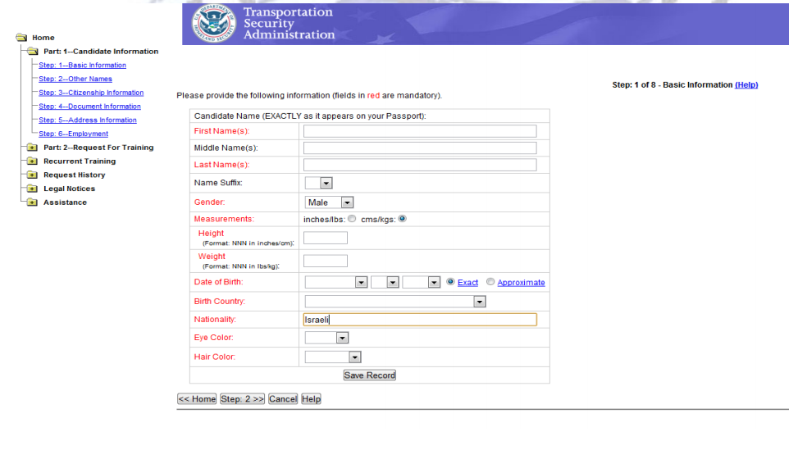
- Step Two – Fill out any additional names you have
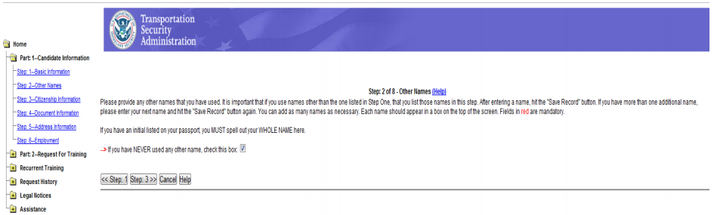
- Step Three – Mention ANY additional citizenships. Even if you had them as a baby – if you were born in COUNTRY A but were raised in COUNTRY B since you were a toddler, you must still mention ALL citizenships.
- You can press SAVE RECORD and add new listings for all your citizenships.
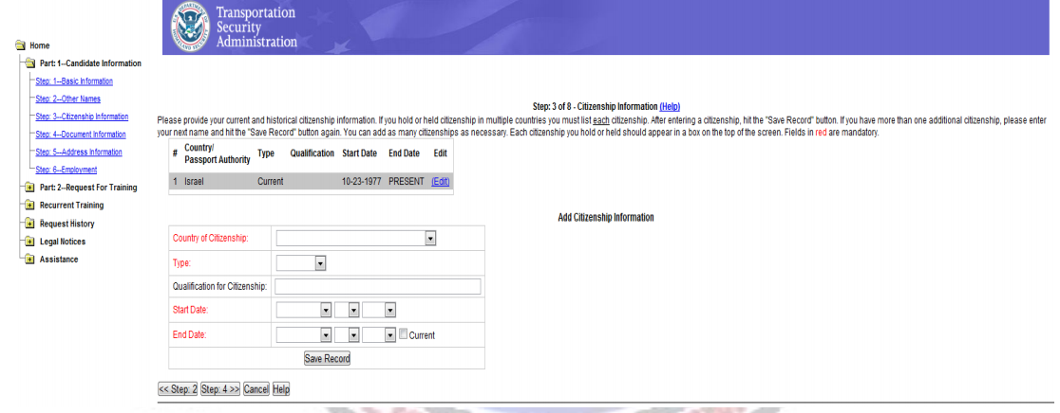
- Step Four – You must scan and upload the following documents:
- Passport Page (front page with picture+ Extension, if you have had one)
- Visa Page
- American pilot license (if you have one).
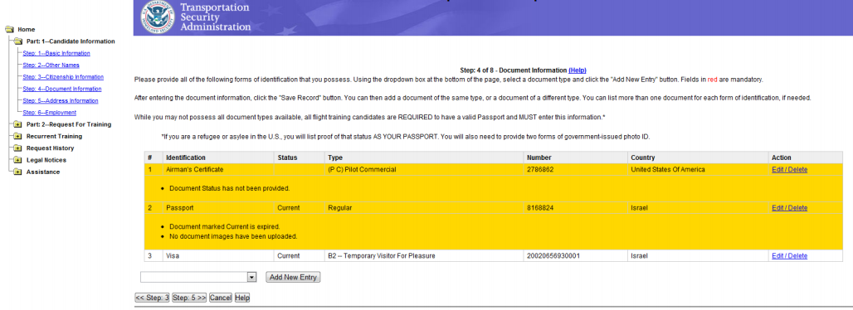
- Step Five – Fill out ALL the addresses where you lived for the past FIVE years (over 30 days)
- Important notes:
- Accuracy – not very important
- VERY IMPORTANT – No OVERLAP of dates, no intervals between addresses.
- Press SAVE RECORD to add new listings.
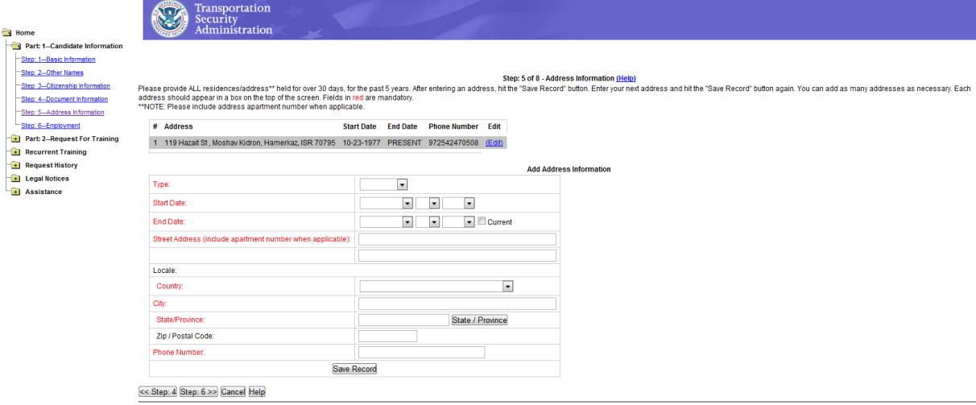
- Step Six – Name and Place of Employment/ Employer.
- If you are unemployed, put down “UNEMPLOYED” in occupation and employer.
- If you are independent, put down “SELF EMPLOYED” in occupation and employer.
- If you are a student, put down “STUDENT” in occupation and employer.
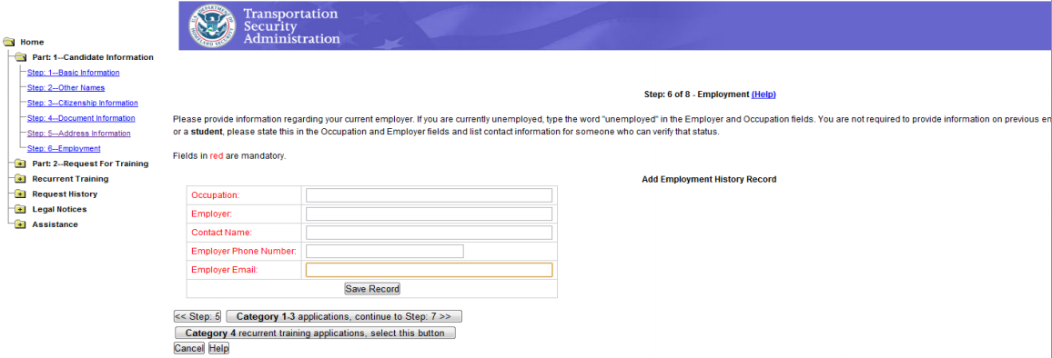
- Step Seven – Fill out the course you want to take
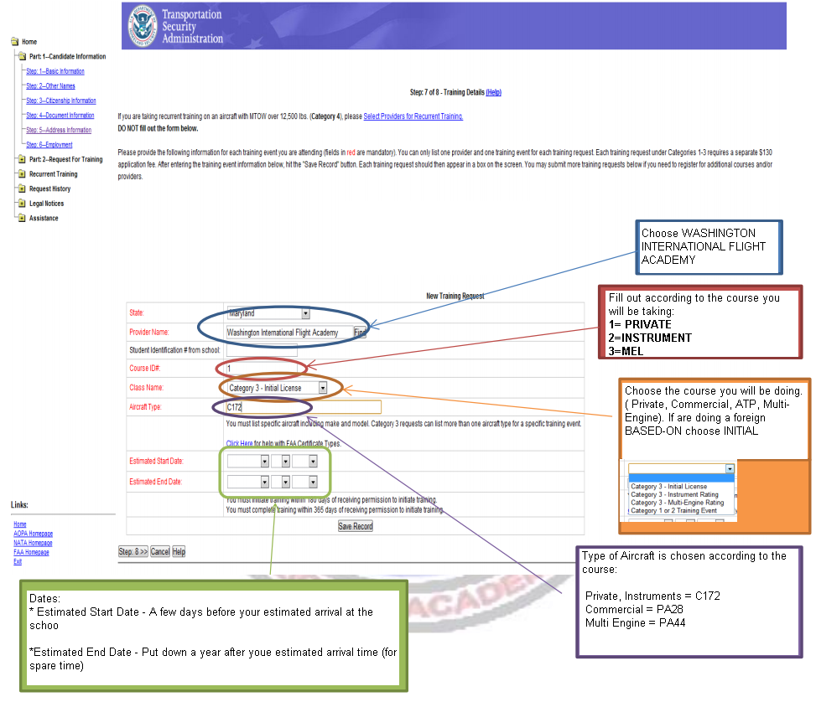
- Step Eight – End of Process – Mark CATEGORY III only!
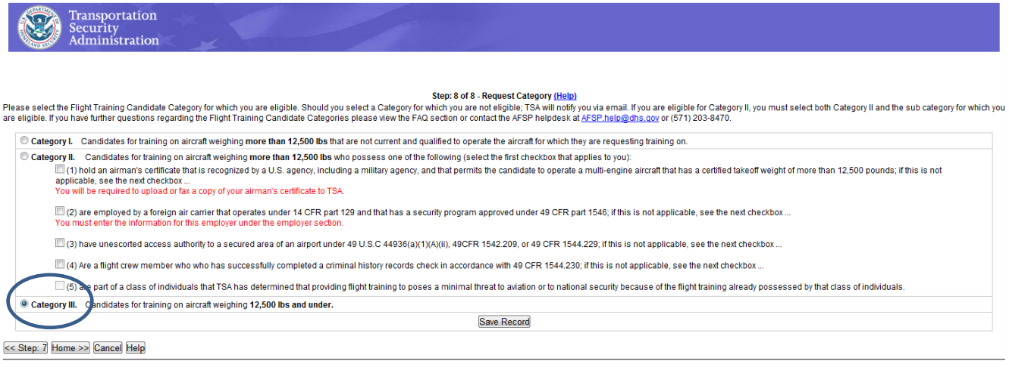
- Step Nine – You will be taken to the HOME page:
- You must press SUBMIT – At this point the request is sent to the school
- After the school has approved your request, you will receive an email. The HOME page will display a $ sign, press it to pay about 130$ (fee dependent on TSA)
- After the payment, you will see a PAID icon on the right column.
- After a few days you should receive and email with the headline Documentation Accepted/Fingerprint Instructions. Keep this email, you will need to print it out for the fingerprint submission process.
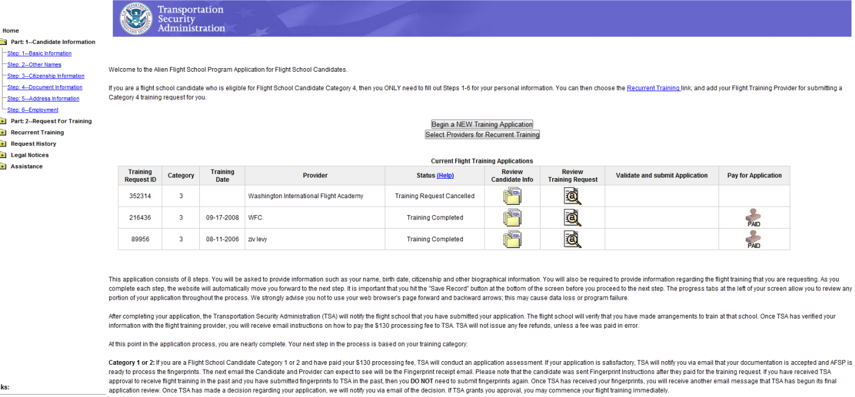
- When you reach the school, you will need to fill out the NATA form
- https://secure.natacs.aero/afsp/afsp_form.asp?agency=1358&agent_number=1002
- Pay another 99$, print out the form and go to the following address to submit your fingerprints:
All American Protective services LLC
7361 Calhoun PI
Suite 485
Dearwood, Maryland
(301)-296-4499

