Commercial Pilot Training Course Outline (TCO)
Chief Flight Instructor: Harry Kraemer, Assistant Chief Flight Instructor: Keith Doersom

Stage 1 Introduction to the Commercial Certificate
- Module 1
- Module 2
- Module 3
- Module 4
- Module 5
- Module 6

Stage 2 Cross-Country Flight Experience
- Module 1
- Module 2
- Module 3
- Module 4
- Module 5
- Module 6

Stage 3 Complex Aircraft and Night Flying Experience
- Module 1
- Module 2
- Module 3
- Module 4
- Module 5
- Module 6

Stage 4 Prep for Checkride
- Module 1
- Module 2
- Module 3
- Module 4
- Module 5
- Module 6

Instructor qualifications

Minimum required for both flight and ground instruction
- Current Instructor certificate for the instruction to be given (CFI)
- Third class medical
- Good standing in the community
- Must attend monthly instructor meetings held on the first Thursday of each month

Commercial Pilot Syllabus

Course Objective
The objective of this syllabus is for the student to acquire the necessary aeronautical skill, knowledge and experience to meet the requirements of a Commercial Pilot certificate with an Airplane category rating and a Single-Engine Land class rating.

Prerequisites
The student must be able to read, speak, write and understand the English language, meet the physical standards for a second-class medical certificate, and possess a valid private pilot certificate with an instrument rating, or possess a valid private pilot certificate and be concurrently enrolled in an instrument rating course (ASEL) and pass the required instrument rating practical test prior to completing the commercial pilot certification course. The student must be 18 years old at the time of the practical test to gain certification.

Experience Requirements for a Commercial Certificate Include
190 hours of flight time (250 hours for 14 CFR Part 61 programs)
100 hours of ground training (no minimum time is stipulated for 14 CFR Part 61 programs)
- Flight training = 190.00 hours total (35 hours Private Pilot, 35 hours Instrument Rating, 120 hours Commercial Certificate)
- Ground Training = 100.00 hours (35 hours each for the Private and Commercial Certificate, 30 hours Instrument Rating)

Commercial Pilot Certification Course
The Commercial certificate is made up of 2 requirements: Aeronautical Skill and Aeronautical Knowledge. This syllabus is written to satisfy Part 141 requirements. The syllabus is in four Stages, each containing six Modules. Each stage must be completed in 90 days. Each Module contains both a flight and ground lesson. This presents an integrated flight training process and will promote easier learning and a more efficient flight-training program. Ideally, the ground lesson will be completed prior to the flight. Each flight lesson must include a pre- and post-flight briefing.

Testing Procedures
Each module contains review questions. The review questions must be answered prior to moving on to the next module. A Stage Exam is included with each stage, testing the student on both the ground and flight training material covered throughout the stage. This exam must be passed with a minimum score of 80%, and reconciled to 100%, to proceed to the next Stage. It is essential that the objective of each module be accomplished before moving on to the next module.

Commercial Pilot Syllabus continued…

Minimum Requirements
This is the time necessary to qualify for a Commercial Pilot Certificate under FAR 141, meeting the 35 hours of ground instruction, and the120 hours of flight time. Many factors play into the finishing flight time: frequency of flying, cooperative weather, airplane and instructor scheduling, and lapses in the flight training process. It is recommended the student fly at least twice a week. This type of schedule produces the most efficient training, and cuts down on review time. If there is an extended lapse in between flights, it may be necessary to review maneuvers. The student should feel comfortable performing each task in all previous modules before progressing to the next stage. If the student exceeds more than five hours of minimum 141 recommended time allotted per module, the chief flight instructor must be informed.

Instruction in a pilot trainer that meets the requirements of 141.41 (a) (1) may be credited for not more than 20 of the required 75 hours of dual instruction. Instruction in a pilot trainer that meets the requirements of 141.41 (a) (2) may be credited for not more than 10 hours of the required 75 hours of dual instruction. When a ground-training device is used, the ideal sequence is to learn the maneuver in the ground training device and practice it in the airplane.

Stage 1
Introduction to the Commercial Certificate

Objective
The objective of Stage 1 is for the student to become proficient in, and have an understanding of the following:

Ground Training
- Course objective
- School requirements, procedures, regulations
- Grading criteria
- Forces acting on an airplane
- Stability and control
- Airframe
- Flight instruments
- Basic flight maneuvers
- Flight information
- Flight physiology
- Regulations

Flight Training
- Flight training process
- Training airplane
- Preflight
- Certificates and documents, including minimum equipment list
- Steep Turns
- Chandelles
- Lazy Eights
- Eights-on-Pylons
- Maneuvering During Slow Flight
- Power-off Stalls
- Power-on Stalls
- Spin awareness
- Normal and crosswind takeoff, climb, approach and landing
- Soft-field takeoff, climb, approach, and landing
- Short-field takeoff, climb, approach, and landing
- Go-around procedures
- Aeromedical factors

Introduction to the Commercial Certificate continued…

Completion Standards
Stage 1 is complete when the student achieves the objective of each module, and can list or describe the correct process or reference for accomplishing elements, exercises and activities. Student shall score at least 80% on the Stage 1 Exam, and all deficient areas shall be reconciled to 100%. Student shall have a second-class medical certificate upon completion of this stage.

Stage 1 / Module 1

Minimum 141 Requirements
Dual, Local 2.5 hours flight (.3 instrument)
Solo, Local 1.5 hours flight(s)
Ground instruction 2.0 hours

Ground Training

Objective
For the student to be introduced to the Commercial Pilot Certification program, and learn the flight school requirements, procedures, regulations, and grading criteria. Student shall also review stability and control and the forces acting on an airplane.

- Review course and objectives
- School requirements, procedures, regulations
- Grading criteria, expectations of student
- Review objective of Stage 1

The forces acting on an airplane
- Weight
- Lift & Bernoulli’s Principle, including: dynamic and static pressure, airspeed, airfoil shape, aerodynamic force, pressure distribution and CP movement
- Drag, including: total drag, parasite drag, skin friction drag, form drag, interference drag, induced drag, angle of attack, wing design, lift and drag ratio, flaps, leading edge devices
- Thrust, including: propeller motion, forces on a propeller blade, propeller efficiency, controllable-pitch propellers, takeoff effects of propellers, torque effect, gyroscopic effect, P-factor
- Stability, including: static and dynamic stability, stability vs. maneuverability, airplane equilibrium, pitching moments, longitudinal-directional-lateral stability

Control, including: elevator, ailerons, rudder, control effectiveness

Completion Standards
This module is complete when the student has an understanding of all covered material.

Stage 1 / Module 1 continued…

Flight training

Objective
For the student to be introduced to the commercial course and training airplane, and gain proficiency in preflight, Steep Turns, Slow Flight, Stalls, and normal and crosswind takeoffs and landings.

Flight lesson
Dual Flight (2.5 hours)
- Discussion of the flight training process
- Introduction to the training airplane
- Preflight, including certificates, documents and minimum equipment list
- Checklist use
- Normal/Crosswind takeoff and climb
- Steep Turns
- Maneuvering During Slow Flight
- Power-on Stalls
- Power-off Stalls
- Normal/Crosswind approach and landing
- Postflight procedures
- Instrument cockpit check

Solo Flight(s) (1.5 hours)
- Preflight
- Checklist use
- Normal/Crosswind takeoff and climb
- Steep Turns
- Maneuvering During Slow Flight
- Power-on Stalls
- Power-off Stalls
- Normal/Crosswind approach and landing
- Postflight procedures

Stage 1 / Module 1 continued…

Completion Standards
This module is complete when the student can maintain flight within ±150 feet altitude, ±15 degrees heading, and ±15 knots airspeed while demonstrating the maneuvers listed in the content of this module.

Date of completion______________________

Signature_____________________________

Time flown____________________________

A/C_________ PCATD_________

Stage 1 / Module 2

Minimum 141 Requirements
Dual, Local 1.5 hours flight (.3 instrument)
Solo, Local 3.0 hours flight(s)
Ground instruction 1.5 hours

Ground Training

Objective
For the student to review the airplane’s airframe and flight instruments.

Airframe
- Fuselage
- Wings
- Empennage
- Flight controls
- Landing gear
- Engine and propeller

Flight instruments
- Pressure instruments
- Pitot-static system
- Airspeed indicator
- Altimeter
- Vertical speed indicator
- Gyroscopic instruments
- Turn coordinator/turn indicator
- Attitude indicator
- Heading indicator
- Magnetic compass

Completion Standards
This module is complete when the student has an understanding of all covered material.

Stage 1 / Module 2 continued…

Flight Training

Objective
For the student to review the aeromedical factors of flight, gain additional experience in Steep Turns, Slow Flight, Stalls, and soft-field takeoffs and landings, and be introduced to Chandelles.

Flight lesson
Dual Flight (1.5 hours)
- Discussion of aeromedical factors of flight
- Preflight
- Checklist use
- Soft-field takeoff and climb
- Steep Turns
- Maneuvering During Slow Flight
- Power-on Stalls
- Power-off Stalls
- Chandelles
- Soft-field approach and landing
- Postflight procedures
- Instrument approach procedures

Solo Flight(s) (3.0 hours)
- Preflight
- Checklist use
- Soft-field takeoff and climb
- Normal/Crosswind takeoff and climb
- Steep Turns
- Maneuvering During Slow Flight
- Power-on Stalls
- Power-off Stalls
- Chandelles
- Soft-field approach and landing
- Normal/Crosswind approach and landing
- Postflight procedures

Stage 1 / Module 2 continued…

Completion Standards
This module is complete when the student can maintain flight within ±150 feet altitude, ±15 degrees heading, and ±15 knots airspeed while demonstrating the maneuvers listed in the content of this module.

Date of completion______________________

Signature_____________________________

Time flown____________________________

A/C_________ PCATD_________

Stage 1 / Module 3

Minimum 141 Requirements
Dual, Local 1.0 hours flight
Solo, Local 3.0 hour flight(s)
Ground instruction 1.0 hour

Ground Training

Objective
For the student to understand the basic flight maneuvers required of the Commercial pilot, and the tools available for obtaining flight information.

Basic flight maneuvers
- Straight-and-level flight
- Climbing and descending
- Turning and load factor
- Stalling
- Spinning

Flight information
- NOTAMs
- Airport/Facility Directory
- Aeronautical Information Manual
- Federal Aviation Regulations
- Pilot/Controller Glossary
- Advisory Circulars

Completion Standards
This module is complete when the student has an understanding of all covered material.

Stage 1 / Module 3 continued…

Flight Training

Objective
For the student to continue practicing Steep Turns, Slow Flight, Stalls, Chandelles, and short-field takeoffs and landings, and be introduced to Lazy Eights.

Flight Lesson
Dual Flight (1.0 hour)
- Preflight
- Checklist use
- Short-field takeoff and climb
- Steep Turns
- Maneuvering During Slow Flight
- Power-on Stalls
- Power-off Stalls
- Chandelles
- Lazy Eights
- Short-field approach and landing
- Postflight procedures

Solo Flight(s) (3.0 hours)
- Preflight
- Checklist use
- Normal/Crosswind takeoff and climb
- Soft-field takeoff and climb
- Short-field takeoff and climb
- Steep Turns
- Maneuvering During Slow Flight
- Power-on Stalls
- Power-off Stalls
- Chandelles
- Lazy Eights
- Normal/Crosswind approach and landing
- Soft-field approach and landing
- Short-field approach and landing
- Postflight procedures

Stage 1 / Module 3 continued…

Completion Standards
This module is complete when the student can maintain flight within ±150 feet altitude, ±15 degrees heading, and ±15 knots airspeed while demonstrating the maneuvers listed in the content of this module.

Date of completion______________________

Signature_____________________________

Time flown____________________________

A/C_________ PCATD_________

Stage 1 / Module 4

Minimum 141 Requirements
Dual, Local 1.5 hours flight (.3 instrument)
Solo, Local 3.0 hour flight(s)
Ground instruction 1.0 hour

Ground Training

Objective
For the student to gain an understanding of flight physiology.

Flight physiology
- Am I fit to fly, including: physical fitness, mental fitness, medical checks, medication, upper respiratory tract problems, corrective lenses, food poisoning, alcohol, smoking, fatigue and sleep deprivation, blood donation
- Low temperatures
- Respiration, including: increased altitude, hypoxia, carbon monoxide poisoning, hyperventilation, decompression sickness
- Balance, including: sensing acceleration, inner ear balance mechanism, motion sickness, vertigo, spatial disorientation, sensory illusions
- Vision, including: structure of the eye, adaptation of eyes to darkness, scanning for traffic, visual illusions on the approach

Completion Standards
This module is complete when the student has an understanding of all covered material.

Stage 1 / Module 4 continued…

Flight training

Objective
For the student to gain proficiency in normal, crosswind, soft & short field takeoff and landings. Steep turns, maneuvering during slow flight, stalls, chandelles, lazy eights, and go-around procedures, and to be introduced to Eights-on-Pylons.

Flight Lesson
Dual Flight (1.5 hours)
- Preflight
- Checklist use
- Normal/Crosswind takeoff and climb
- Maneuvering During Slow Flight
- Power-on Stalls
- Power-off Stalls
- Chandelles
- Lazy Eights
- Eights-on-Pylons
- Maneuvering under instrument conditions
- Go-around procedures
- Normal/Crosswind approach and landing
- Postflight procedures

Solo Flight(s) (3.0 hours)

Preflight
- Checklist use
- Normal/Crosswind takeoff and climb
- Short-field takeoff and climb
- Soft-field takeoff and climb
- Steep Turns
- Maneuvering During Slow Flight
- Power-on Stalls
- Power-off Stalls
- Chandelles
- Lazy Eights
- Eights-on-Pylons
- Go-around procedures
- Normal/Crosswind approach and landing
- Short-field approach and landing
- Soft-field approach and landing
- Postflight procedures

Stage 1 / Module 4 continued…

Completion Standards
This module is complete when the student can maintain flight within ±150 feet altitude, ±15 degrees heading, and ±15 knots airspeed while demonstrating the maneuvers listed in the content of this module.

Date of completion______________________

Signature_____________________________

Time flown____________________________

A/C_________ PCATD_________

Stage 1 / Module 5

Minimum 141 Requirements
Dual, Local 1.5 hours flight
Solo, Local 3.0 hours flight(s)
Ground instruction 1.0 hour

Ground Training

Objective
For the student to learn the regulations pertinent to the commercial pilot and commercial flight operations.

Regulations
- 14 CFR Part 1 Definitions and abbreviations
- 14 CFR Part 61 Pilot certification
- 14 CFR Part 91 General operating and flight rules
- NTSB Part 830
- 14 CFR Part 125
- 14 CFR Part 135

Completion Standards
This module is complete when the student has an understanding of all covered material.
Stage 1 / Module 5 continued…

Flight Training

Objective
For the student to gain additional proficiency in takeoffs and landings, go-around procedures, steep turns, slow flight, stalls, chandelles, lazy eights, and eights-on-pylons, and be introduced to spin awareness.

Flight lesson
Dual Flight (2.0 hours)
- Preflight
- Checklist use
- Soft-field takeoff and climb
- Steep Turns
- Maneuvering During Slow Flight
- Power-on Stalls
- Power-off Stalls
- Spin awareness
- Chandelles
- Lazy Eights
- Eights-on-Pylons
- Go-around procedures
- Soft-field approach and climb
- Postflight procedures
- Partial panel

Solo Flight(s) (1.5 hours)

Preflight
- Checklist use
- Normal/Crosswind takeoff and climb
- Soft-field takeoff and climb
- Short-field takeoff and climb
- Steep Turns
- Maneuvering During Slow Flight
- Stalls power on and power off
- Chandelles
- Lazy Eights
- Eights-on-Pylons
- Go-around procedures
- Normal/Crosswind approach and landing
- Soft-field approach and landing
- Short-field approach and landing
- Postflight procedures

Stage 1 / Module 5 continued…

Completion Standards
This module is complete when the student can maintain flight within ±100 feet altitude, ±10 degrees heading, and ±10 knots airspeed while demonstrating the maneuvers listed in the content of this module.

Date of completion______________________

Signature_____________________________

Time flown____________________________

A/C_________ PCATD_________

Stage 1 / Module 6 and

Stage Check

Minimum 141 Requirements
Dual, Local 2.5 hours flight (.3 instrument)
Solo, Local 1.5 hours flight(s)
Stage check
Ground instruction 1.5 hours, Stage exam

Ground Training

Objective
For the student to review all Stage 1 objectives in preparation for the Stage 1 Exam.

- The forces acting on an airplane
- Stability and control
- Airframes
- Flight instruments
- Basic flight maneuvers
- Flight physiology
- Aeronautical decision making
- Regulations

Completion Standards
Stage 1 Exam must be passed with a minimum score of 80%, and reconciled to 100%.

Stage 1 / Module 6 and

Stage Check continued…

Flight Training

Objective
For the student to review takeoffs, landings, steep turns, chandelles, lazy eights, eights-on-pylons, slow flight, stalls, and go-around procedures. For the Stage Check, student should demonstrate skill in the following areas according to the completion standards.

Flight lesson:
Dual Flight (2.5 hours, .3 hood)
- Preflight
- Confirm student’s second-class medical
- Checklist use
- Soft-field takeoff and climb
- Steep Turns
- Maneuvering During Slow Flight
- Power-on and power off Stalls
- Spin awareness
- Chandelles
- Lazy Eights
- Eights-on-Pylons
- Maneuvering under instrument conditions
- Go-around procedures
- Soft-field approach and climb
- Postflight procedures
- Instrument approach
Stage 1 / Module 6 and

Stage Check continued…

Solo Flight(s) (1.5 hours)
- Preflight
- Checklist use
- Normal/Crosswind takeoff and climb
- Soft-field takeoff and climb
- Short-field takeoff and climb
- Steep Turns
- Maneuvering During Slow Flight
- Power-on and power off Stalls
- Chandelles
- Lazy Eights
- Eights-on-Pylons
- Go-around procedures
- Normal/Crosswind approach and landing
- Soft and short-field approach and landing
- Postflight procedures

Completion Standards
This module is complete when the student can maintain flight within ±100 feet altitude, ±10 degrees heading, and ±10 knots airspeed while demonstrating the maneuvers listed in the content of this module.

Date of completion______________________

Signature_____________________________

Time flown____________________________

Stage exam score __________________

Stage check successful______________

A/C__________ PCATD____________

Stage 2

Cross-Country Flight Experience

Objective
The objective of Stage 2 is for the student to become proficient in and have an understanding of the following:

Ground Training
- Charts and airspace
- Visual navigation fundamentals
- Using the flight computer
- Weight and balance
- Radio navigation: VOR, ADF, Radar, Transponder, DME, RNAV, VDF, GPS
- Flight planning
- Enroute navigation
- Operational weather factors

Flight Training
- Cross-country flight planning

National airspace system
- Pilotage and Dead Reckoning
- Radio navigation and radar services
- Diversion
- Lost procedures

Completion Standards
Stage 2 is complete when the student achieves the objective of each module, and can list or describe the correct process or reference for accomplishing elements, exercises and activities. Student shall score at least 80% on the Stage 2 Exam and all deficient areas shall be reconciled to 100%.

Stage 2 / Module 1

Minimum 141 Requirements
Dual, Cross-country 2.5 hours flight (.3 instrument)
Solo, Cross-country 7.0 hours flight(s)
Ground instruction 2.0 hours

Ground Training

Objective
For the student to gain an understanding of charts and airspace and visual navigation fundamentals.

VFR charts
- WAC
- Sectional charts
- VFR terminal area charts

Airspace

Class A
- Class B
- Class C
- Class D
- Class E
- Class G
- Special use airspace
- Other airspace

Visual navigation fundamentals
- Horizontal navigation, including: types of navigation, time/speed/distance
- Vertical navigation, including: VFR cruising altitude, safety altitudes

Completion Standards
This module is complete when the student has an understanding of all covered material.
Stage 2 / Module 1 continued…

Flight Training

Objective
For the student to gain experience in cross-country operations, including a landing at least 100 NM from the departure airport, cross-country flight planning, the national airspace system, pilotage and Dead Reckoning, radio navigation and radar services, and diversion and lost procedures. The dual cross-country will be conducted in day VFR conditions.

Flight lesson
Dual Flight (2.5 hours)
- Cross-country flight planning
- Review national airspace system
- Preflight
- Checklist use
- Short-field takeoff and climb
- Soft-field takeoff and climb
- Pilotage and Dead Reckoning
- Maneuvering under instrument conditions
- Radio navigation and radar services
- Diversion procedures
- Lost procedures
- Simulated engine failure
- Simulated electrical failure
- Simulated radio failure
- Simulated instrument failure
- Short-field approach and landing
- Soft-field approach and landing
- Postflight procedures

Solo Flight(s) (7.0 hours)
- Cross-country flight planning
- Preflight
- Checklist use
- Short-field takeoff and climb
- Soft-field takeoff and climb
- Pilotage and Dead Reckoning
- VOR navigation
- ADF navigation
- Radar services
- Short-field approach and landing
- Soft-field approach and landing
- Postflight procedures

Stage 2 / Module 1 continued…

Completion Standards
This module is complete when the student has gained cross-country flight experience including a landing at least 100 NM from the departure airport, while maintaining the navigation log, keeping flight within ±100 feet altitude, ±10 degrees heading, ±10 knots
airspeed, the enroute checkpoints and destination within 3 minutes of the ETA, and can verify the airplane’s position within 1 nautical mile of the planned route at all times.

Date of completion______________________

Signature_____________________________

Time flown____________________________

A/C_________ PCATD_________

Stage 2 / Module 2

Minimum 141 Requirements
Dual, Complex aircraft 2.5 hours flight (.3 instrument)
Solo, Cross-country 8.0 hours flight(s)
Ground instruction 1.5 hours

Ground Training

Objective
For the student to review weight-and-balance and using the flight computer.

Using the flight computer
- The flight computer for flight planning
- Finding TAS
- Finding heading and groundspeed
- Finding the time en route and fuel requirements
- Finding wind components
- Conversions
- Calculating the wind velocity in flight

Weight-and-balance
- Empty weight
- Gross weight
- Weight of fuel and oil
- Other weight limitations
- Moment of a force
- Balancing a loaded airplane
- Finding the position of the CG
- Airplane datums
- Effect of CG position on airplane handling
- Finding the CG of a loaded airplane
- Index units
- Graphical presentation of weight-and-balance data
- Tabular presentation of weight-and-balance data
- Finding the moment index for an item
- Weight-shift calculations
- Weight-change calculations
- CG movement
- Weight-shift and weight-change by formula
- Mean aerodynamic chord

Stage 2 / Module 2 continued…

Completion Standards
This module is complete when the student has an understanding of all covered material.

Stage 2 / Module 2 continued…

Flight Training

Objective
For the student to gain additional experience in solo cross-country operations, and be introduced to dual flight in a complex aircraft.

Flight lesson
Dual Flight (2.5 hours)
- Preflight
- Checklist use
- Cockpit management
- Engine starting
- Taxiing
- Normal/Crosswind takeoff and climb
- Cruise procedures
- Power settings
- Constant-speed propeller use
- Retractable landing gear and flaps use
- Go-around procedures
- Normal/Crosswind approach and landing
- Postflight procedures
- Holding patterns

Solo Flight(s) (8.0 hours)
- Cross-country flight planning
- Preflight
- Checklist use
- Short-field takeoff and climb
- Soft-field takeoff and climb
- Pilotage and Dead Reckoning
- VOR navigation
- ADF navigation
- Radar services
- Short-field approach and landing
- Soft-field approach and landing
- Postflight procedures

Stage 2 / Module 2 continued…

Completion Standards
This module is complete when the student has gained cross-country flight experience including a landing at least 50 NM from the departure airport, while maintaining the navigation log, keeping flight within ±100 feet altitude, ±10 degrees heading, ±10 knots airspeed, the enroute checkpoints and destination within 3 minutes of the ETA, and can verify the airplane’s position within 1 nautical mile of the planned route at all times. Student should demonstrate a private pilot proficiency level while performing basic flight
operations in a complex aircraft.

Date of completion______________________

Signature_____________________________

Time flown____________________________

A/C_________ PCATD_________

Stage 2 / Module 3

Minimum 141 Requirements
Dual, Local 2.0 hours flight (.3 instrument)
Solo, Cross-country 8.0 hours flight(s)
Ground instruction 1.0 hour

Ground Training

Objective:
For the student to review radio navigation, including VOR, ADF,
radar, the transponder, DME, RNAV, and VDF.
Content:

Radio navigation
- VOR
- VOR cockpit instruments
- Operational use of the VOR
- Intercepting course with a VOR
- Tracking with a VOR
- NDB
- ADF
- ADF cockpit displays
- Operational use of the ADF
- Radar
- Transponder
- DME
- VORTACs (RNAV)
- LORAN
- GPS
- VHF direction finding (VDF)
- Bearing changes, time and distance to station

Completion Standards
This module is complete when the student has an understanding of all covered material.
Stage 2 / Module 3 continued…

Flight Training

Objective
For the student to gain additional experience in solo cross-country operations, and review commercial maneuvers during a dual flight.

Flight lesson
Dual Flight (2.0 hours)
- Preflight
- Checklist use
- Soft-field takeoff and climb
- Steep Turns
- Maneuvering During Slow Flight
- Power-on Stalls
- Power-off Stalls
- Chandelles
- Lazy Eights
- Eights-on-Pylons
- Maneuvering solely by reference to instruments
- Soft-field approach and landing
- Postflight procedures

Solo Flight(s) (8.0 hours)
- Cross-country flight planning
- Preflight
- Checklist use
- Short-field takeoff and climb
- Soft-field takeoff and climb
- Pilotage and Dead Reckoning
- VOR navigation
- ADF navigation
- Radar services
- Short-field approach and landing
- Soft-field approach and landing
- Postflight procedures

Stage 2 / Module 3 continued…

Completion Standards
This module is complete when the student has gained cross-country flight experience including a landing at least 50 NM from the departure airport, while maintaining the navigation log, the enroute checkpoints and destination within 3 minutes of the ETA, and can verify the airplane’s position within 1 nautical mile of the planned route at all times. Student should keep flight within ±100 feet altitude, ±10 degrees heading, ±10 knots airspeed while performing the maneuvers listed in the content of this module.

Date of completion______________________

Signature_____________________________

Time flown____________________________

A/C_________ PCATD_________

Stage 2 / Module 4

Minimum 141 Requirements
Dual, Complex aircraft 2.0 hours flight (.3 instrument)
Solo, Cross-country 8.0 hours flight(s)
Ground instruction 1.0 hour

Ground Training

Objective
For the student to review cross-country flight planning and enroute navigation.

Flight planning
- Weather and operational considerations
- Pre-flight planning

Enroute navigation
- Compensating for wind effect
- Airmanship

The flight sequence, departure, cruise, descent
- Map-reading in flight
- Chart orientation in the airplane
- Log keeping
- Position lines
- Off-course HDG corrections
- Correction angle
- Diversions
- Enroute diversions
- Diversion to an alternate airport
- Weather and weather updates
- Uncertain of position
- Mental navigation checks
- Low-level navigation
- ELT

Completion Standards
This module is complete when the student has an understanding of all covered material.
Stage 2 / Module 4 continued…

Flight Training

Objective
For the student to gain additional experience in solo cross-country operations and dual complex aircraft operations.

Flight lesson
Dual Flight (2.0 hours)
- Discussion of performance and limitations
- Discussion of system operations
- Preflight
- Checklist use
- Cockpit management
- Engine starting
- Taxiing
- Short-field takeoff and climb
- Cruise procedures
- Power settings
- Constant-speed propeller use
- Retractable landing gear and flaps use
- Steep Turns
- Maneuvering During Slow Flight
- Power-on Stalls
- Power-off Stalls
- Maneuvering solely by reference to instruments
- Simulated engine failure
- Simulated systems and equipment failure
- Go-around procedures
- Short-field approach and landing
- Postflight procedures

Solo Flight(s) (8.0 hours)
- Cross-country flight planning
- Preflight
- Checklist use
- Short & soft-field takeoff and landings
- Pilotage and Dead Reckoning
- VOR navigation
- ADF navigation
- Radar services
- Postflight procedures

Stage 2 / Module 4 continued…

Completion Standards
This module is complete when the student has gained cross-country flight experience including a landing at least 50 NM from the departure airport, while maintaining the navigation log, keeping flight within ±100 feet altitude, ±10 degrees heading, ±10 knots
airspeed, the enroute checkpoints and destination within 3 minutes of the ETA, and can verify the airplane’s position within 1 nautical mile of the planned route at all times. Student should demonstrate a private pilot proficiency level while performing the maneuvers listed in a complex aircraft.

Date of completion______________________

Signature_____________________________

Time flown____________________________

A/C_________ PCATD_________

Stage 2 / Module 5

Minimum 141 Requirements
Dual, Local 2.0 hours flight (.3 instrument)
Solo, Long-cross-country 7.0 hours flight
Ground instruction 1.0 hour

Ground Training

Objective
For the student to review operational weather factors.

Operational weather factors
- Structural icing
- Induction icing
- Instrument icing
- Visibility
- Particles in the air
- Inversions and reduced visibility
- Condensation
- Fog
- Turbulence
- Localized friction effects
- Winds associated with mountains
- Flying in turbulence
- Clear air turbulence
- Classification of turbulence
- Windshear
- Thunderstorms
- Microburst

Completion Standards
This module is complete when the student has an understanding of all covered material.
Stage 2 / Module 5 continued…

Flight Training

Objective
For the student to obtain the solo long-cross-country requirements required for the Commercial certificate, and to review the commercial maneuvers during dual flight. This cross country will have landings at a minimum of 3 points and one segment of the flight will consist of a straight line distance of at least 250 NMs.

Flight lesson
Dual Flight (2.0 hours)
- Preflight
- Checklist use
- Short-field takeoff and climb
- Steep Turns
- Maneuvering During Slow Flight
- Power-on Stalls
- Power-off Stalls
- Chandelles
- Lazy Eights
- Eights-on-Pylons
- Maneuvering solely by reference to instruments
- Short-field approach and landing
- Postflight procedures

Solo Flight (7.0 hours) (flight must include landings at a minimum of 3 points, one of which is at least 250 NM from the original departure point)
- Cross-country flight planning
- Preflight
- Checklist use
- Short & soft field takeoff and landings
- Pilotage and Dead Reckoning
- VOR navigation
- ADF navigation
- Radar services
- Postflight procedures

Stage 2 / Module 5 continued…

Completion Standards
This module is complete when the student has gained cross-country flight experience including at least three landings, one of which is at least 250 NM from the departure airport, while maintaining the navigation log, the enroute checkpoints and destination within 3 minutes of the ETA, and can verify the airplane’s position within 1 nautical mile of the planned route at all times. Student should keep flight within ±100 feet altitude, ±10 degrees heading, ±10 knots airspeed while performing the maneuvers listed in the content of this module.

Date of completion______________________

Signature_____________________________

Time flown____________________________

A/C_________ PCATD_________

Stage 2 / Module 6 and
Stage Check

Minimum 141 Requirements:
Dual, Local 2.5 hours flight (.3 instrument)
Solo, Local 2.0 hours flight(s)
Stage check
Ground instruction 1.5 hours
Stage exam

Ground Training

Objective
For the student to review Stage 2 objectives in preparation of the Stage 2 Exam.

- Charts
- Airspace
- Visual navigation fundamentals
- Using the flight computer
- Weight-and-balance
- Radio navigation
- Flight planning
- Enroute navigation
- Operational weather factors

Completion Standards
Stage 2 Exam must be passed with a minimum score of 80% and reconciled to 100%.

Stage 2 / Module 6 and
Stage Check continued…

Flight Training

Objective
For the student to review commercial maneuvers according to commercial pilot practical test standards. For the Stage Check, student should demonstrate skill in the following areas according to the completion standards.

Flight lesson
Dual Flight (2.5 hours)
- Preflight
- Checklist use
- Soft-field takeoff and climb
- Steep Turns
- Maneuvering During Slow Flight
- Power-on Stalls
- Power-off Stalls
- Spin awareness
- Chandelles
- Lazy Eights
- Eights-on-Pylons
- Maneuvering under instrument conditions
- VOR navigation
- ADF navigation
- Go-around procedures
- Soft-field approach and climb
- Postflight procedures
Stage 2 / Module 6 and
Stage Check continued…

Solo Flight(s) (2.0 hours)
- Preflight
- Checklist use
- Normal/Crosswind takeoff and climb
- Soft-field takeoff and climb
- Short-field takeoff and climb
- Steep Turns
- Maneuvering During Slow Flight
- Power-on Stalls
- Power-off Stalls
- Chandelles
- Lazy Eights
- Eights-on-Pylons
- VOR navigation
- ADF navigation
- Go-around procedures
- Normal/Crosswind approach and landing
- Soft-field approach and landing
- Short-field approach and landing
- Postflight procedures

Completion Standards:
This module is complete when the student can maintain flight within ±100 feet altitude, ±10 degrees heading, and ±10 knots airspeed while demonstrating the maneuvers listed in the content of this module.

Date of completion______________________

Signature_____________________________

Time flown____________________________

Stage exam score __________________

Stage check successful______________

A/C__________ PCATD____________

Stage 3

Complex Aircraft and Night Flying Experience

Objective
The objective of Stage 3 is for the student to become proficient in and have an understanding of the following:

Ground Training
- Complex aircraft, including: engines & engine operation, systems, performance
- Airports and airport operations

Flight Training
- Complex airplane operations, including: performance & limitations, operation of systems, preflight, cockpit management, taxiing
- Slow flight
- Stalls
- Steep turns
- Normal, crosswind, short and soft takeoffs and landings
- Airport and runway markings and lighting
- Parking and securing
- Supplemental oxygen (discussion)
- Pressurization (discussion)
- Night flight operations

Completion Standards
Stage 3 is complete when the student achieves the objective of each module, and can list or describe the correct process or reference for accomplishing elements, exercises and activities. Student shall score at least 80% on the Stage 3 Exam, and all deficient areas shall be reconciled to 100%.
Stage 3 / Module 1

Minimum 141 Requirements:
Dual, Complex aircraft 2.5 hours flight (.3 instrument)
Solo, Local 1.5 hours flight(s)
Ground instruction 2.0 hours

Ground Training

Objective
For the student to gain an understanding of engines and engine operations, with special attention to complex aircraft application.

Review objective of Stage 3

Engine
- Four-stroke engine cycle
- Valves and valve timing
- Ignition
- Starter
- Exhaust system
- Carburetor
- Accelerator pump
- Idling system
- Fuel and air mixture control
- Abnormal combustion
- Carburetor ice
- Fuel injection systems

Engine operation
- Starting the engine
- Stopping the engine
- Changing power setting with a constant-speed propeller
- Engine handling
- Rough running
- Cross-checking engine instruments
- Taxiing
- Engine failure in flight
- Engine fire in flight
- Engine fire on startup

Completion Standards:
This module is complete when the student has an understanding of all covered material.

Stage 3 / Module 1 continued…

Flight Training

Objective
For the student to review commercial maneuvers during solo flight
and gain additional experience in dual complex aircraft operations,
including a maximum weight takeoff and landing.

Flight lesson
Dual Flight (2.5 hours)
- Discussion of supplemental oxygen and pressurization
- Preflight
- Checklist use and cockpit management
- Taxiing
- Normal, maximum-weight, takeoff and climb
- Steep Turns
- Maneuvering During Slow Flight
- Power-on Stalls
- Power-off Stalls
- Maneuvering solely by reference to instruments
- Simulated engine failure
- Simulated system and equipment failure
- Normal approach and landing
- Parking and securing
- Postflight procedures

Stage 3 / Module 1 continued…

Solo Flight(s) (1.5 hours)

Preflight
- Checklist use
- Normal/Crosswind takeoff and climb
- Soft-field takeoff and climb
- Short-field takeoff and climb
- Steep Turns
- Maneuvering During Slow Flight
- Power-on Stalls
- Power-off Stalls
- Chandelles
- Lazy Eights
- Eights-on-Pylons
- VOR and ADF navigation
- Go-around procedures
- Normal/Crosswind approach and landing
- Soft-field approach and landing
- Short field takeoff and landing
- Postflight procedures

Completion Standards
This module is complete when the student can maintain flight within ±100 feet altitude, ±10 degrees heading, ±10 knots airspeed while performing the maneuvers listed in the content of this module.

Date of completion______________________

Signature_____________________________

Time flown____________________________

A/C_________ PCATD_________

Stage 3 / Module 2

Minimum 141 Requirements
Dual, Cross-country, Night,
Complex aircraft 4.0 hours flight (.5 instrument)
Solo, Local 1.5 hours flight(s)
Ground instruction 1.5 hours

Ground Training

Objective
For the student to gain an understanding of systems and airplane performance factors, with special attention to complex aircraft applications.

Aircraft systems
- Fuel system
- Oil system
- Cooling system
- Electrical system
- Vacuum system

Airplane performance factors
- Airworthiness
- Airframe limitations
- Air density

Completion Standards
This module is complete when the student has an understanding of all covered material.
Stage 3 / Module 2 continued…

Flight Training

Objective:
For the student to gain the required experience of a night cross-country, in a complex aircraft during dual flight operations, and additional experience performing the commercial maneuvers.

Flight lesson

Dual Flight (4.0 hours)*
- Discussion of night flying regulations
- Cross-country planning
- Preflight
- Use of checklists and cockpit management
- Normal/Crosswind takeoff and climb
- Pilotage and Dead Reckoning
- Radio navigation and radar services
- Diversion and lost procedures
- Simulated engine failure
- Simulated systems and equipment failure
- Maneuvering under instrument conditions
- Normal/Crosswind approach and landing
- Postflight procedures
* Night flight must include a landing at a point more than 100 miles
from the point of departure. This flight will be at least 2 hours and in VFR conditions.
Stage 3 / Module 2 continued…

Solo Flight(s) (1.5 hours)
- Preflight
- Checklist use
- Normal/Crosswind takeoff and climb
- Soft-field takeoff and climb
- Short-field takeoff and climb
- Steep Turns
- Maneuvering During Slow Flight
- Power-on and -off Stalls
- Chandelles
- Lazy Eights
- Eights-on-Pylons
- VOR and ADF navigation
- Go-around procedures
- Normal/Crosswind approach and landing
- Soft-field approach and landing
- Short-field approach and landing
- Postflight procedures

Completion Standards:
This module is complete when the student has completed the required night cross-country in a complex aircraft. Student will continue practicing all commercial maneuvers according to the Commercial Practical Test Standards. Upon completion of this
module, student should receive the complex endorsement to conduct solo complex aircraft operations.

Date of completion______________________

Signature_____________________________

Time flown____________________________

A/C_________ PCATD_________

Stage 3 / Module 3

Minimum 141 Requirements
Dual, Local 2.0 hours flight (.3 instrument)
Solo, Complex aircraft 1.5 hours flight
Ground instruction 1.0 hour

Ground Training

Objective
For the student to gain an understanding of takeoff and landing performance, specifically with reference to complex aircraft application.

Takeoff performance
- Factors affecting takeoff performance
- Takeoff distance graph
- Different presentations of performance data

Landing performance
- Factors affecting landing performance
- Landing distance graph
- Landing distance table
- Wake turbulence
- Avoiding wake turbulence
- Jet blast
- Ground effect
- Increased lifting ability
- Reduced drag
- Ground effect during landing
- Ground effect during takeoff
- Windshear
- Effects of windshear on an airplane
- Overshoot and undershoot effect
- Taxiing during wind and/or windshear

Completion Standards:
This module is complete when the student has an understanding of all covered material.

Stage 3 / Module 3 continued…

Flight Training

Objective
For the student to demonstrate competency of commercial maneuvers during dual flight, and gain experience in solo complex aircraft operations.

Flight lesson
Dual Flight (2.0 hours)
- Preflight
- Checklist use
- Short-field takeoff and climb
- Steep Turns
- Maneuvering During Slow Flight
- Power-on Stalls
- Power-off Stalls
- Chandelles
- Lazy Eights
- Eights-on-Pylons
- Maneuvering solely by reference to instruments
- Short-field approach and landing
- Postflight procedures
Solo Flight (1.5 hours)

Preflight
- Checklist use
- Normal/Crosswind takeoff and climb
- Short-field takeoff and climb
- Soft-field takeoff and climb
- Cruise procedures
- Power setting and mixture control
- Steep Turns
- Maneuvering During Slow Flight
- Power-on Stalls
- Power-off Stalls
- Normal/Crosswind approach and landing
- Short-field approach and landing
- Soft-field approach and landing
- Postflight procedures

Stage 3 / Module 3 continued…

Completion Standards:

This module is complete when the student can demonstrate commercial maneuvers according to the commercial practical test standards, and perform complex aircraft operations accurately and smoothly. Student should make 3 solo takeoffs and landings to a full stop in the complex aircraft.

Date of completion______________________

Signature_____________________________

Time flown____________________________

A/C_________ PCATD_________

Stage 3 / Module 4

Minimum 141 Requirements
Dual, Local 2.0 hours flight (.3 instrument)
Solo, Complex aircraft 1.5 hours flight
Ground instruction 1.0 hour

Ground Training

Objective
For the student to gain an understanding of enroute performance,
specifically with reference to complex aircraft applications.

Performance
- Cruise altitude and power setting
- Indicated outside air temperature
- Presentation of performance data
- Fuel consumption
- Effect of wind in cruise
- Climb performance
- Maximum rate of climb
- Cruise or normal climb
- Cruise performance
- Specific range
- Flying for endurance

Completion Standards
This module is complete when the student has an understanding of all covered material.

Stage 3 / Module 4 continued…

Flight Training

Objective:
For the student to demonstrate proficiency in the commercial maneuvers during a dual flight, and gain additional experience during solo complex aircraft operations.

Flight lesson
Dual Flight (2.0 hours)
- Preflight
- Checklist use
- Soft-field takeoff and climb
- Steep Turns
- Maneuvering During Slow Flight
- Power-on Stalls
- Power-off Stalls
- Chandelles
- Lazy Eights
- Eights-on-Pylons
- Maneuvering solely by reference to instruments
- Soft-field approach and landing
- Postflight procedures

Solo Flight (1.5 hours)

Preflight
- Checklist use
- Normal/Crosswind takeoff and climb
- Short-field takeoff and climb
- Soft-field takeoff and climb
- Cruise procedures
- Power setting and mixture control
- Steep Turns
- Maneuvering During Slow Flight
- Power-on Stalls
- Power-off Stalls
- Normal/Crosswind approach and landing
- Short-field approach and landing
- Soft-field approach and landing
- Postflight procedures

Stage 3 / Module 4 continued…

Completion Standards:
This module is complete when the student can demonstrate commercial maneuvers according to the commercial practical test standards, and perform complex aircraft operations accurately and smoothly. Student should make 3 solo takeoffs and landings to a full stop in the complex aircraft.

Date of completion______________________

Signature_____________________________

Time flown____________________________

A/C_________ PCATD_________
Stage 3 / Module 5

Minimum 141 Requirements:
Dual, Local 2.0 hours flight (.3 instrument)
Solo, Complex aircraft 1.0 hour flight(s)
Ground instruction 1.0 hour

Ground Training

Objective
For the student to review airports and airport operations, with specific reference to complex aircraft applications.

Airports
- Taxiway and runway markings
- LAHSO
- Airport lighting

Airport operations
- Listening to the ATIS
- Before taxiing
- Standard traffic pattern
- Legs of a traffic pattern
- Wind effect in the traffic pattern
- Departing the traffic pattern
- Using the radio
- Entering the traffic pattern
- Airport radar services

Completion Standards:
This module is complete when the student has an understanding of all covered material.
Stage 3 / Module 5 continued…

Flight Training

Objective
For the student to demonstrate proficiency in the commercial maneuvers during a dual flight, and gain additional experience during solo complex aircraft operations.

Flight lesson
Dual Flight (2.0 hours)
- Preflight
- Checklist use
- Short-field takeoff and climb
- Steep Turns
- Maneuvering During Slow Flight
- Power-on Stalls
- Power-off Stalls
- Chandelles
- Lazy Eights
- Eights-on-Pylons
- Maneuvering solely by reference to instruments
- Short-field approach and landing
- Postflight procedures

Solo Flight(s) (1.0 hour)

Preflight
- Checklist use
- Normal takeoff and climb
- Crosswind takeoff and climb
- Short-field takeoff and climb
- Soft-field takeoff and climb
- Cruise procedures
- Power setting and mixture control
- Steep Turns
- Maneuvering During Slow Flight
- Power-on Stalls
- Power-off Stalls
- Normal approach and landing
- Crosswind approach and landing
- Short-field approach and landing
- Soft-field approach and landing
- Postflight procedures

Stage 3 / Module 5 continued…

Completion Standards
This module is complete when the student can demonstrate commercial maneuvers according to the commercial practical test standards, and perform complex aircraft operations accurately and smoothly. Upon completion of this module, student will have the required 10 takeoffs and landings and the 5.0 hours of solo flight in a complex aircraft.

Date of completion______________________

Signature_____________________________

Time flown____________________________

A/C_________ PCATD_________

Stage 3 / Module 6 and
Stage Check

Minimum 141 Requirements
Dual, Complex aircraft 2.5 hours flight (.3 instrument)
Solo, Local 1.5 hours flight(s)
Stage check
Ground instruction 1.5 hours
Stage exam

Ground Training

Objective
For the student to review Stage 3 objectives in preparation of the Stage 3 Exam.

- Engines
- Engine operation
- Systems
- Airplane performance factors
- Takeoff and landing performance
- Enroute performance
- Airports and airport operations

Completion Standards:
Stage 3 Exam must be passed with a minimum score of 80%, and reconciled to 100%.

Stage 3 / Module 6 and
Stage Check continued…

Flight Training
Objective:
For the student to review complex aircraft operations and continue
to practice the commercial maneuvers during solo flight. For the
Stage Check, student should demonstrate skill in the following areas
according to completion standards.

Flight lesson
Dual Flight (2.5 hours)
- Preflight
- Checklist use
- Cockpit management
- Normal/Crosswind takeoff and climb
- Power setting and mixture control
- Cruise procedures
- Steep Turns
- Maneuvering During Slow Flight
- Power-on Stalls
- Power-off Stalls
- Maneuvering under instrument conditions
- Unusual attitude recovery
- Simulated engine failure
- Simulated systems and equipment failure
- Simulated instrument failure
- Simulated fire in flight
- Normal/Crosswind approach and landing
- Go-around procedures
- Postflight procedures

Stage 3 / Module 6 and

Stage Check continued…

Solo Flight(s) (1.5 hours)

Preflight
- Checklist use
- Normal/Crosswind takeoff and climb
- Soft-field takeoff and climb
- Short-field takeoff and climb
- Steep Turns
- Maneuvering During Slow Flight
- Power-on Stalls
- Power-off Stalls
- Chandelles
- Lazy Eights
- Eights-on-Pylons
- VOR navigation
- ADF navigation
- Go-around procedures
- Normal/Crosswind approach and landing
- Soft-field approach and landing
- Short-field approach and landing
- Postflight procedures

Completion Standards:
This module is complete when the student can demonstrate complex airplane operations and commercial maneuvers, maintaining commercial pilot practical test standards.

Date of completion______________________

Signature_____________________________

Time flown____________________________

Stage exam score __________________

Stage check successful______________

A/C__________ PCATD____________

Stage 4
Prep for Checkride

Objective
The objective of Stage 4 is for the student to become proficient in and have an understanding of the following:

Ground Training
- Heating effects in the atmosphere
- Wind
- Clouds and thunderstorms
- Air masses and frontal weather
- Weather reports and forecasts
- Commercial Practical Test Standards
- Prep for oral portion of checkride

Flight Training

Weather information
- Physiological aspects of night flying
- Lighting and equipment for night flying
- Emergency descent
- Emergency approach and landing
- Systems and equipment malfunctions
- Emergency equipment and survival gear
- The experience and knowledge required by the Commercial License
- All Commercial maneuvers and experience required by PTS
- Sign-off for the commercial checkride

Completion Standards
Stage 4 is complete when the student achieves the objective of each module, and can list or describe the correct process or reference for accomplishing elements, exercises and activities. Student shall score at least 80% on the Stage 4 Exam, and all deficient areas shall be reconciled to 100%. Students must take and pass the FAA Commercial Written Exam. At the completion of this stage, student is signed off to take the Commercial Pilot checkride.

Stage 4 / Module 1

Minimum 141 Requirements:
Dual, Night 2.5 hours flight (.3 instrument)
Solo, Night 1.5 hours flight
Ground instruction 1.5 hours

Ground Training

Objective:
For the student to gain an understanding of meteorology, specifically the heating effects in the atmosphere and wind.

Review objective of Stage 4

Atmosphere
- Air density
- Subdivision of the atmosphere
- Air is a mixture of gases
- Standard atmosphere
- Heat exchange processes
- Terrestrial re-radiation
- General circulation
- Local heating and cooling
- Local air movements
- Temperature inversions

Wind
- How wind is described
- Causes of wind
- Coriolis effect
- Geostrophic wind
- Gradient wind
- Surface wind
- Wind in the tropics
- High-level weather
- Tropopause
- Jetstreams

Completion Standards:
This module is complete when the student has an understanding of all covered material.

Stage 4 / Module 1 continued…

Flight Training

Objective:
For the student to gain additional night flight experience.

Flight lesson
Dual Flight (2.5 hours)
- Weather information
- Discussion of physiological aspects of night flying
- Discussion of lighting and equipment for night flying
- Preflight
- Checklist use
- Normal/Crosswind takeoff and climb
- Steep Turns
- Maneuvering During Slow Flight
- Power-on Stalls
- Power-off Stalls
- Maneuvering solely by reference to instruments
- Maneuvering under instrument conditions
- Simulated emergency descent
- Simulated emergency approach and landing
- Simulated systems and equipment malfunction
- Normal/Crosswind approach and landing
- Go-around procedures
- Postflight procedures

Solo Flight (1.5 hours)
- Preflight
- Checklist use
- Normal/Crosswind takeoff and climb (4)
- Maneuvering During Slow Flight
- Power-on Stalls
- Power-off Stalls
- Steep Turns
- Normal/Crosswind approach and landing (4)
- Go-around procedures
- Postflight procedures
Stage 4 / Module 1 continued…

Completion Standards
This module is complete when the student can demonstrate correct operating procedures for night flying. Flight must be maintained within ±100 feet altitude, ±10 degrees heading, and ±10 knots airspeed while performing the maneuvers listed in the content of
this module.

Date of completion______________________

Signature_____________________________

Time flown____________________________

A/C_________ PCATD_________
Stage 4 / Module 2

Minimum 141 Requirements
Dual, Local 2.0 hours flight (.3 instrument)
Solo, Local, Night 1.5 hours flight
Ground instruction 2.0 hours

Ground Training

Objective:
For the student to gain an understanding of meteorology, specifically clouds and thunderstorms, and air masses and frontal weather.

Clouds
- Naming of clouds
- Moisture in the atmosphere
- Adiabatic processes
- Formation of clouds
- Precipitation from clouds
- High-level clouds
- Middle-level clouds
- Low-level clouds

Thunderstorms

Life cycle of a thunderstorm
- Severe thunderstorms
- Danger of thunderstorms
- Lifted index
- Clouds at high levels
- Airborne weather radar

Air masses

Frontal weather
- Warm front
- Cold front
- Occluded front
- Stationary front
- Development and decay of fronts
- Depressions, areas of low pressure
- Anticyclones, areas of high pressure

Completion Standards:
This module is complete when the student has an understanding of all covered material.
Stage 4 / Module 2 continued…

Flight Training

Objective:
For the student to review commercial maneuvers and instrument
flight, and for the student to gain additional solo-night experience.

Flight lesson
Dual Flight (2.0 hours)
- Preflight
- Cockpit management

VFR maneuvers
- Short-field takeoff and climb
- Steep Turns
- Maneuvering During Slow Flight
- Power-on Stalls
- Power-off Stalls
- Chandelles
- Lazy Eights
- Eights-on-Pylons
- Maneuvering solely by reference to instruments
- Short-field approach and landing
- Go-around procedures

IFR maneuvers
- VOR holding procedures
- VOR instrument approach
- Missed approach procedures
- Postflight procedures

Solo Flight (1.5 hours)
- Preflight
- Checklist use
- Normal/Crosswind takeoff and climb (4)
- Maneuvering During Slow Flight
- Power-on Stalls
- Power-off Stalls
- Steep Turns
- Normal/Crosswind approach and landing (4)
- Go-around procedures
- Postflight procedures

Stage 4 / Module 2 continued…

Completion Standards

This module is complete when the student has gained additional solo night flying experience and has reviewed commercial maneuvers and instrument flying procedures.

Commercial maneuvers must be performed according to Commercial practical test standards, and instrument flight must maintain specified minimums.

Date of completion______________________

Signature_____________________________

Time flown____________________________

A/C_________ PCATD_________

Stage 4 / Module 3

Minimum 141 Requirements
Dual, Local 2.0 hours flight (.3 instrument)
Solo, Cross-country, Night 1.0 hour flight
Ground instruction 2.0 hours

Ground Training

Objective
For the student to review weather reports and forecasts.

Obtaining a weather briefing

Weather reports
- Weather depiction charts
- Surface analysis charts
- Radar summary charts
- METAR
- Pilot weather reports (PIREPs)

Weather forecasts

Low-level significant weather prognostic charts
- Terminal aerodrome forecasts (TAF)
- Aviation area forecasts (FA) and TWEB route forecasts
- Weather advisories
- Winds and temperatures aloft forecasts (FD)
- Convective outlook charts (AC)
- Staying informed in the air
- Constant pressure analysis charts
- Other weather information
- RADAT
- Composite moisture stability chart
- Radar weather reports (SD)

Completion Standards
This module is complete when the student has an understanding of all covered material.
Stage 4 / Module 3 continued…

Flight Training

Objective
For the student to gain experience in solo night cross-country operations, and additional proficiency in commercial maneuvers and instrument flight.

Flight lesson
Dual Flight (2.0 hours)

Preflight
- Cockpit management

VFR maneuvers
- Soft-field takeoff and climb
- Steep Turns
- Maneuvering During Slow Flight
- Power-on Stalls
- Power-off Stalls
- Chandelles
- Lazy Eights
- Eights-on-Pylons
- Maneuvering solely by reference to instruments
- Soft-field approach and landing
- Go-around procedures

IFR maneuvers
- NDB holding procedures
- NDB instrument approach
- Missed approach procedures
- Postflight procedures

Solo Flight (1.0 hour)
- Cross-country flight planning
- Preflight
- Checklist use
- Normal/Crosswind takeoff and climb (2)
- Cross-country procedures
- Pilotage and Dead Reckoning
- VOR navigation
- ADF navigation
- Radar services
- Normal/Crosswind approach and landing (2)
- Go-around procedures
- Postflight procedures

Stage 4 / Module 3 continued…

Completion Standards
This module is complete when the student has gained additional solo night flying experience and has reviewed commercial maneuvers and instrument flying procedures. Commercial maneuvers must be performed according to commercial practical test standards, and instrument flight must maintain specified minimums. Upon completion of this module, student will have the required 5 hours of solo night flying experience with 10 takeoffs and landings (with each landing involving a flight with a traffic pattern) at an airport with an operating control tower, and 40 hours of solo cross-country experience.

Date of completion______________________

Signature_____________________________

Time flown____________________________

A/C_________ PCATD_________

Stage 4 / Module 4

Minimum 141 Requirements
Dual, Local 2.0 hours flight (.3 instrument)
Solo, Local 1.5 hours flight(s)
Ground instruction 2.0 hours

Ground Training

Objective
For the student to gain complete proficiency in all areas included in the Commercial Practical Test Standards.

Review the Commercial Practical Test Standards

Completion Standards
This module is complete when the student has an understanding of all areas in the Commercial Pilot PTS.

Stage 4 / Module 4 continued…

Flight Training

Objective:
For the student to gain proficiency in the commercial maneuvers and instrument flight operations.

Flight lesson
Dual Flight (2.0 hours)
- Preflight
- Cockpit management

VFR maneuvers
- Normal/Crosswind takeoff and climb
- Steep Turns
- Maneuvering During Slow Flight
- Power-on Stalls
- Power-off Stalls
- Chandelles
- Lazy Eights
- Eights-on-Pylons
- Maneuvering solely by reference to instruments
- Normal/Crosswind approach and landing
- Go-around procedures

IFR maneuvers
- ILS instrument approach
- Missed approach procedures
- Postflight procedures

Stage 4 / Module 4 continued…

Solo Flight(s) (1.5 hours)
- Preflight
- Checklist use
- Normal/Crosswind takeoff and climb
- Soft-field takeoff and climb
- Short-field takeoff and climb
- Steep Turns
- Maneuvering During Slow Flight
- Power-on Stalls
- Power-off Stalls
- Chandelles
- Lazy Eights
- Eights-on-Pylons
- VOR navigation
- ADF navigation
- Go-around procedures
- Normal/Crosswind approach and landing
- Soft-field approach and landing
- Short-field approach and landing
- Postflight procedures

Completion Standards
This module is complete when all the commercial maneuvers are completed according to PTS, and instrument flight maintains specified minimums.

Date of completion______________________

Signature_____________________________

Time flown____________________________

A/C_________ PCATD_________

Stage 4 / Module 5

Minimum 141 Requirements:
Dual, Complex aircraft 2.0 hours flight (.3 instrument)
Solo, Local 1.5 hours flight(s)
Ground instruction 2.0 hours

Ground Training

Objective
For the student to review all areas of aeronautical knowledge required of the Commercial certificate.

Review all Commercial Pilot subject matter from the Commercial Practical Test Standards

Completion Standards
Review Commercial Practical Test Standards in preparation for the checkride.

Stage 4 / Module 5 continued…

Flight Training

Objective
For the student to gain proficiency in the commercial maneuvers and complex aircraft operations.

Flight lesson
Dual Flight (2.0 hours)
- Preflight
- Cockpit management

VFR maneuvers
- Normal/Crosswind takeoff and climb
- Steep Turns
- Maneuvering During Slow Flight
- Power-on Stalls
- Power-off Stalls
- Chandelles
- Lazy Eights
- Eights-on-Pylons
- Maneuvering solely by reference to instruments
- Simulated engine failure
- Simulated systems and equipment failure
- Normal/Crosswind approach and landing
- Go-around procedures

IFR maneuvers
- Simulated instrument failure
- ILS instrument approach
- Missed approach procedures
- Postflight procedures

Stage 4 / Module 5 continued…

Solo Flight(s) (1.5 hours)
- Preflight
- Checklist use
- Normal/Crosswind takeoff and climb
- Soft-field takeoff and climb
- Short-field takeoff and climb
- Steep Turns
- Maneuvering During Slow Flight
- Power-on Stalls
- Power-off Stalls
- Chandelles
- Lazy Eights
- Eights-on-Pylons
- VOR navigation
- ADF navigation
- Go-around procedures
- Normal/Crosswind approach and landing
- Soft-field approach and landing
- Short-field approach and landing
- Postflight procedures

Completion Standards:
This module is complete when all the commercial maneuvers are completed according to PTS, and instrument flight maintains specified minimums.

Date of completion______________________

Signature_____________________________

Time flown____________________________

A/C_________ PCATD_________

Stage 4 / Module 6 and
Stage Check

Minimum 141 Requirements
Dual, Local 2.5 hours flight (.3 instrument)
Solo, Local 1.5 hours flight(s)
Stage check
Ground instruction 1.5 hours
Stage exam

Ground Training

Objective
For the student to review all Stage 4 objectives, in preparation of the Stage 4 Exam.

- Heating effects in the atmosphere
- Wind
- Clouds and thunderstorms
- Air masses and frontal weather
- Weather reports and forecasts
- Commercial practical test standards
- Areas of knowledge required of the commercial pilot

Completion Standards
Stage 4 Exam must be passed with a minimum score of 80%, and reconciled to 100%.
Stage 4 / Module 6 and
Stage Check continued…

Flight Training

Objective
For the student to review all the commercial pilot skill requirements. For the Stage Check, student should demonstrate skill in the following areas according to the completion standards.

Flight lesson
Dual Flight (2.5 hours)
- Cross-country flight planning (VFR, IFR)
- Preflight
- Compliance with ATC procedures and clearances
- Intercept and track VOR radial and NDB bearing
- Holding procedures
- Simulated engine, instrument, and radio failure
- Recover from unusual attitudes
- Steep Turns
- Maneuvering During Slow Flight
- Power-on and off Stalls
- Chandelles
- Lazy Eights
- Eights-on-Pylons
- Maneuvering solely by reference to instruments
- Normal/Crosswind approach and landing
- Short-field approach and landing
- Soft-field approach and landing
- Go-around procedures
- VOR, NDB, ILS approaches
- Postflight procedures
Stage 4 / Module 6 and
Stage Check continued…

Solo Flight(s) (1.5 hours)
- Preflight
- Checklist use
- Normal/Crosswind takeoff and climb
- Soft-field takeoff and climb
- Short-field takeoff and climb
- Steep Turns
- Maneuvering During Slow Flight
- Power-on and off Stalls
- Chandelles
- Lazy Eights
- Eights-on-Pylons
- VOR and ADF navigation
- Go-around procedures
- Normal/Crosswind approach and landing
- Soft-field approach and landing
- Short-field approach and landing
- Postflight procedures

Completion Standards
This module is complete when all the maneuvers and areas of aeronautical knowledge are demonstrated according to the Commercial PTS.

Date of completion______________________

Signature_____________________________

Time flown____________________________

Stage exam score __________________

Stage check successful______________

A/C__________ PCATD____________

FAA Knowledge exam score_________

Stage Exams

Stage 1 Exam … page 83
Stage 2 Exam … page 89
Stage 3 Exam … page 100
Stage 4 Exam … page 109

Stage 1 Exam Name________________________
Grade________________________
Date_________________________
Instructor _____________________

- When the angle-of-attack of a symmetrical airfoil is increased, the center of pressure will
  - Move aft
  - Move forward
  - Not move
- A symmetrical airfoil moving through the air at zero degrees angle-of-attack
- Will generate a low static pressure above the wing and a high static pressure beneath the wing
- Will produce a high pressure above the wing and a low pressure beneath the wing
- Will cause similar acceleration of the airflow over both upper and lower surfaces, similar velocities of flow generating similar pressures and therefore no lift
- The lift generated by an airfoil is
- Proportional to the square of the velocity of the relative airflow
- Inversely proportional to the air density
- Inversely proportional to the wing surface area
- If the airplane attitude remains in a new position after the control column is pressed forward and released, the airplane is said to display
- Negative longitudinal static stability
- Positive longitudinal static stability
- Neutral longitudinal stability
- If the airplane attitude oscillates about its original position before gradually settling down after the control column is pressed forward and released, the airplane is said to display
- Positive dynamic stability
- Neutral static stability
- Negative dynamic stability
- Longitudinal dynamic instability in an airplane can be identified by
- Bank oscillations becoming progressively steeper
- Pitch oscillations becoming progressively steeper
- The need to apply continuous forward pressure on the column
- If a tire has moved so that the creep marks are out of alignment, then
- The tire is serviceable
- The tire should be inspected and possibly reinstalled or replaced
- Tire pressure should be checked
- Most light airplane braking systems are operated
- By cables
- Pneumatically
- Hydraulically
- How many hours are required for completion of the Commercial Certificate, following a Part 141 program?
- 190 hours of flight training, 100 hours of ground training
- 250 hours of flight training, 35 hours of ground training
- 120 hours of flight training, 35 hours of ground training
- What is density altitude?
- The altitude above the standard datum plane
- The pressure altitude corrected for non-standard temperature
- The altitude read directly from the altimeter
- If a pilot changes the altimeter setting from 30.11 to 22.96, what is the approximate change in indication?
- The altimeter will indicate 15 in. higher
- The altimeter will indicate 150 feet higher
- The altimeter will indicate 150 feet lower
- In the Northern Hemisphere, a magnetic compass will normally indicate a turn toward the north if
- A right turn is entered from an east heading
- A left turn is entered from a west heading
- The aircraft is accelerated while on an east or west heading
- Minimum thrust for steady cruise flight occurs at
- Maximum cruise speed
- Minimum cruise speed
- The speed for minimum total drag
- Refer to Exam figure 1. At the airspeed represented by point B, in steady flight the pilot can expect to obtain the airplane’s maximum
- Endurance
- Glide range and cruise range
- Coefficient
- While maintaining a constant bank angle and altitude in a coordinated turn, an increase in airspeed will
- Decrease the rate of turn resulting in a decreased load factor
- Decrease the rate of turn resulting in no change in load factor
- Increase the rate of turn resulting in no change in load factor
- During a night flight, you observe a steady white light and a flashing red light ahead and at the same altitude. What is the general direction of movement of the other aircraft?
- The other aircraft is crossing to the left
- The other aircraft is crossing to the right
- The other aircraft is flying away from you

To best overcome the effects of spatial disorientation, a pilot should
- Rely on body sensations
- Increase the breathing rate
- Rely on aircraft instrument indications

- In a nonpressurized airplane, at high altitudes, the amount of oxygen that diffuses across the lung membranes and into the blood is
- Decreased because of the low partial pressure of oxygen
- Decreased because of the lower temperatures
- Unchanged to that at sea level
- If a pilot does not meet the recency of experience requirements for night flight and official sunset is 1800 CST, the latest time passengers should be carried is
- 1759 CST
- 1829 CST
- 1859 CST
- For FAR Part 135 operations, the airplane flight manual specifies a maximum altitude loss of 75 feet for malfunction of the autopilot under cruise conditions. What is the lowest altitude above terrain the autopilot may be used during enroute operations?
- 500 feet
- 1000 feet
- 1500 feet
- Which is required equipment for powered aircraft during VFR night flights?
- Anticollision light system
- Gyroscopic direction indicator
- Gyroscopic bank and pitch indicator
- In theory, if the angle of attack and other factors remain constant and the airspeed is doubled, the lift produced at the higher speed will be
- The same as the lower speed
- Two times greater than at the lower speed
- Four times greater than at the lower speed
- Refer to Exam figure 2. How much altitude will this airplane lose in 3 miles of gliding at an angle of attack of 8 degrees?
- 440 feet
- 880 feet
- 1320 feet
- Stall speed is affected by
- Weight, load factor, and power
- Load factor, angle of attack, and power
- Angle of attack, weight, and air density
- If the same angle of attack is maintained in ground effect as when out of ground effect, lift will
- Increase and induced drag will decrease
- Decrease and parasite drag will increase
- Increase and induced drag will increase

- Which procedure should you follow to avoid wake turbulence if a large jet crosses your course from left to right approximately 1 mile ahead and at your altitude?
- Make sure you are slightly above the path of the jet
- Slow your airspeed to Va and maintain altitude and course
- Make sure you are slightly below the path of the jet and perpendicular to the course
- What is the operational difference between the turn coordinator and the turn and slip indicator? The turn coordinator
- Is always electric; the turn and slip indicator is always vacuum driven
- Indicates bank angle only; the turn and slip indicator indicates rate of turn and coordination
- Indicates roll rate, rate of turn, and coordination; the turn and slip indicator indicates rate of turn and coordination
- A pilot is entering an area where significant clear air turbulence has been reported. Which action is appropriate upon encountering the first ripple?
- Maintain altitude and airspeed
- Adjust airspeed to that recommended for rough air
- Enter a shallow climb or descent at maneuvering speed
- What flight time must be shown, in a reliable record, by a pilot exercising the privileges of a commercial certificate?
- Flight time showing aeronautical training and experience to meet requirements for a certificate or rating
- All flight time flown for compensation or hire
- Only flight time for compensation or hire with passengers aboard which is necessary to meet the recent flight experience requirements
- FAR Part 135 applies to which operation
- Nonstop sightseeing flights that begin and end at the same airport and are conducted within a 25 SM radius of that airport
- Aerial operations for compensation, such as aerial photography, pipeline patrol, rescue, and crop dusting
- Commercial operations (not air carrier) in an aircraft with less than 20 passenger seats and a maximum payload capacity of less than 6000 pounds

Stage 1 Exam Figure 1

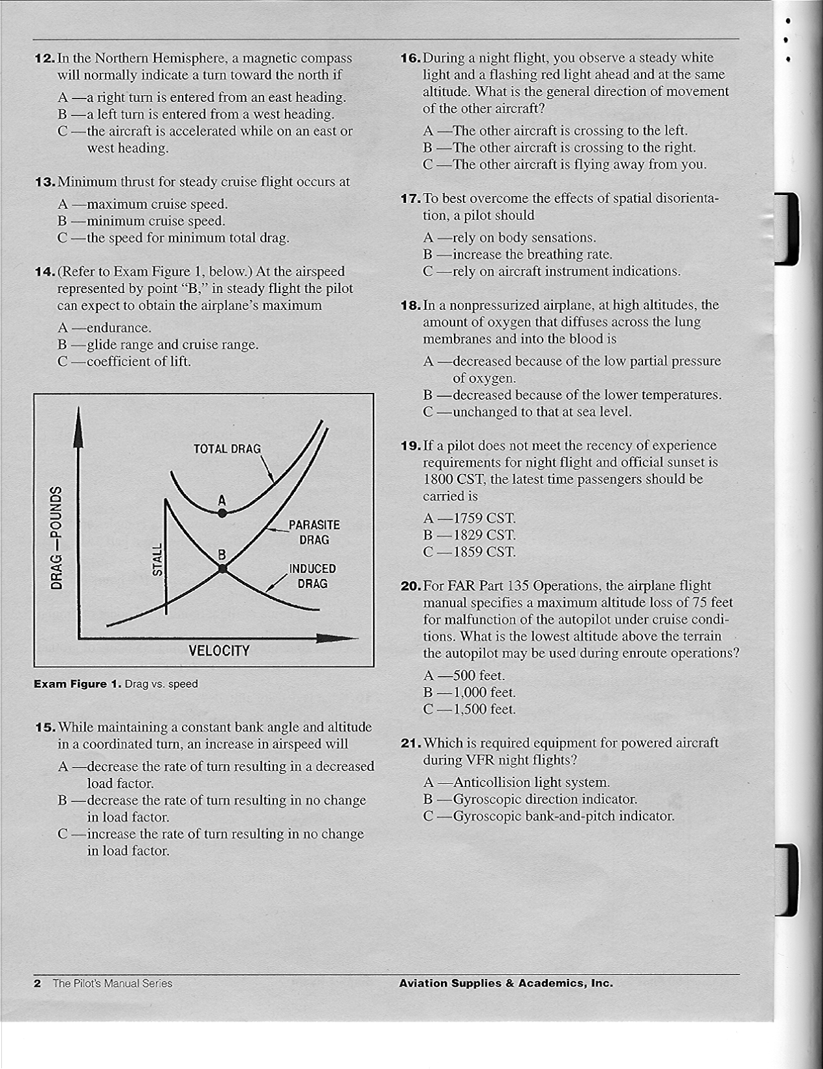

Stage 1 Exam Figure 2

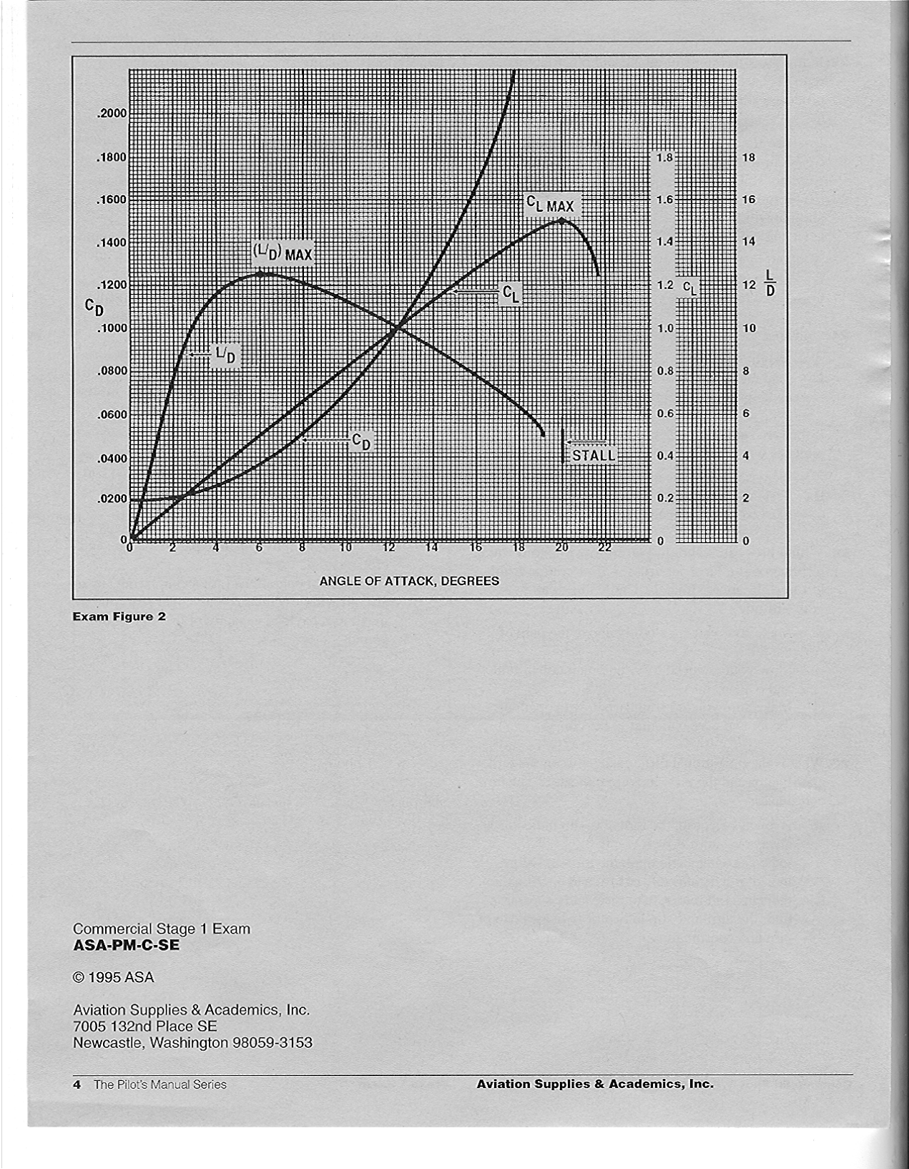

Stage 2 Exam Name________________________
Grade________________________
Date_________________________
Instructor _____________________

- What is the minimum radio equipment required for operation within Class B airspace?
  - Two way radio communication equipment and a 4096 transponder
  - Two way radio communications equipment and a 4096 code transponder and a DME
  - Two way radio communications equipment and a 4096 code transponder with an encoding altimeter (Mode C)
- Pilots flying over a national wildlife refuge are requested to fly no lower than
- 1000 feet AGL
- 2000 feet AGL
- 3000 feet AGL
- If fuel consumption is 80 pounds per hour and groundspeed is 180 knots, how much fuel is required for an airplane to travel 460 NM?
- 205 pounds
- 212 pounds
- 460 pounds
- An airplane departs an airport under the following conditions:

Airport elevation 1000 ft
Cruise altitude 9500 ft
Rate of climb 500 fpm
Average true airspeed 135 kt
True course 215 degrees
Average wind velocity 290 degrees T at 20 knots
Variation 3W
Deviation –2 degrees
Average fuel consumption 13 gal/hr
Determine the approximate time, compass heading, distance, and fuel consumed during the climb.
- 14 minutes, 234 degrees, 26 NM, 3.9 gallons
- 17 minutes, 224 degrees, 36 NM, 3.7 gallons
- 17 minutes, 242 degrees, 31 NM, 3.5 gallons

- Refer to Exam figure 1. Given:
Empty weight (oil included) 1271 lbs
Empty weight moment (in-lb/1000) 102.04
Pilot and copilot 360 lbs
Cargo 340 lbs
Fuel 37 gal
Will the CG remain within limits after 30 gallons of fuel have been used in flight?
- Yes, the CG will remain within limits
- No, the CG will be located aft of the CG limit
- Yes, but the CG will be located in the shaded area of the CG envelope
- Refer to Exam figure 2. Which illustration indicates that the airplane should be turned 150 degrees left in intercept the 360 degree radial at a 60 degree angle inbound?
- A
- B
- C
- Refer to Exam figure 3. If an aircraft has the indications shown in instrument group 3, then makes a 180 degree turn to the left and continues straight ahead, it will intercept which radial?
- 135 radial
- 270 radial
- 360 radial
- Calculate distance to the station given:

Wingtip bearing change
Time elapsed between bearing change is 5 min
True airspeed is 115 knots
- 230 NM, 45 min
- 115 NM, 60 min
- 85 Nm, 45 min
- While cruising at 135 knots and on a constant heading, the ADF needle decreases from a relative bearing of 315 degrees to 270 degrees in 7 minutes. The approximate time and distance to the station being used is
- 7 minutes and 16 miles
- 14 minutes and 28 miles
- 19 minutes and 38 miles
- Refer to Exam figure 4. Determine the magnetic bearing to the station as indicated by the ADF dial
- 330 degrees
- 180 degrees
- 210 degrees

- What is a suitable cruise altitude at or above your safety altitude of 4300 feel MSL if the cloud bases are at 7000 MSL and your planned magnetic course is 250 degrees?
- 5500 feel MSL
- 4500 feel MSL
- 6500 feet MSL
- Refer to Exam figure 5. If more than one cruising altitude is intended, which should be entered in block 7 of the flight plan?
- Initial cruising altitude
- Highest cruising altitude
- Lowest cruising altitude
- You are 2 NM left of course after traveling 15 NM. What is the tracking error?
- 8 degrees left
- 8 degrees right
- 12 degrees left
- What is indicated if ice pellets are encountered at 8000 feet?
- Freezing rain at higher altitude
- You are approaching an area of thunderstorms
- You will encounter hail if you continue your flight
- Which conditions are favorable for the formation of a surface based temperature inversion?
- Clear, cool nights with calm or light wind
- Area of unstable air rapidly transferring heat from the surface
- Broad areas of cumulus clouds with smooth, level bases at the same altitude
- In what ways do advection fog, radiation fog, and steam fog differ in their formation or location?
- Radiation fog is restricted to land areas; advection fog is most common along coastal areas; steam fog forms over a water surface
- Advection fog deepens as wind speed increases up to 20 knots; steam fog requires calm or very light wind’ radiation fog forms when the ground or water cools the air by radiation
- Steam fog forms from moist air moving over a colder surface; advection fog requires cold air over a warmer surface; radiation fog is produced by radiation cooling of the ground
- Which in flight hazard is most commonly associated with warm fronts?
- Advection fog
- Radiation fog
- Precipitation induced fog

- Given:

Wind 175 degrees at 20 kts
Distance 135 NM
True course 075 degrees
Fuel consumption 105 lb/hr
Determine the time enroute and fuel consumption
- 1 hour 28 minutes and 73.2 pounds
- 1 hour 38 minutes and 158 pounds
- 1 hour 30 minutes and 175 pounds
- Given:

Pressure altitude 12,000 ft
True air temperature +50 degrees F
From the conditions given, the approximate density altitude is
- 11,900 feet
- 14,130 feet
- 18,150 feet
- Given:

True course 345 degrees
True heading 355 degrees
True airspeed 85 kts
Groundspeed 95 kts
Determine the wind direction and speed
- 095 degrees and 19 kts
- 113 degrees and 19 kts
- 238 degrees and 18 kts
- Given:

Distance off course 9 miles
Distance flown 95 miles
Distance to fly 125 miles
To converge at the destination, the total correction angle would be
- 4 degrees
- 6 degrees
- 10 degrees
- To track inbound on the 215 radial of a VOR station, the recommended procedure is to set the OBS to
- 215 and make heading corrections toward the needle
- 215 and make heading corrections away from the needle
- 035 and make heading corrections toward the needle

- Inbound on the 040 radial, a pilot selects the 055 radial, turns 15 degrees to the left and notes the time. While maintaining a constant heading, the pilot notes the time for the CDI to center is 15 minutes. Based on this information, the ETE to the station is
- 8 minutes
- 15 minutes
- 30 minutes
- An aircraft is maintaining a magnetic heading of 265 degrees and the ADF shows a relative bearing of 065. This indicates that the aircraft is crossing the
- 065 degree magnetic bearing from the radio beacon
- 150 degree magnetic bearing from the radio beacon
- 330 degree magnetic bearing from the radio beacon
- The relative bearing on an ADF changes from 265 degrees to 260 degrees in 2 minutes. If the groundspeed is 145 knots, the distance to the station would be
- 26 NM
- 37 NM
- 58 NM
- While maintaining a constant heading, a relative bearing of 10 degrees doubles in 5 minutes. If the true airspeed is 105 knots, the time and distance to the station is approximately
- 5 minutes and 8.7 miles
- 10 minutes and 17 miles
- 15 minutes and 31.2 miles
- What designated airspace associated with an airport become inactive when the control tower at that airport is not in operation?
- Class D which then becomes Class C
- Class D which then becomes Class E
- Class B
- Which is true relating to the blue and magenta colors used to depict airports on Sectional Aeronautical Charts?
- Class E airports are shown in blue; Class C and D are magenta
- Class B airports are shown in blue; Class D and E are magenta
- Class E airports are shown in magenta; Class b, C, and D are blue
- What is the minimum flight visibility and proximity to cloud requirements for VFR flight at 6500 feet MSL in Class C, D, and E airspace?
- 1 mile visibility, clear of clouds
- 3 miles, 1000 above and 500 feet below the clouds
- 5 miles, 1000 above and 1000 below

- To operate an airplane under SPECIAL VFR within Class D airspace at night, which is required?
- The pilot must hold an instrument rating, but the airplane need not be equipped for IFR flight as long as the weather will remain at or above SVFR minimums
- The Class D airspace must be specifically designated as a night SVFR area
- The pilot must hold an instrument rating and the airplane must be equipped for IFR flight

Stage 2 Exam Figure 1

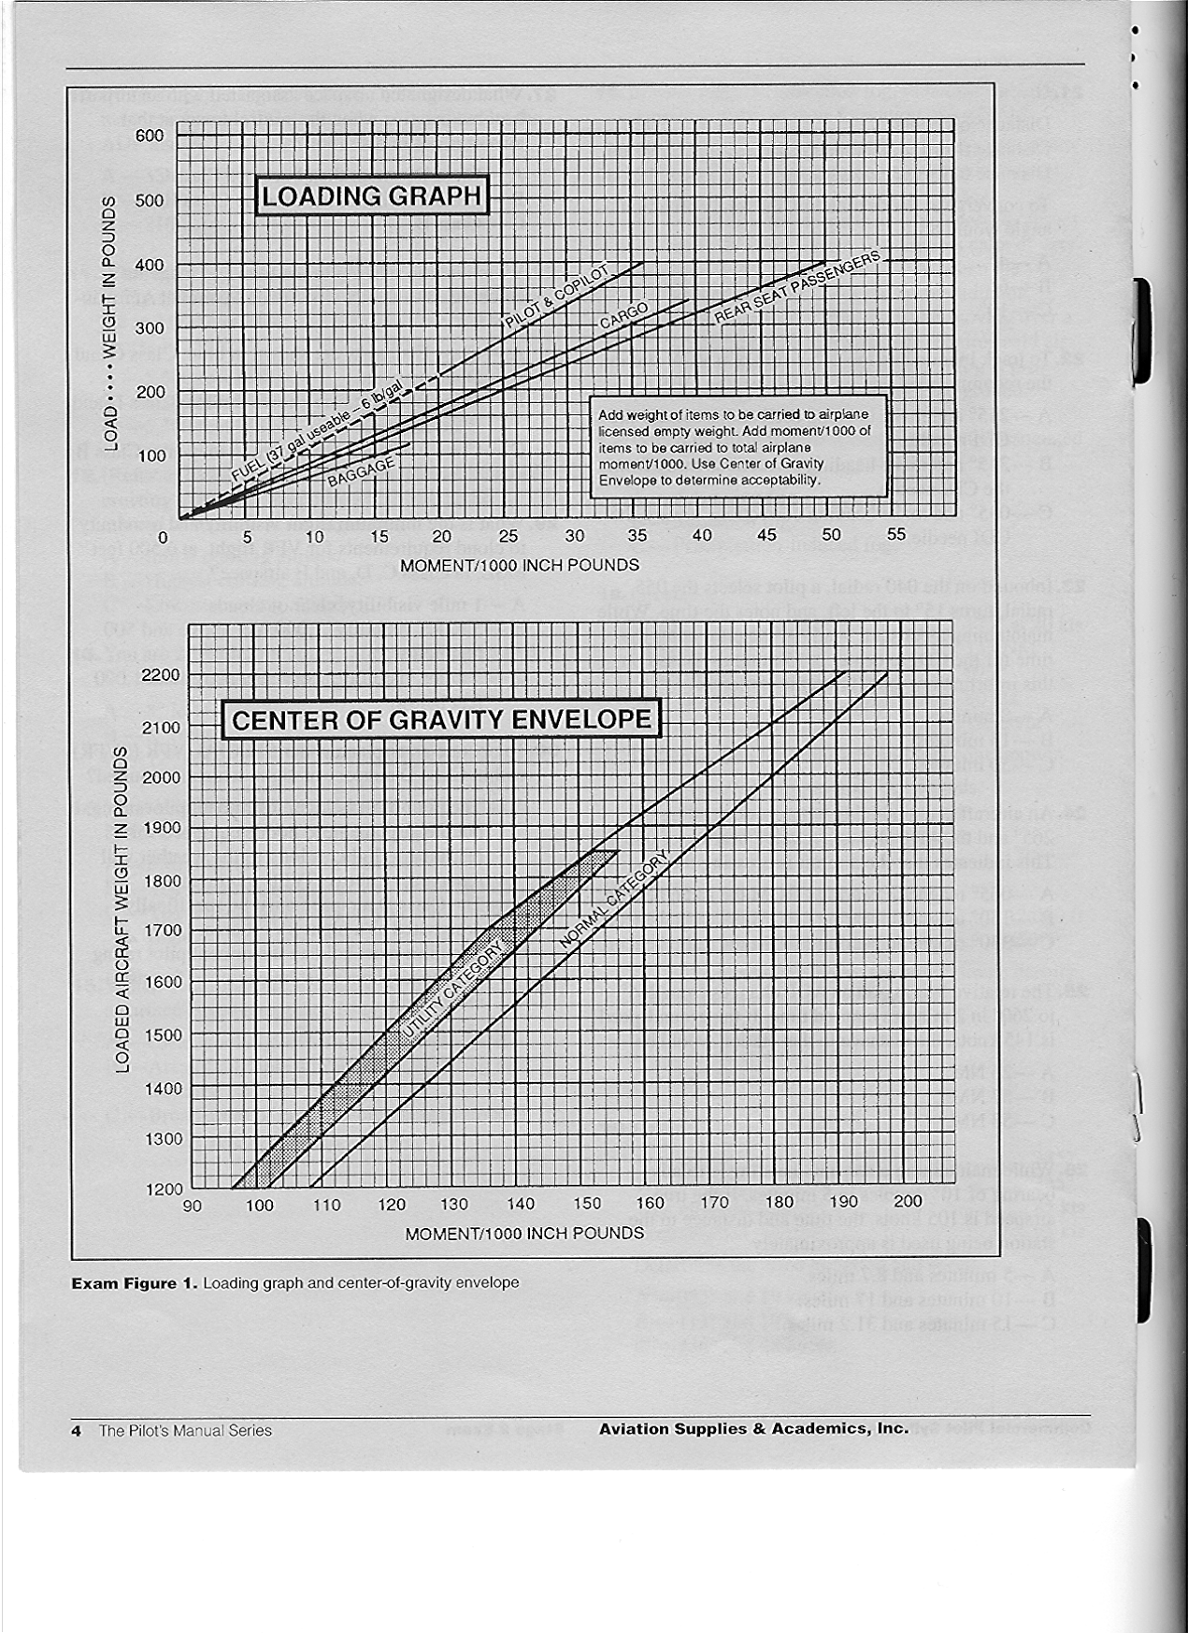

Stage 2 Exam Figure 2

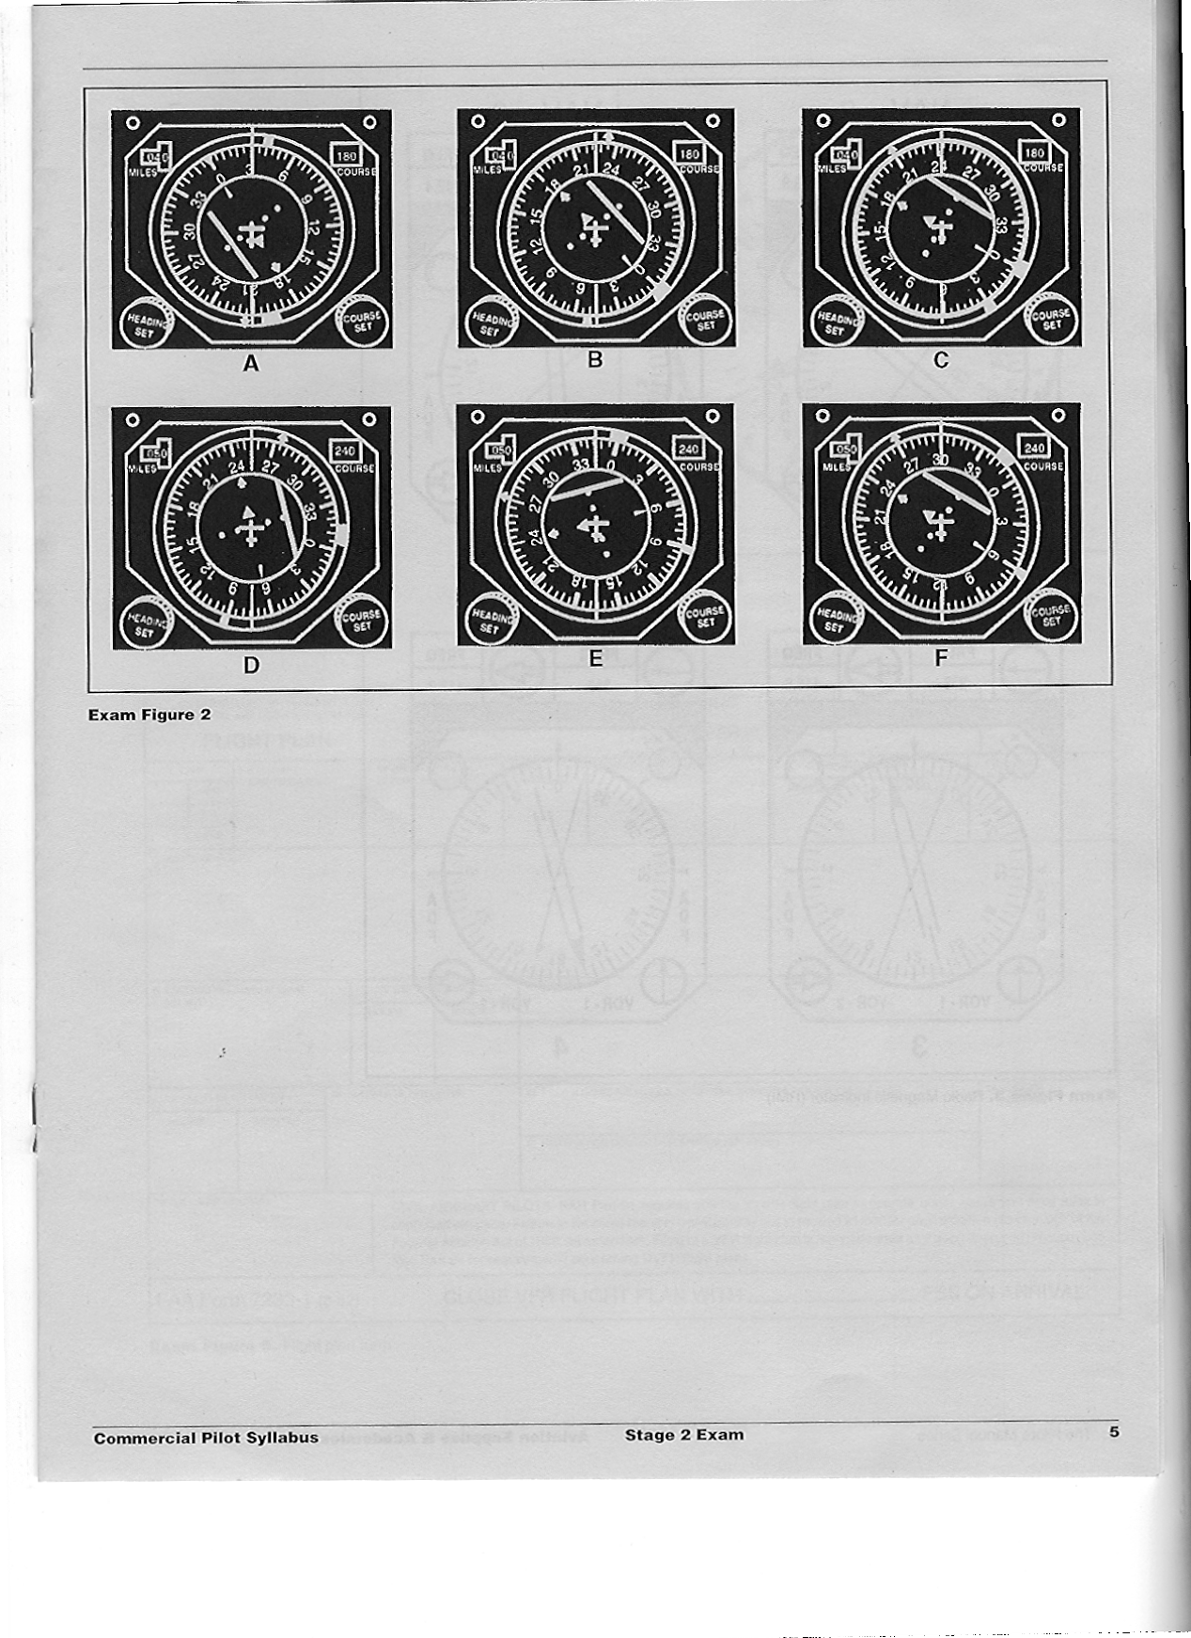

Stage 2 Exam Figure 3

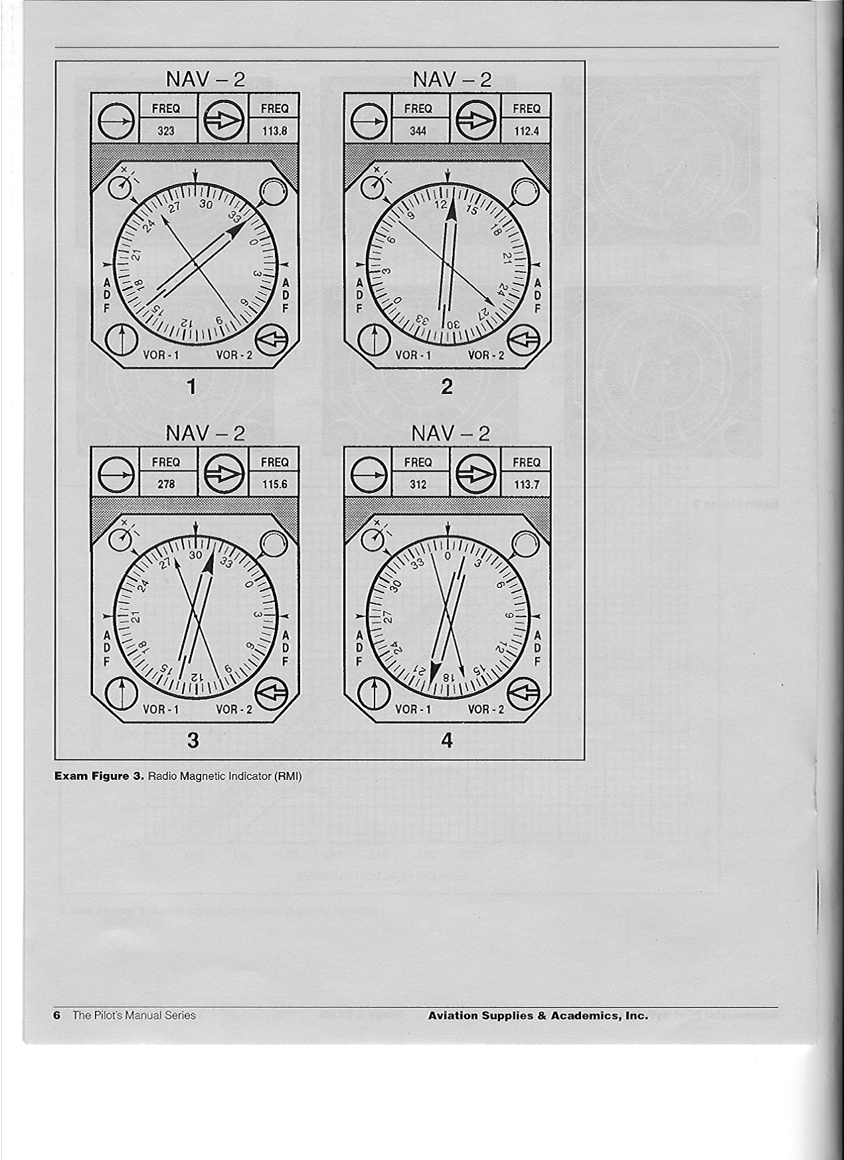

Stage 2 Exam Figure 4

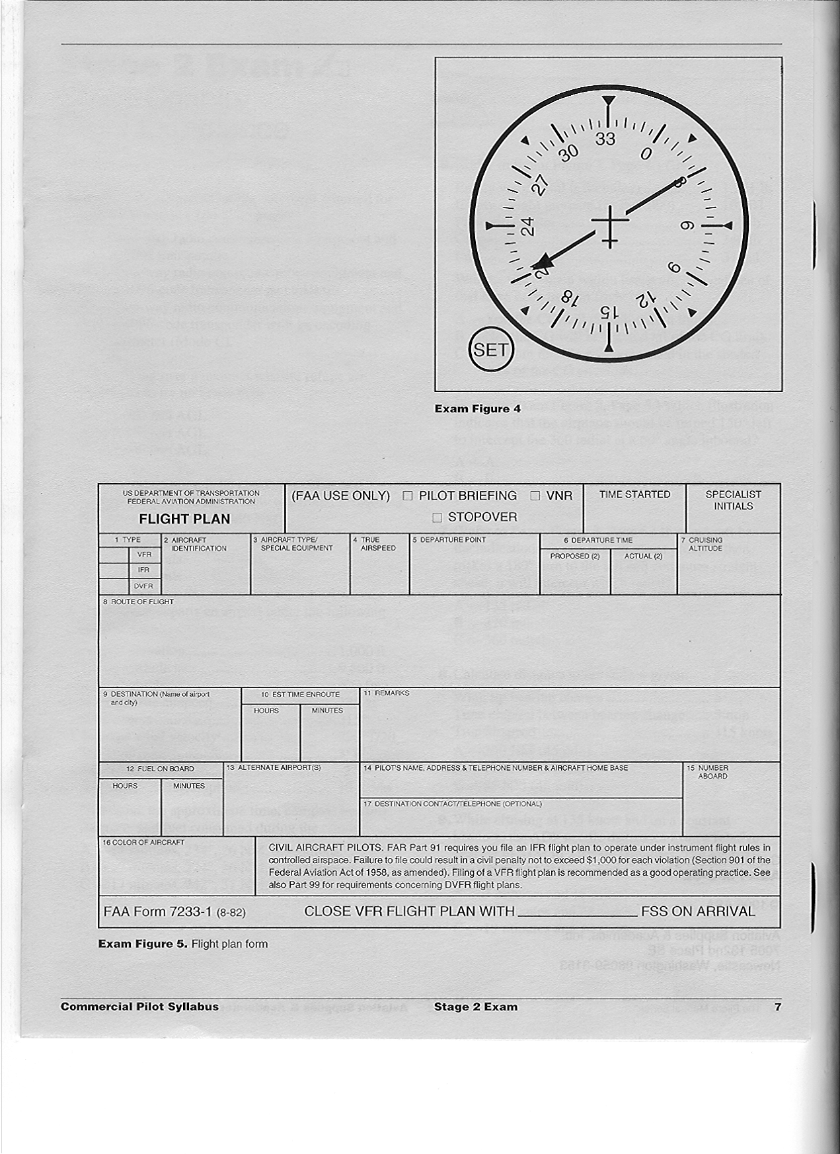

Stage 2 Exam Figure 5

Stage 3 Exam Name________________________
Grade________________________
Date_________________________
Instructor _____________________

1. The spark plugs in a piston engine are provided with a high energy (or high tension)
electrical supply from
- the battery at all times.
- the magnetos.
- the battery at start-up, and then the magnetos.
2. While cruising at 9,500 feet MSL, the fuel/air mixture is properly adjusted. What will occur
if a descent to 4,500 feet MSL is made without readjusting the mixture?
- The fuel/air mixture may become excessively lean
- There will be more fuel in the cylinders than is needed for normal combustion, and the excess fuel will absorb heat and cool the engine
- The excessively rich mixture will create higher cylinder head temperatures and may cause detonation.
3. Which condition is most favorable to the development of carburetor icing?
- Any temperature below freezing and a relative humidity of less than 50 percent.
- Between 32ºF and 50º F and low humidity.
- Between 20º F and 70º F and high humidity.
4. In an airplane with a constant-speed propeller, which of the following procedures should
be used?
- When power is decreased, reduce rpm before manifold pressure.
- When power is increased, increase rpm before manifold pressure.
- When power is increased or decreased, adjust manifold pressure before rpm.
5. When operating a constant-speed propeller
- avoid high rpm setting with high manifold pressures.
- avoid low rpm setting with high manifold pressures.
- always use a rich mixture with high rpm settings.
6. If the oil temperature gauge and the cylinder head temperature gauge are both reading
higher than the normal operating range, a possible cause is
- an over-rich mixture and too much power.
- a too-lean mixture and too much power.
- fuel with a higher-than-specified fuel rating.

7. What type of fuel can be substituted in an aircraft if the recommended octane is not
available?
- The next higher octane aviation gas.
- The next lower octane aviation gas.
- Unleaded automotive gas of the same octane rating.
8. If you allow a fuel tank to run dry in flight before changing tanks, you run the risk of
- air being drawn into the fuel lines and causing a vapor lock.
- overheating the fuel pump, leading to failure.
- pumping foreign matter into the fuel lines.
9. The battery master switch should be turned to OFF after the engine is stopped to avoid
the battery discharging through
- the magnetos.
- the alternator or generator.
- the electrical services connected to it.
10. If the operational category of an airplane is listed as “utility” it would mean that this airplane
could be operated in which of the following maneuvers?
- All types of acrobatics.
- Limited acrobatics, including spins.
- Any maneuver except acrobatics or spins.
11. Which V-speed represents maximum landing gear extended speed?
- VLF
- VLO
- VFE
12. Which combination of atmospheric conditions will reduce airplane takeoff and climb
performance?
- Low temperature, low relative humidity, and low density altitude.
- High temperature, low relative humidity, and low density altitude.
- High temperature, high relative humidity, and high density altitude.
13. Which procedure should you follow to avoid wake turbulence if a large jet crosses your
course from left to right approximately 1 mile ahead and at your altitude?
- Make sure you are slightly above the path of the jet.
- Slow your airspeed to VA and maintain altitude and course.
- Make sure you are slightly below the path of the jet and perpendicular to the course.

14.What is ground effect?
- The result of the interference of the surface of the earth with the airflow patterns about an airplane.
- The result of an alteration in airflow patterns increasing induced drag about the wings of an airplane.
- The result of the disruption of the airflow patterns about the wings of an airplane to the
point where the wings will no longer support the airplane in flight.
15 (Refer to Exam Figure 8) Given:
Temperature …………….….….… 30ºF
Pressure altitude ……..……..…... 6,000 feet
Weight …………………….……… 3,300 pounds
Headwind …………………..….… 20 knots
What is the total takeoff distance over a 50-foot
obstacle?
- 1,100 feet.
- 1,300 feet.
- 1,500 feet.
16. Which maximum range factor decreases as weight decreases?
- Maximum range altitude.
- Maximum range airspeed.
- Maximum range angle-of-attack.
17. (Refer to Exam Figure 9) What flight time is available allowing for VFR day fuel reserve
under the following conditions if the mixture is leaned correctly?
Pressure altitude ........................ 18,000 ft
Temperature ....................…........ -21ºC
Power ................................…...... 2,400 rpm, 28" MP
Usable fuel .......................…....... 425 lb
- 5 hours 28 minutes.
- 4 hours 01 minutes.
- 3 hours 14 minutes.
18. A military air station can be identified by a rotating beacon that emits
- white and green alternating flashes.
- two, quick, white flashes between green flashes.
- green, yellow, and white flashes.
19. A flashing white light signal from the control tower to a taxiing aircraft is an indication to
- taxi at a faster speed.
- taxi only on taxiways and not cross runways.
- return to the starting point on the airport.

20. After landing at a tower-controlled airport, when should the pilot contact ground control?
- When advised to do so by the tower.
- Prior to turning off the runway.
- After reaching a taxiway that leads directly to the parking area.
21. Leaving the carburetor heat on while taking off
- leans the mixture for more power on takeoff.
- will decrease the takeoff distance.
- will increase the ground roll.
22. For internal cooling, reciprocating aircraft engines are especially dependent on
- a properly functioning cowl flap augmenter.
- the circulation of lubricating oil.
- the proper freon/compressor output ratio.
23. To develop maximum power and thrust, a constant-speed propeller should be set to a
blade angle that will produce a
- large angle of attack and low RPM.
- small angle of attack and high RPM.
- large angle of attack and high RPM.
24. During preflight in cold weather, crankcase breather lines should receive special attention
because they are susceptible to being clogged by
- congealed oil from the crankcase.
- moisture from the outside air which has frozen.
- ice from crankcase vapors that have condensed and subsequently frozen.
25. Propeller efficiency is the
- ratio of thrust horsepower to brake horsepower.
- actual distance a propeller advances in one revolution.
- ratio of geometric pitch to effective pitch.
26. Baggage weighing 90 pounds is placed in a normal category airplane’s baggage
compartment which is placarded at 100 pounds. If this airplane is subjected to a positive
load factor of 3.5 Gs, the total load of the baggage would be
- 315 pounds and would be excessive.
- 315 pounds and would not be excessive.
- 350 pounds and would not be excessive.

27. Given:
Total weight ............................…............ 4,137 lb
CG location ............................................ Station 67.8
Fuel consumption .................................. 13.7 GPH
Fuel CG ................................................. Station 68.0
After 1 hour 30 minutes of flight time, the CG would be located at station
- 67.79.
- 68.79.
- 70.78.
28. (Refer to Exam Figure 10) Rwy 30 is being used for landing. Which surface wind would
exceed the airplane’s crosswind capability of 0.2 VSO , if VSO is 60 knots?
- 260º at 20 knots.
- 275º  at 25 knots.
- 315º  at 35 knots.
29. Which type of approach and landing is recommended during gusty wind conditions?
- A power-on approach and power-on landing.
- A power-off approach and power-on landing.
- A power-on approach and power-off landing.
30. (Refer to Exam Figure 11) Using a maximum rate of climb, how much fuel would be
used from engine start to 6,000 feet pressure altitude?
Aircraft weight ............................................ 3,200 lb
Airport pressure altitude ............................. 2,000 ft
Temperature ............................................... 270ºC
- 10 pounds.
- 14 pounds.
- 24 pounds.

Stage 3 Exam Figure 1
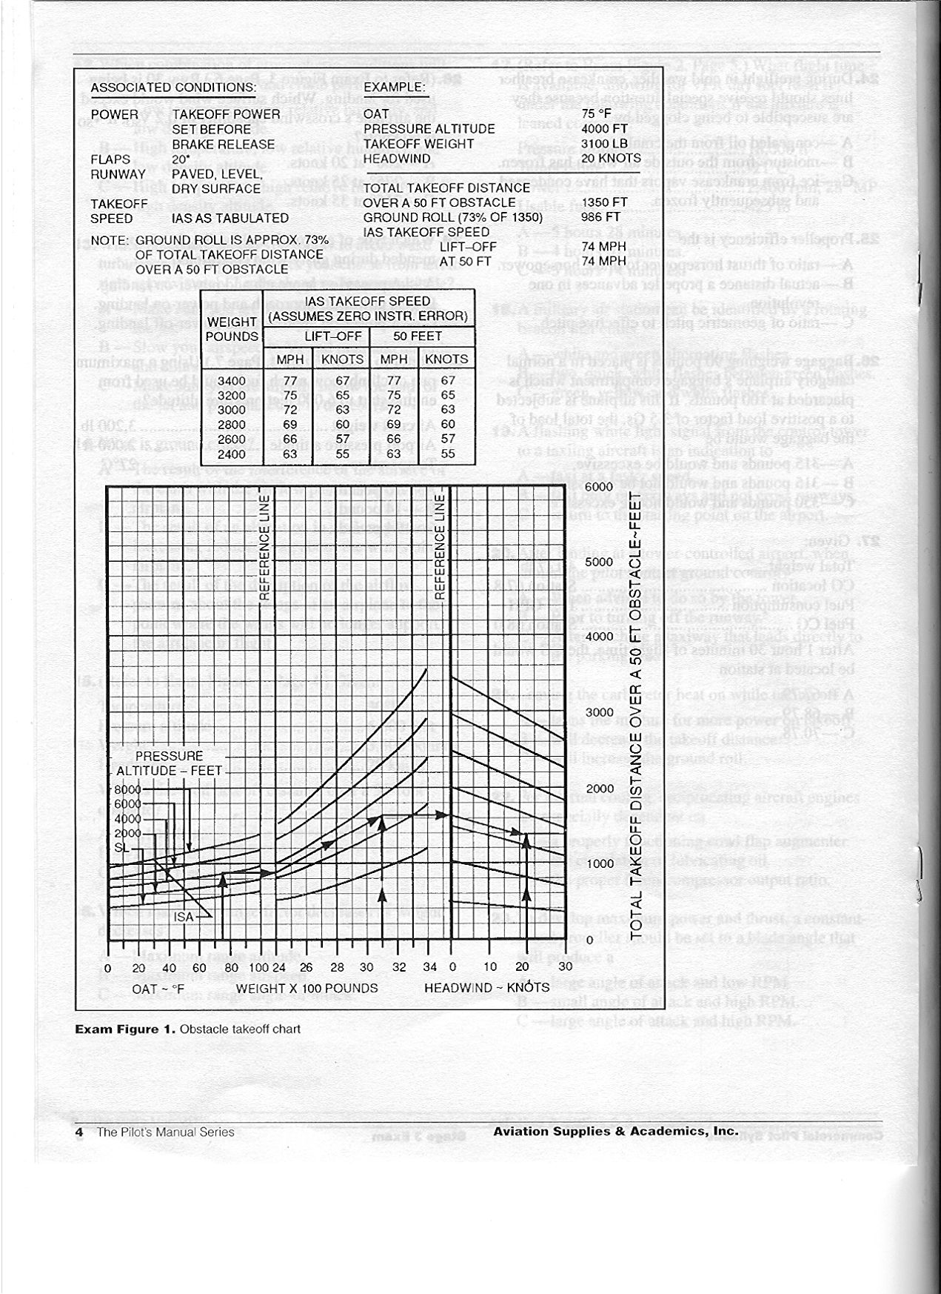

Stage 3 Exam Figure 2

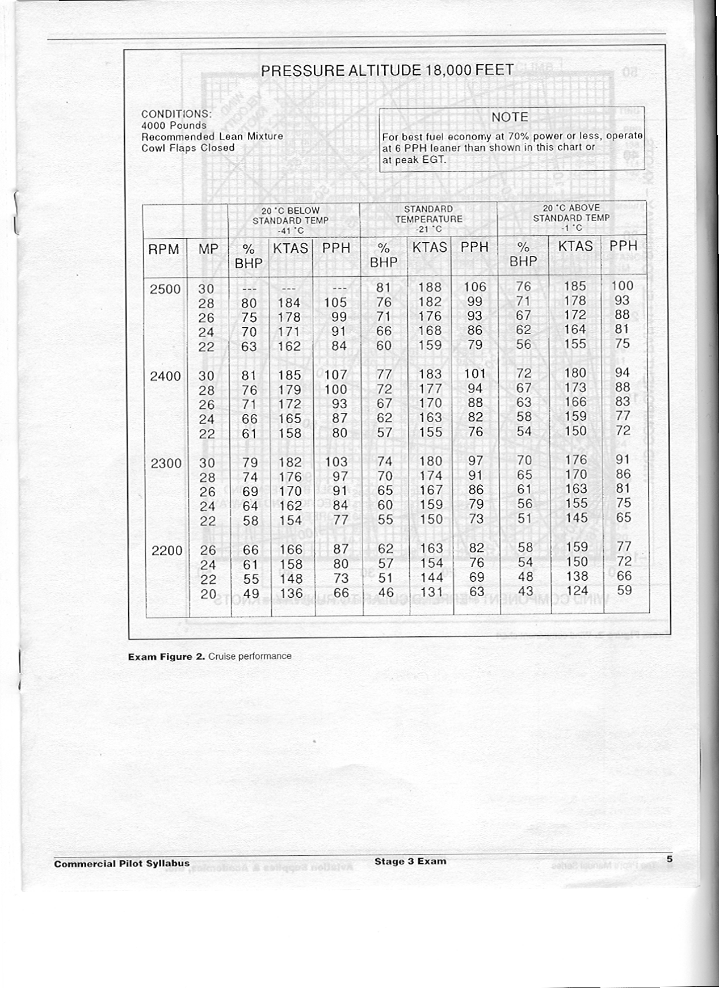

Stage 3 Exam Figure 3

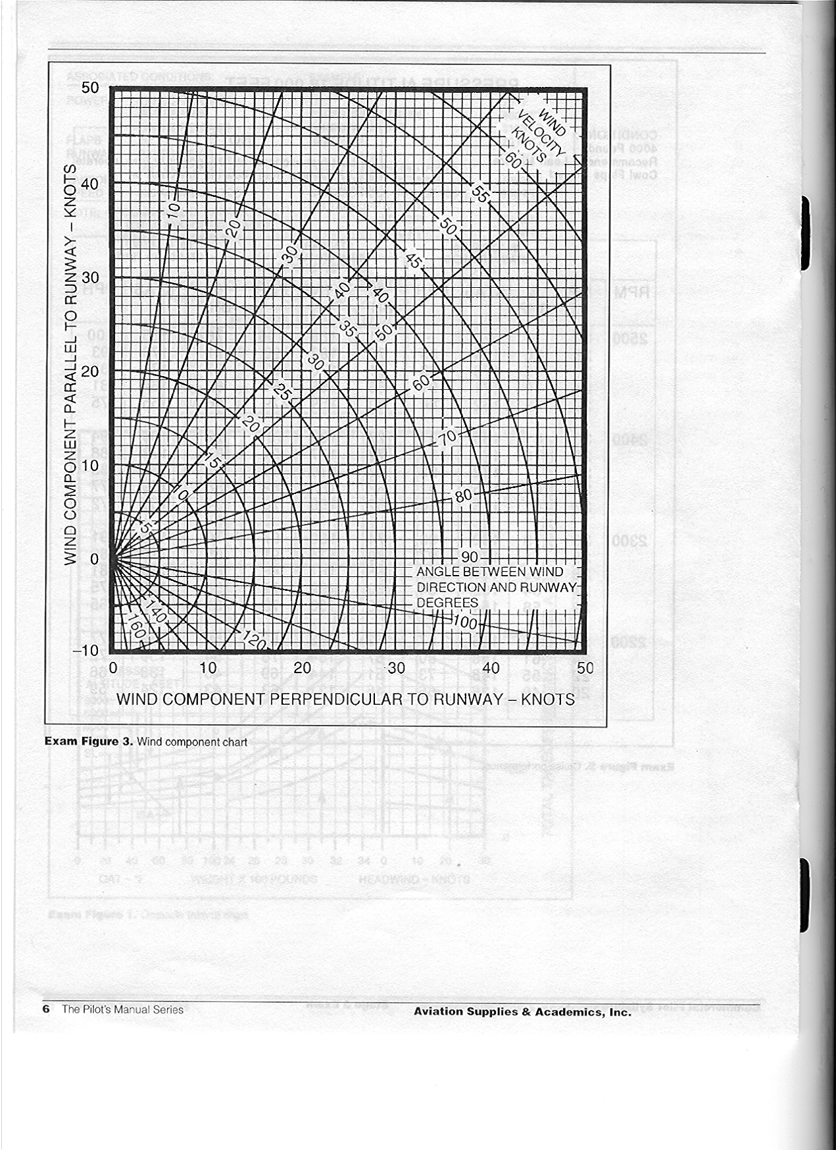

Stage 3 Exam Figure 4

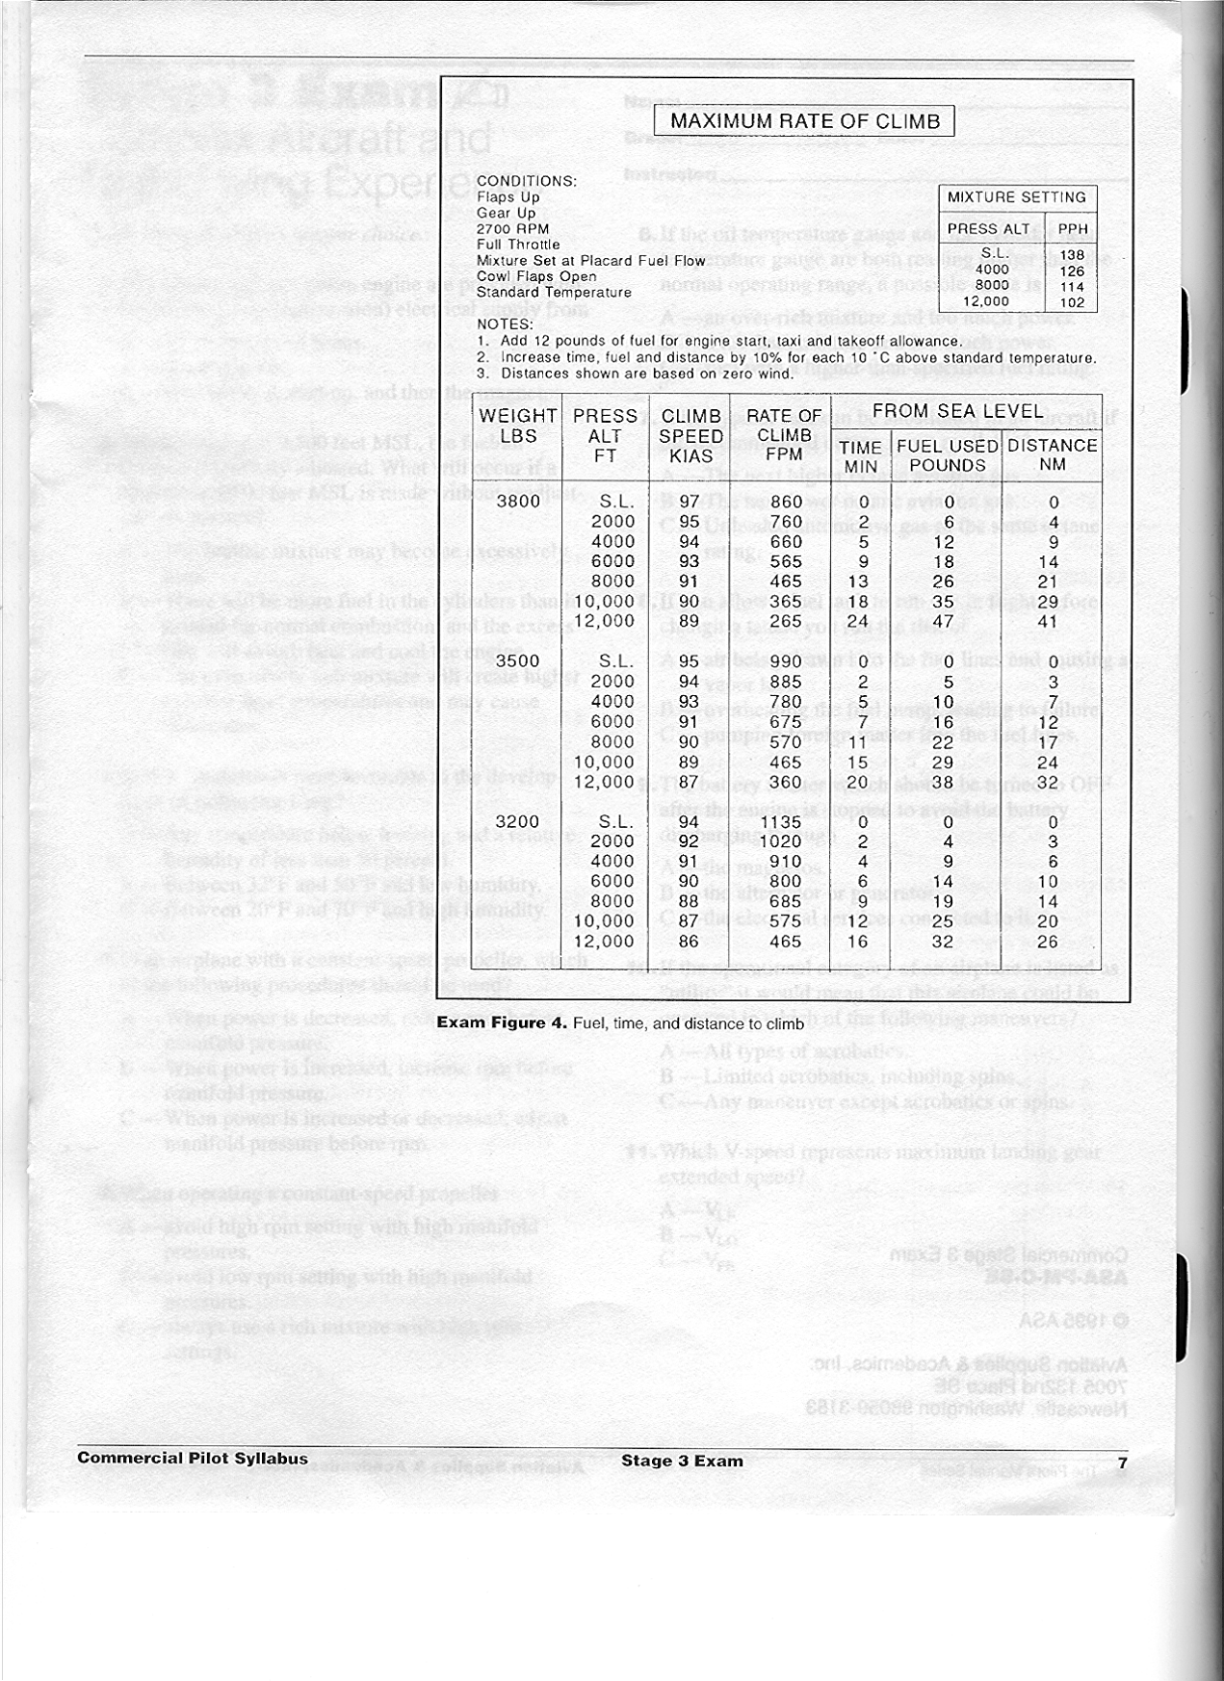

Stage 4 Exam Name________________________
Grade________________________
Date_________________________
Instructor _____________________

1. Most of the water vapor in the atmosphere is contained in the
- Tropopause.
- Troposphere.
- Stratosphere.
2. Every physical process of weather is accompanied by or is the result of
- A heat exchange.
- The movement of air.
- A pressure differential.
3. Convective circulation patterns associated with sea breezes are caused by
- Warm, dense air moving inland from over the water.
- Water absorbing and radiating heat faster than the land.
- Cool, dense air moving inland from over the water.
4. What causes air to flow counterclockwise around a low-pressure area in the Northern
Hemisphere?
- Coriolis force.
- Surface friction.
- Pressure gradient.
5. During the summer months in the middle latitudes, the jetstream shifts toward the
- North and speed decreases.
- South and speed increases.
- North and speed increases.
6. A strong windshear can be expected
- In the jetstream from above a core having a speed of 60 to 90 knots.
- If the 5 degrees C isotherms are spaced between 7 degrees and 10 degrees  of latitude.
- On the low-pressure side of a jetstream core where the speed at the core is stronger than 110 knots.
7. When an air mass is stable, which of these conditions are most likely to exist?
- Towering cumulus and cumulonimbus clouds.
- Moderate to severe turbulence at the lower levels.
- Smoke and/or dust are concentrated at the lower levels with resulting poor visibility.
8. What minimum distance should exist between intense radar echoes before any attempt is
made to fly between these thunderstorms?
- 20 miles.
- 30 miles.
- 40 miles.

9. Which combination of weather-producing variables would likely result in cumuliform-type
clouds, good visibility, and shower rain?
- Stable, moist air and orographic lifting.
- Unstable, moist air and orographic lifting.
- Unstable, moist air and no lifting mechanism.
10.Which is true with respect to a high or low-pressure system?
- A high-pressure area or ridge is an area of rising air.
- A low-pressure area or trough is an area of descending air.
- A high-pressure area or ridge is an area of descending air.
11.When flying into a low-pressure area in the Northern Hemisphere, the wind direction and
velocity will be from the
- Left and decreasing.
- Left and increasing.
- Right and decreasing.
12.Which is true regarding a cold front occlusion?
- The air ahead of the warm front is colder than the air behind the overtaking cold front.
- The air ahead of the warm front is warmer than the air behind the overtaking cold front.
- The air ahead of the warm front has the same temperature as the air behind the overtaking cold front.
13.What is the upper limit of the Low Level Significant Weather Prognostic Chart?
- 30,000 feet.
- 24,000 feet.
- 18,000 feet.
14.Hatching on a Constant Pressure Analysis Chart indicates
- A hurricane eye.
- Wind speed 70 knots to 100 knots.
- Wind speed 110 knots to 150 knots.
15.Terminal aerodrome forecasts are issued
- 3 times daily and are valid for 24 hours.
- 6 times daily and are valid for 8 hours.
- Hourly and are valid for 1 hour.
16.What prevents air from flowing directly from high-pressure areas to low-pressure areas?
- Coriolis force.
- Surface friction.
- Pressure gradient force.
17.What is the approximate base of the cumulus clouds if the temperature at 2,000 feet MSL
is 70 degrees F and the dewpoint is 50 degrees F?
- 3,000 feet MSL.
- 4,000 feet MSL.
- 6,000 feet MSL.

18.Virga is best described as
- Streamers of precipitation trailing beneath clouds which evaporates before reaching the ground.
- Wall cloud torrents trailing beneath cumulonimbus clouds which dissipate before reaching the ground.
- Turbulent areas beneath cumulonimbus clouds.
19.Given:
Winds at 3,000 feet AGL ................................ 30 kts
Surface winds ................................................. Calm
While approaching for landing under clear skies a
few hours after sunrise, one should
- Allow a margin of approach airspeed above normal to avoid stalling.
- Keep the approach airspeed at or slightly below normal to compensate for floating.
- Not alter the approach airspeed, these conditions are nearly ideal.
20.The station originating the following METAR observation has a field elevation of 3,500 feet
MSL. If the sky cover is one continuous layer, what is the thickness of the cloud layer?
(Top of overcast reported at 7,500 feet MSL.)
METAR KHOB 151250Z 17006KT 4SM OVC005 13/11 A2998
- 2,500 feet.
- 3,500 feet.
- 4,000 feet.
21.Which statement pertaining to the following Terminal Aerodrome Forecast (TAF) is true?
TAF KMEM 091135Z 0915 15005KT 5SM HZ BKN060 FM 1600 VRB04KT P6SM SKC
- Wind in the valid period implies surface winds are forecast to be greater than 5 KTS.
- Wind direction is from 160 degrees at 4 KTS and reported visibility is 6 statute miles.
- SKC in the valid period indicates no significant weather and sky clear.
22.What values are used for Winds Aloft Forecasts?
- True direction and MPH.
- True direction and knots.
- Magnetic direction and knots.
23.From which of the following can the observed temperature, wind, and temperature/dewpoint
spread be determined at a specified altitude?
- Stability Charts.
- Winds Aloft Forecasts.
- Constant Pressure Analysis Charts.

24.FSS’s in the conterminous 48 United States having voice capability on VORs or
radiobeacons (NDBs) broadcast
- AIRMETs and SIGMETs at 15 minutes past the hour and each 15 minutes thereafter as long as they are in effect.
- AIRMETs and nonconvective SIGMETs at 15 minutes and 45 minutes past the hour for the first hour after issuance.
- Hourly weather reports at 15 and 45 minutes past each hour for those reporting stations within approximately 150 NM of the broadcaststations.
25.When making an instrument approach at the selected alternate airport, what landing
minimums apply?
- Standard alternate minimums.
- The IFR alternate minimums listed for that airport.
- The landing minimums published for the type of procedure selected.
26.Which is true regarding the use of a Standard Instrument Departure (DP) chart?
- At airfields where DPs have been established, DP usage is mandatory for IFR departures.
- To use a DP, the pilot must possess at least the textual description of the approved standard departure.
- To use a DP, the pilot must possess both the textual and graphic form of the approved standard departure.
27.Most pilots have fallen prey to dangerous tendencies or behavior problems at some time.
Some of these dangerous tendencies or behavior patterns which must be identified and
eliminated include:
- Deficiencies in instrument skills and knowledge of aircraft systems or limitations.
- Performance deficiencies from human factors such as fatigue, illness or emotional problems.
- Peer pressure, get-there-itis, loss of positional or situation awareness, and operating without adequate fuel reserves.
28.When should pilots decline a “land and hold short” (LAHSO) clearance?
- When it will compromise safety.
- If runway surface is contaminated.
- Only when the tower controller concurs.
29.What tolerances must be maintained in order to perform Slow Flight according to the
Commercial Practical Test Standards?
- Altitude must be lower than 1,500 feet AGL, and airspeed maintained at 1.2 VS1,+10/-5.
- Airspeed must be just above stall speed with altitude maintained at ±100 feet, and
heading + or - 10 degrees
- Altitude must be no lower than 1,500 feet AGL, and altitude maintained at ±50 feet,
and heading ±5°.

30.What tolerances must be maintained to perform Stalls according to the Commercial
Practical Test Standards?
- Altitude must remain above 1,500 feet AGL, heading ± 10 degrees and recovery promptly made.
- Altitude must remain above 3,000 feet AGL, heading ± 10 degrees and recovery promptly made.
- Announces first indication of stall, maintains heading ±15°, and recovers promptly.
31.According to the Commercial Practical Test Standards, a Steep Turn must be performed
maintaining
- A coordinated 360 degree turn, with a 50 degree bank, ±5 degrees, rolling out on the entry heading, ±5°.
- A 45 degree  bank, + or – 10 degrees, while coordinating a 360 turn.
- + or - 100 feet, ±10 knots, VA or recommended entry speed, and coordination.
32.According to the Commercial Practical Test Standards, a Chandelle requires
- A coordinated 180-degree turn resulting in an airspeed approximately 1.2 VS1 ±5 knots.
- A coordinated 90-degree turn resulting in a full stall attitude.
- A coordinated 180 degree turn resulting in an airspeed approximately VS0 +5, -0 knots.
33.According to the Commercial Practical Test Standards, Lazy Eights require
- A constant pitch, bank, and turn rate.
- A constantly changing pitch, bank, and turn rate.
- A constant bank, airspeed, and power setting.
34.According to the Commercial Practical Test Standards, Eights-on-Pylons require
- Pylons which will permit approximately 3 to 5 seconds of straight-and-level flight between them.
- Maintaining altitude ±100 feet, heading ± 10 degrees and airspeed ±10 knots.
- A pivotal altitude at least 1,500 feet AGL.

Stage 4 Exam Figure 1
