Kraemer Aviation Services
Aircraft Appraisal Report

Client: XXXXXXX
Phone: XXXXXXXXX
Address: Bethesda, Maryland

This report is intended to be used by:
XXXXXXXXX

This report should not be distributed to anyone other than the intended user without his permission.

Aircraft Identification

Make: HAWKER SIDDELEY Model: DH.125-400A

Serial No: NA736 Reg. No.: N736LE Yr. Mfg.: 1969

Engine (s): Garrett/Honeywell TFE731series.

Airframe Total Time: The aircraft has approximately 8495 TTAF, 7740 cycles, and 7732 landings. Right engine - 4585.8 engine total time – 3471 engine cycles. Left engine - engine total time 4354.4 – 3471 engine cycles. As published by Aircraft Blue Book the average engine overhaul is $600,000 to $700,000 USD per engine.

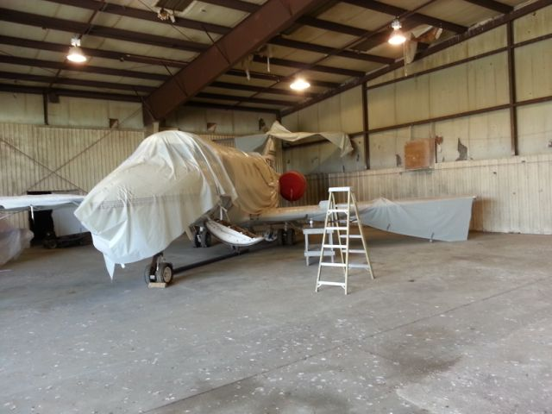

Airframe Condition: Poor condition

Log Books in Aircraft Appear: The log books are in poor condition. Some of the early log books have water damage. Several tail numbers and serial number appear in the log books. It was difficult for the appraiser to know if this was in error or if multiple aircraft records were mixed in with the appraised aircraft records.

Comments: The aircraft is currently parked inside a hangar at the Cambridge-Dorchester Regional Airport in Cambridge, MD (KCGE). The hangar does show signs of water leaks. The aircraft does have some plastic covering on it in some places. The aircraft does have a lot of bird droppings on it. The bird droppings have damaged the paint and metals in some places. The air-stair is broken.

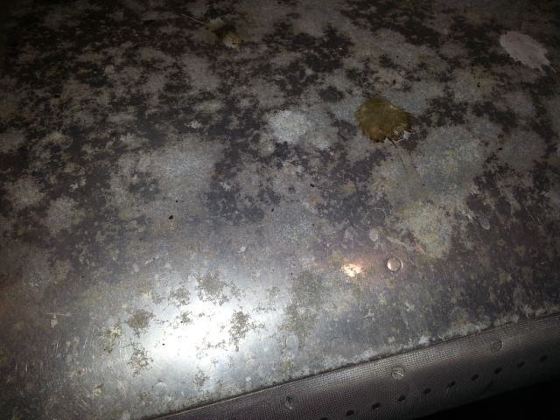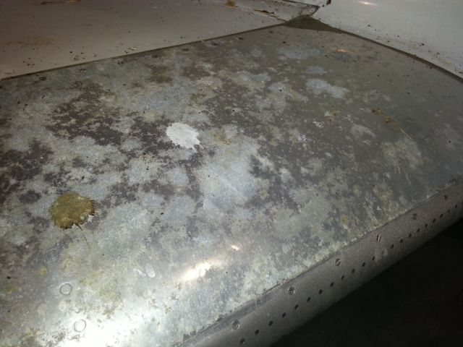

Maintenance Status

Maintenance Annual Date: The last recorded maintenance was in January 2009.

On Progressive Inspection: No

Time Life Limited Systems: Unknown Cycle Life Limited Systems: Unknown

Tires Condition: Poor Type Brakes: Disk Anti-Skid: Unknown

Exterior Paint Condition: Poor. The aircraft does have some plastic covering on it in some places. The aircraft does have a lot of bird droppings on it. The bird droppings have damaged the paint and metals in some places.

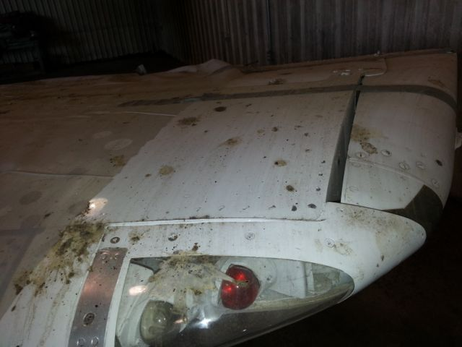

Repaint Date: The aircraft was last repainted around 1989. This was not verified in the maintenance records.

Comments: Overall the aircraft is in poor condition and needs paint, a new interior, avionics upgrade, and engines overhauled. The interior shows signs of damage due to insects and small rodents.

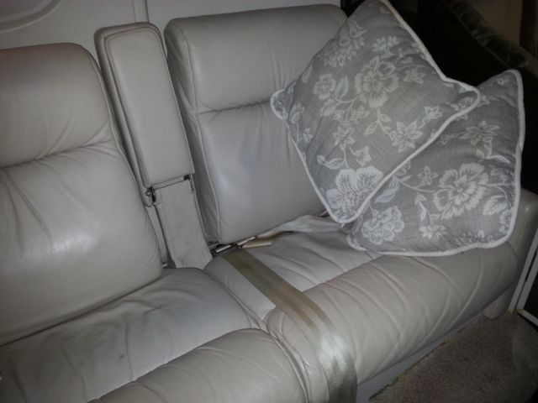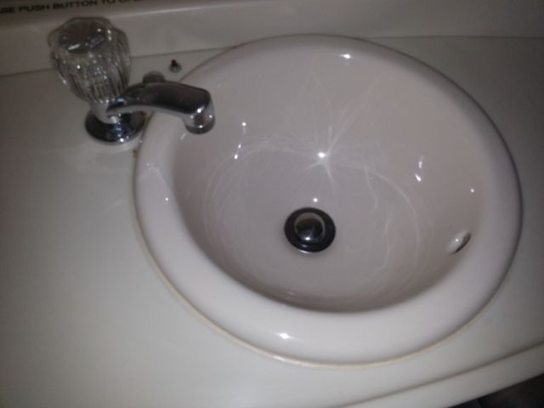

Interior Condition: Poor Cabin Configuration: Passenger

Cockpit Condition: Poor Panel Layout: Good – poor condition and outdated avionics

Pressurized Cabin: Yes Window Condition: Fair

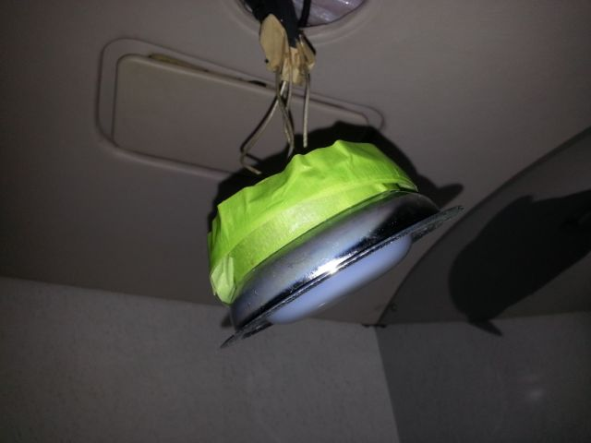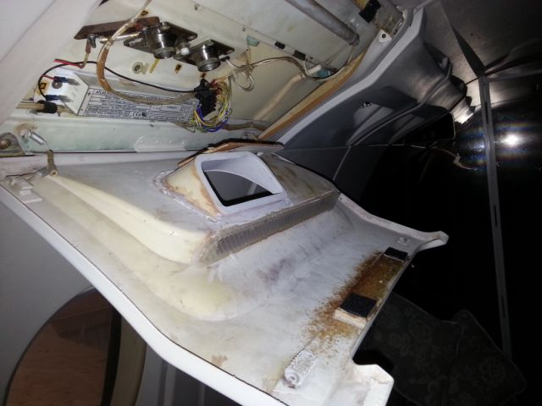

Airframe Modifications

The aircraft appears to have the Garrett/Honeywell TFE731 upgrade

Damage History

Historical Damage: Several tail numbers were used in the aircraft maintenance records/log books. These were: N736LE, N800AF, N731MS, N852A, and N112M. There were also different aircraft serial numbers listed in the maintenance records/log books. A search of the NTSB database showed no records (for a Hawker) for either of the tail numbers listed above.

Engines & Props

Engine Manufacturer: Garrett/Honeywell TFE731series.

Engine Type: Turbofan

Engine Fire Detection: Unknown Engine Fire Bottles: Unknown

Comments: Right engine: 4585.8 engine total time – 3471 engine cycles. Left engine: 4354.4 engine total time– 3471 engine cycles. These engine times are from a log book entry from 2007. As published by Aircraft Blue Book the average engine overhaul is $600,000 to $700,000 USD.

Engine Modifications

Garrett/Honeywell TFE731 upgrade/conversion

Known Maintenance Problems with Engine(s): None known or reported. The engines will most likely need to be overhauled. It is not known if they were preserved properly before “parking” the aircraft.

Estimated Cost to Repair: N/A

Instrumentation

Full Panel: Yes Dual Panel: Yes

Panel Configurations: Average Panel Condition: Poor

IFR Equipped: Yes

Comments: The aircraft has full instrumentation as well as co-pilot instruments. The actual instruments and equipment in the panel are in poor condition. Most of the equipment and/or instruments will most likely need to be overhauled.

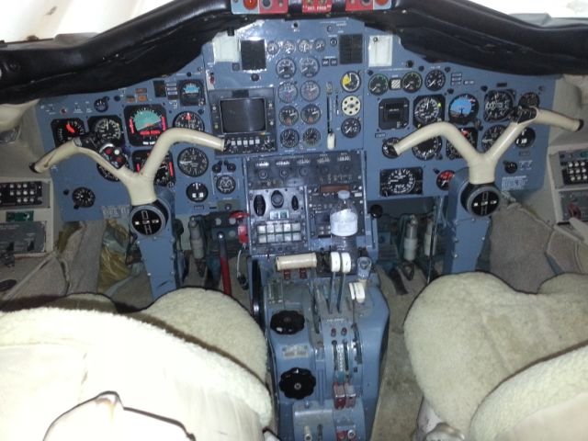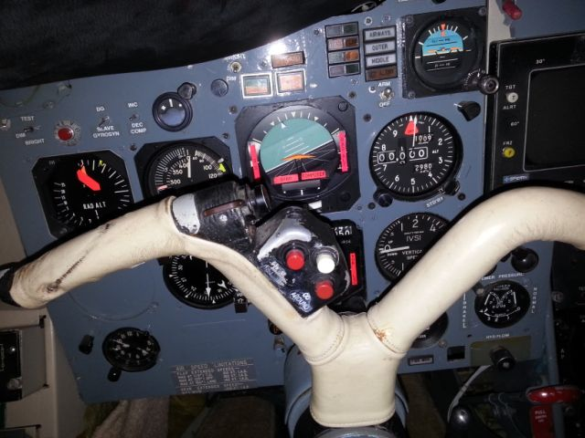

Avionics

The appraiser could not obtain an accurate list of all installed avionics. The lack of an accurate avionics and equipment list does not affect the value of this aircraft. The aircraft has the typical avionics installed on a 1980’s vintage mid size jet. There does not appear to be many modern upgrades to the avionics. Due to the aircraft sitting and unused for so long it is likely that a lot of the equipment will not function properly when powered up.

The Avionics On This Aircraft Are Considered To Be: In poor condition.

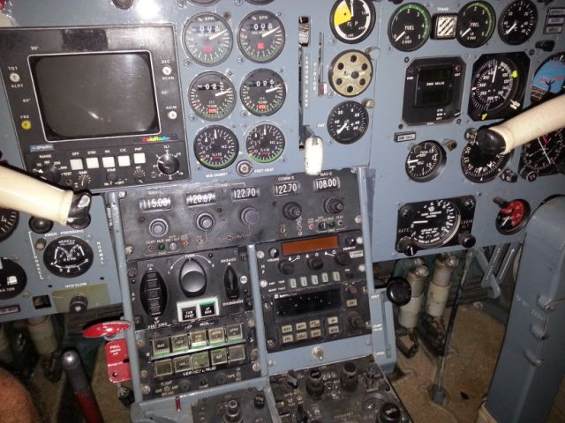

Additional Equipment

Dual Controls: Yes Type: Yoke

Stall Warning System: Yes Stick Shaker: Unknown

Rotating Beacon: Yes Strobe Light: Yes

Taxi Lights: Unknown Navigation Lights: Yes

Fuel Qty: Yes

Additional equipment: Unknown

Comments: The interior is in poor condition. There are signs of insect and small rodent damage inside the aircraft.

De-Icing Systems

This aircraft is equipped for flight into known icing however it is not know if these systems are functioning properly.

Aircraft Appraisers Comments

July 2016 Blue Book retail was $150,000.00 for an aircraft (1969 Hawker 400) with current inspections, good paint, and good interior.

For comparison purposes the appraiser found two comparables listed for sale. One was a 1970 Hawker Siddeley 400A with an asking price of $225,000.00. This aircraft had modern avionics and was currently on a maintenance program. The other was a 1972 400A with modern avionics and upgrades with an asking price of $249,000.00.

Part of the value of the aircraft would be in the engines as cores. The appraiser called around to several aircraft engine companies that rebuild and sell the Honeywell TFE 731 series and was given $10,000 USD per engine as a rough estimate of what the engines may be worth with incomplete logs and missing documentation.

The appraised aircraft N736LE does not have current inspections. The paint and interior are in poor condition. The aircraft has not flown in over 6 years. The last inspection in the log books was in 2009. There is damaged to the aircraft due to bird droppings on the exterior and insects and small rodent damage inside.

Appraisal References

Flymall Market Watch by Kraemer Aviation Services - http://flymall.org/market-watch/

AOPA Vref - http://www.aopa.org/

NAAA Evaluator - http://naaa.trade-a-plane.com/evaluator/appraisals.php?req=new

Aircraft Bluebook Price Digest

And numerous “aircraft for sale” websites.

Appraiser’s General Comments and Notes

The information herein has been prepared from many sources and believed to be correct. The appraiser cannot warrant the accuracy of the source material. The appraiser referenced numerous websites for data and information to compute a fair market value for N736LE. The appraisal inspected this aircraft at the Cambridge-Dorchester Regional Airport in Cambridge, MD (KCGE) on July 21 2016.

All aircraft records were presumed to be authentic, unaltered, and signatures and inspections therein by persons designated and appropriately licensed. AD compliance was attested to by referencing the date of last Annual Inspection or other appropriate Inspection.

The appraiser hereby certifies that he has no personal interest in this aircraft identified in this appraisal or any bias toward any of the parties who may be involved in the resulting transaction coincident to this report. The appraiser fee is not contingent upon a predetermined value being reported or a percentage of the value being reported.

The fair market value for N736LE is based on the research stated in this report and historical sales data versus appraisal values.

It is the opinion of this appraiser that the fair market value of the above aircraft is:

$XXX,000.00 USD

Harry Kraemer

SENIOR CERTIFIED AIRCRAFT APPRAISER

Appraiser’s Credentials

Harry Kraemer is an industry trained appraiser for aircraft, vintage/classic automobiles, and motorcycles. Harry has been in the industry since 1978. He is a FAA licensed aircraft dealer (His company Kraemer Aviation Services holds the license). Harry has been involved in the aircraft sales/appraisal business since the 1980s. In most recent years (since 2007) Harry has completed an average of 70 aircraft appraisals each year. Such appraisals have been used in estate settlements, divorce settlements, and insurance claims. As part of continuing his education Harry has also served as a judge for industry related shows judging vehicles, aircraft, and motorcycles. Harry has received appraisal training from such companies as Cessna Aircraft and several worldwide appraisal organizations. Harry is a member of the Association of Online Appraisers.

Harry is also an active pilot and Master Flight Instructor. Before starting Kraemer Aviation Services in 2002, Harry held numerous senior management positions in aviation including: Assistant Vice President of a Part 91 and 135 Flight Department, Chief Pilot for a 135 operation, Chief Pilot of several different Part 141 Flight Schools, and Aircraft Sales Manager for Frederick Aviation Inc.

Harry holds an Airline Transport Pilot (ATP) certificate and is a Gold Seal Flight Instructor with Instrument Instructor and Multi-engine Instructor ratings. Harry has the distinction of being the only instructor (out of approximately 84,000) to have ever held three Master titles from the National Association of Flight Instructors: Master CFI, Master Ground Instructor, and Master Aerobatic Instructor. Harry has received dozens of aviation industry awards including several from the Federal Aviation Administration.

Harry has published over 90 papers in over a dozen different aviation publications including: FAA Aviation News, Aviation Maintenance, Avionics Magazine, and IFR Refresher. Harry has served as a contributing editor for several aviation publications. Harry is also a research consultant for Gleim Publications. Harry served as an Aviation Safety Counselor for the Baltimore FSDO for over 15 years and currently serves as an EAA Flight Advisor for the Experimental Aircraft Association.

