Kraemer Aviation Services
Aircraft Appraisal Report

Client: D Kelly
Phone: XXXXXX
Address: XXXXXXXXX
XXXXXXXXX

This report is intended to be used by:
D Kelly

This report should not be distributed to anyone other than the intended user without his permission.

Aircraft Identification

Make: KITFOX Model: IV 1200

Serial No: 1663 Reg. No.: N213Y Yr. Mfg.: 1998

Type of Aircraft: BOMBARDIER - ROTAX

Airframe Total Time: 94.1 Hrs. (Hobbs) No. Landings: N/A Cycles: N/A

Airframe Condition: Better than average

Log Books in Aircraft Appear: Original and in good order.

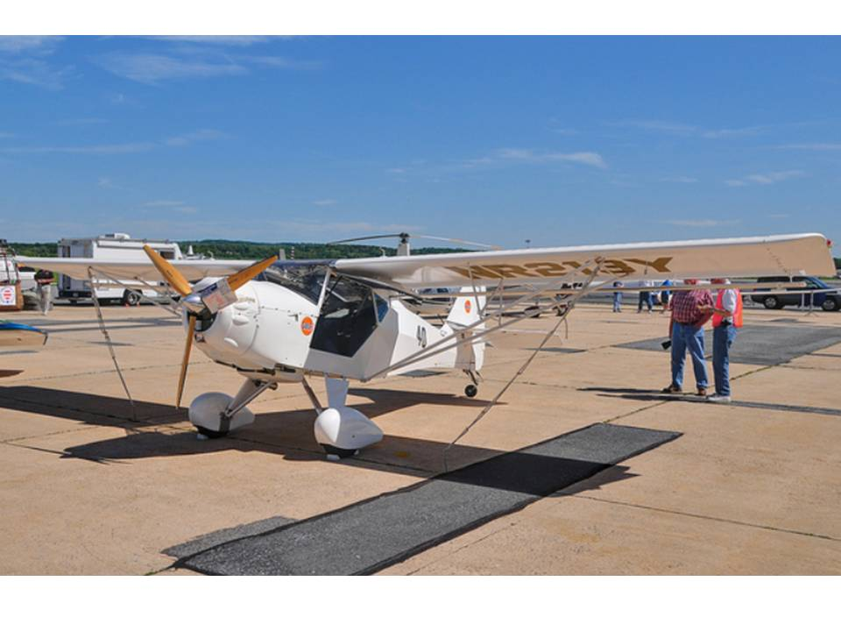

Comments: The aircraft is hangared at the Frederick Municipal Airport in Frederick, Maryland (KFDK). The aircraft was built by the current owner D Kelly. Overall the aircraft is in very good condition. It has been painted to resemble the famous racing plane the Howard DGA-6 (Mister Mulligan). For more information on the Howard DGA-6 see http://en.wikipedia.org/wiki/Howard_DGA-6.

The aircraft was completed (built) by the owner from a kit (non “quick-build”) and gotten to flying stages between 1992 and 1998. Phase 1 was completed during the next six months. N213Y was kept on a trailer and stored in a garage between flights for about 3 years after which a hangar became available at KFDK. The aircraft has been stored in the hangar since.

Below is a picture of the Howard DGA-6 (replica).

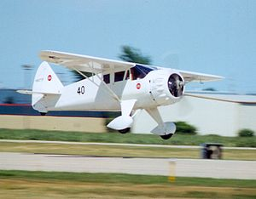

Maintenance Status

Maintenance Annual Date: The owner is currently completing an annual and expects the annual to be completed and signed off in March 2012.

On Progressive Inspection: No

Comments: The aircraft log books are original, legible and organized. There are one airframe log book and one engine log book. . They are clear and fairly easy to read. The aircraft has a hobbs meter installed and all logbook entries reference the hobbs time.

Time Life Limited Systems: N/A Cycle Life Limited Systems: N/A

Tires Condition: Good Type Brakes: Disk Anti-Skid: No

Exterior Paint Condition: High Average

Repaint Date: N/A Repainted By: N/A

Comments: The aircraft has been stored in a hangar since new. The paint is in excellent condition as are the plexiglass windows. The aircraft shows no wear or fading of the paint and/or interior. It is practically in the same condition as when it was new. New gear shock cords have been recently installed.

Interior Condition: High Average Cabin Configuration: Passenger

Cockpit Condition: High Average Panel Layout: Good

Pressurized Cabin: No Window Condition: Excellent

Comments: The cockpit/cabin is in excellent condition. The seats are like new. The birch wood floor is in very good condition. The aircraft also has Hooker Harness system installed for each of the seats.

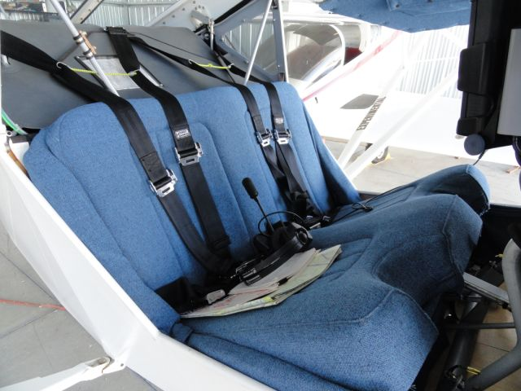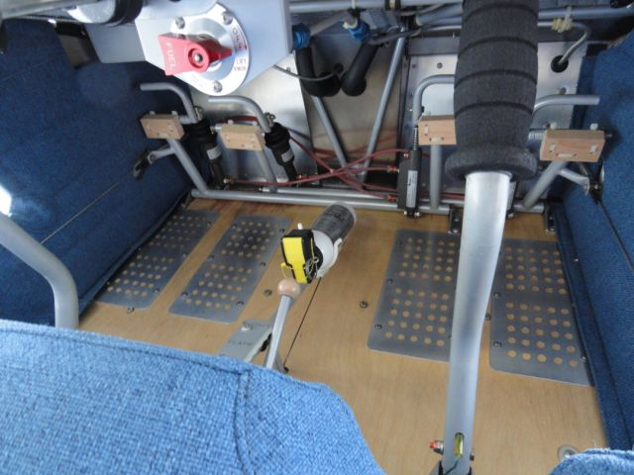

Airframe Modifications

Modification: One additional wing rib per bay (4 total per bay) for added strength

Modification: Wings struts were enlarged to added strength. The builder has made numerous additional modifications to the aircraft for added strength and support.

Modification: Aircraft modified to Model IV Speedster specifications (kit was a Model IV). Modifications to the basic "Classic IV" kit to bring it into conformity with the slightly newer "Speedster" or "1200" (gross allowable take-off weight) configuration were carried out after consultation with the kit provider/designer and included shortening of each wing by one bay, addition of an added fourth false rib to each remaining bay, strengthening and streamlining of struts and jury struts, strengthening of fuselage carry-through structure between the spar roots, and increasing the vertical tail and rudder area. An electric pitch trim system was installed and a trim tab was added to the elevator.

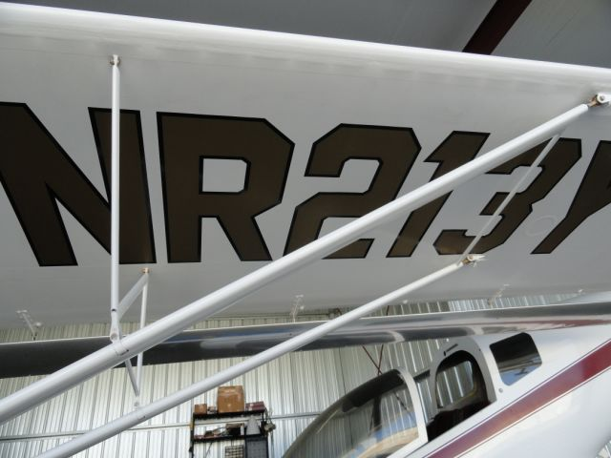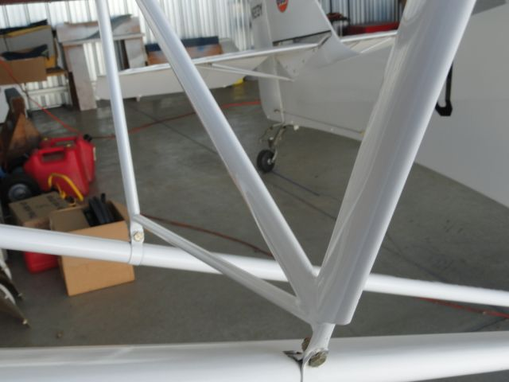

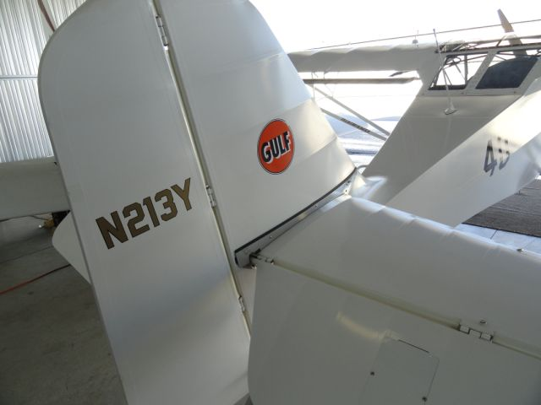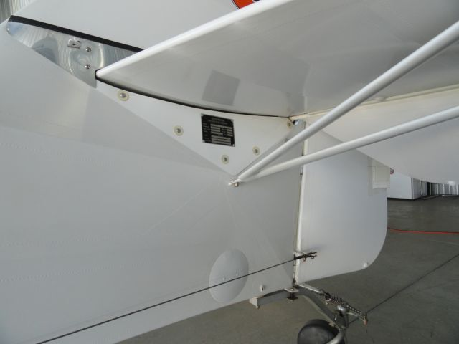
Damage History

Current Damage: There is a slight dent on the right flaperon tip as a result of a partial ground loop.

Historical Damage: None Listed

Engines & Props

Engine Manufacturer: Rotax Model: 912 UL (80 HP)

Engine Type: Piston

Engine Fire Detection: No Engine Fire Bottles: No

Prop Reversers: No

Prop Type: Ground adjustable Propeller TBO: N/A Hrs.

Engine Time Since Factory New: 94.1 Hrs.

Comments: At the last compression check the readings were 79, 80, 79, and 80. The prop is a GSC 3 blade ground adjustable wood prop. The air filter is a K&N. The owner reports no mechanical issues with the engine. The stator was replaced in the internal generator per Rotax service directive. The impeller in the oil pump was replaced per Rotax service directive. The original rocker arm bushings were replaced per Rotax service directive. The carburetors have been overhauled and balanced per Rotax service instructions. New sparkplugs were recently installed.

Propeller Make: GSC Model: Wood Number of Blades: 3

TSO/NEW: 94.1 Hrs. Date O/H: N/A

Comments: The prop has been shimmed to achieve perfect tracking of the three blades.

Engine Modifications

None known or reported.

Known Maintenance Problems with Engine(s): None known or reported.

Estimated Cost to Repair: N/A

General Engine Comments: Engine and propeller appear to be in very good condition.

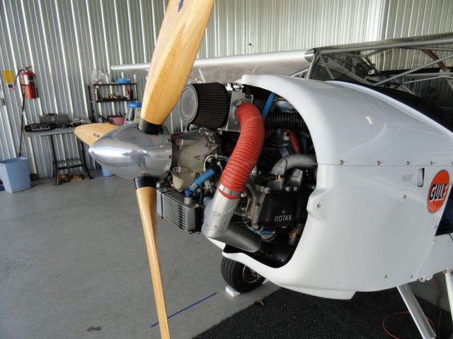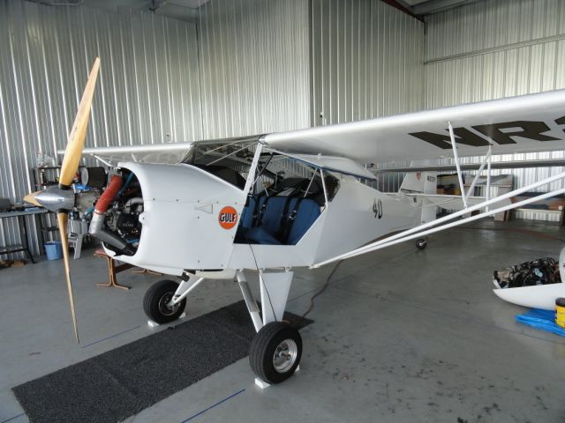

Instrumentation

Full Panel: Yes Dual Panel: No

Panel Configurations: Above avg Panel Condition: Above average

IFR Equipped: No

Comments: The aircraft has full instrumentation and is equipped with Terra radios and a Garmin GPS. It has dual PTT switches – one on each control stick. It also has an ELT and a Quartz Chronometer.

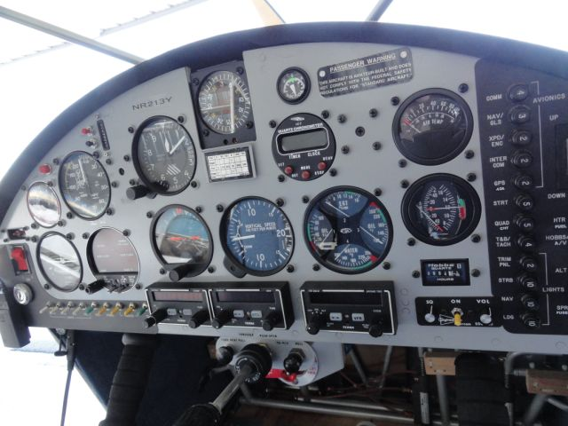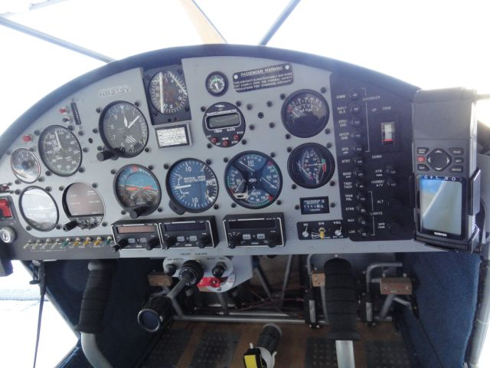

Avionics

Type of Avionic: Comm
Mfg: Terra
Model: 760 D

Type of Avionic: Nav Receiver
Mfg: Terra
Model: 200 D

Type of Avionic: Transponder
Mfg: Terra
Model: 250 D

Type of Avionic: GPS
Mfg: GARMIN
Model: GPS 90

Type of Avionic: Intercom
Mfg: Sigtronics

The Avionics On This Aircraft Are Considered To Be: Better than average.

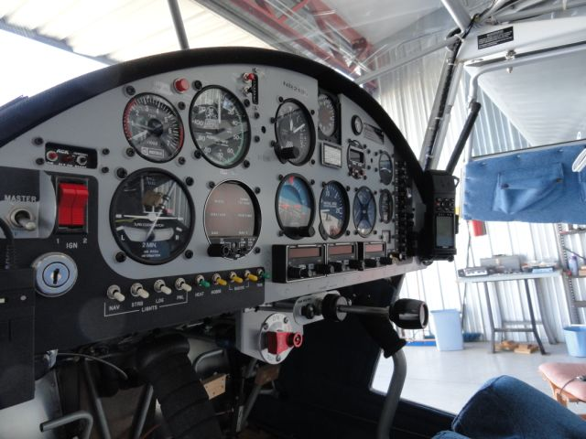

Additional Equipment

Dual Controls: Yes Type: Stick

Stall Warning System: Yes Stick Shaker: No

Rotating Beacon: Yes Strobe Light: Yes

Taxi Lights: Yes Navigation Lights: Yes

Long Range Fuel: No Fuel Qty: Yes

Other Equipment: The cabin is layout is very user friendly and all switches and controls are within easy reach of the pilot. There is a baggage compartment behind the seats. A fire extinguisher is mounted with easy reach of the pilot. In addition to the equipment listed above the aircraft has an AOA indicator, low fuel warning system, and electric trim. The stall warning device a variable pressure angle of attack indicating system with both aural and visual indicator/warnings.

Comments: The interior is in excellent condition. The temper foam seats have no wear at all.

De-Icing Systems

This section does not apply to this aircraft.

Comments: This type of aircraft is not typically equipped for icing conditions.

Aircraft Appraisers Comments

This 1998 Kitfox IV received its Airworthiness Certificate in 1998. The aircraft was completed (built) by the owner from a kit (non “quick-build”) and gotten to flying stages between 1992 and 1998. Phase 1 was completed during the next six months. N213Y was kept on a trailer and stored in a garage between flights for about 3 years after which a hangar became available at KFDK. The aircraft has been stored in the hangar since. It has received regular scheduled maintenance since new.

It should be noted that N213Y has numerous upgrades and modifications and overall the aircraft is in excellent condition. The aircraft has systems that are usually found on larger and/or production aircraft such as the angle of attack indicating system and electric trim. The aircraft is an excellent example of a home built aircraft.

A search of the NTSB and FAA databases showed no accidents or incidents.

This aircraft, N213Y, was personally inspected on February 9 2010 by Harry Kraemer an industry trained/certified appraiser at the Frederick Municipal Airport (KFDK).

Appraisal References

Estimated kit (base price) $15,995
2009 price per http://en.wikipedia.org/wiki/Denney_Kitfox

New Rotax engine (2012 price)
Source: http://www.rotaxservice.com/rotax_engines/rotax_912UL.htm $15,357

The average “asking” price for a used Rotax 912 UL is $12,600

The National Aircraft Appraisers (NAAA) Association showed a low value for the Kitfox IV as $16,800 and a high value as $26,250 USD.

The NAAA value for N213Y adjusted for actual airframe and engine times was $25,676

Appraiser’s General Comments and Notes

The information herein has been prepared from many sources and believed to be correct. The appraiser cannot warrant the accuracy of the source material. The appraiser referenced numerous websites for data and information to compute a fair market value on N213Y. At the time of the appraisal there were no comparables listed on the many “aircraft for sale” websites. The appraiser did find several references for the engine value – see http://flymall.org/market-watch/index.php?filters%5Bmake%5D=&filters%5Bmodel%5D=912UL+Engine&filters%5Byear%5D=.

An inspection and inventory was conducted by a physical examination of the external surfaces of the aircraft, cockpit and passenger cabin. It includes an inventory and assessment of condition of avionics, instrumentation and aircraft systems. No inspection plates were removed for internal inspection. Further, the logbooks and other aircraft records were carefully examined for compliance with FAA regulations relating to Airworthiness Directives, damage and maintenance history, along with other required inspections. All aircraft records were presumed to be authentic, unaltered, and signatures and inspections therein by persons designated and appropriately licensed. AD compliance was attested to by referencing the date of last Annual Inspection or other appropriate Inspection.

The appraiser hereby certifies that he has no personal interest in this aircraft identified in this appraisal or any bias toward any of the parties who may be involved in the resulting transaction coincident to this report. The appraiser fee is not contingent upon a predetermined value being reported or a percentage of the value being reported.

The fair market value for N213Y is based on the research stated in this report and historical sales data versus appraisal values.

A visual inspection and log book analysis was performed 02/09/2012 on the aircraft N213Y at: Frederick Municipal Airport, located in Frederick, Maryland. It is the opinion of this appraiser that the fair market value of the above aircraft is:

$24,548.00 USD

Harry Kraemer

SENIOR CERTIFIED AIRCRAFT APPRAISER

