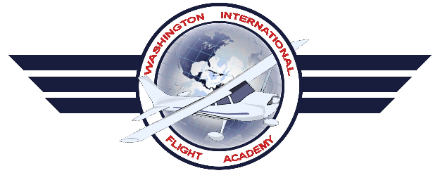
Washington International Flight Academy

Training Course Outline

Instrument Rating
Airplane Single Engine Land

List of Effective Pages
Topic |  |  |  | Revised By | Date |  | Rev # | Page:
List of Effective Pages |  |  |  | Harry Kraemer | 01/07/2016 |  | 7 | 2
Record of Revisions |  |  |  | Harry Kraemer | 01/07/2016 |  | 7 | 3
Facilities Overview |  |  |  | Harry Kraemer | 01/07/2016 |  | 7 | 4
Ground Instructional Facilities |  |  |  | Harry Kraemer | 01/07/2016 |  | 7 | 4
Overall Office Layout |  |  |  | Harry Kraemer | 01/07/2016 |  | 7 | 5
Airport |  |  |  | Harry Kraemer | 01/07/2016 |  | 7 | 7
Airport Facilities |  |  |  | Harry Kraemer | 01/07/2016 |  | 7 | 7
Aircraft |  |  |  | Harry Kraemer | 01/07/2016 |  | 7 | 8
Chief & Assistant Chief Instructor |  |  |  | Harry Kraemer | 01/07/2016 |  | 7 | 8
Instructor Requirements |  |  |  | Harry Kraemer | 01/07/2016 |  | 7 | 8
Sample Enrollment Certificate |  |  |  | Harry Kraemer | 01/07/2016 |  | 7 | 9
Sample Graduation Certificate |  |  |  | Harry Kraemer | 01/07/2016 |  | 7 | 10
WIFA Instrument TCO Rev 7
Revised Jan 3 2016

Record of Revisions
Revision Number | Revision Date | Insertion Date | By |  |  | Comments
~Original~ | 01/20/2013 | 01/20/2013 | Benzion Zwebner |  |  | Original Submission
Rev 7 | 01/08/2016 |  | Harry Kraemer |  |  | Added AATD, Modified Graduation Certificate
Rev 7 | 01/08/2016 |  | Harry Kraemer |  |  | Added two aircraft to fleet  Changed Assistant Chief Instructor
Rev 7 | 01/08/2016 |  | Harry Kraemer |  |  | Changed Chief Instructor and Assistant Chief Instructor
Rev 7 | 01/08/2016 |  | Harry Kraemer |  |  | Modified Ground Instruction Facilities and Overall Office Layouts. Aircraft Added to Fleet
Rev 7 | 01/08/2016 |  | Harry Kraemer |  |  | Added Aircraft
Rev 7 | 01/08/2016 |  | Harry Kraemer |  |  | Amended Chief and Assistant Instructors

WIFA Instrument TCO Rev 7
Revised Jan 3 2016

Washington International Flight Academy Facilities Overview

Washington International Flight Academy is located at the Montgomery County Airpark (GAI) Airport, Gaithersburg, MD and is operated as:
Washington International Flight Academy
Montgomery County Airpark (GAI) Airport.
7940 Airpark Rd., Gaithersburg, MD 20879

GROUND INSTRUCTIONAL FACILITIES.
Ground instructional facilities are located in Washington International Flight Academy facility, located at Montgomery County Airpark (GAI) Airport, Gaithersburg, MD. Training space consists of 1 training room with 3 separate cubicles, a classroom capably of group study sessions and a room dedicated for a Redbird FMX AATD. Each training sp/ace has a table and chairs for student and instructor. The classroom has accommodations for group training. The following diagram depicts the main reception facility to be used.
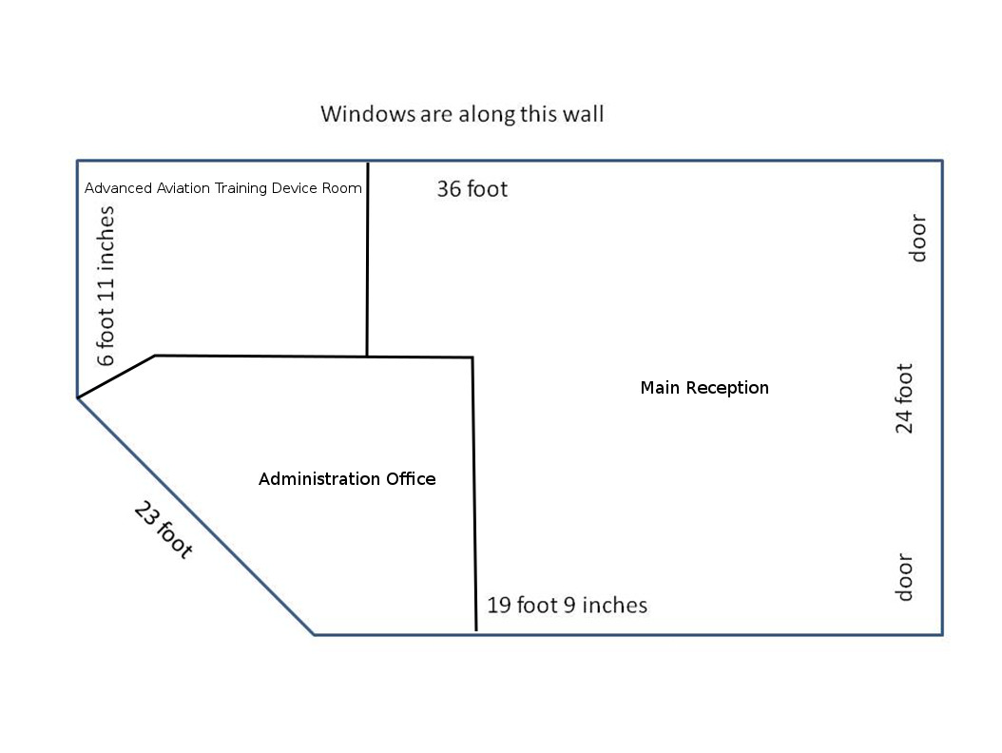

WIFA Instrument TCO Rev 7
Revised Jan 3 2016

Washington International Flight Academy Overall Office Layout
All office/classroom/briefing areas are located together in the same building. Aircraft are in tie downs within 50 feet and in a hangar nearby. A restroom is located within the facility. Air conditioning is provided and available for use as needed in addition to heating.

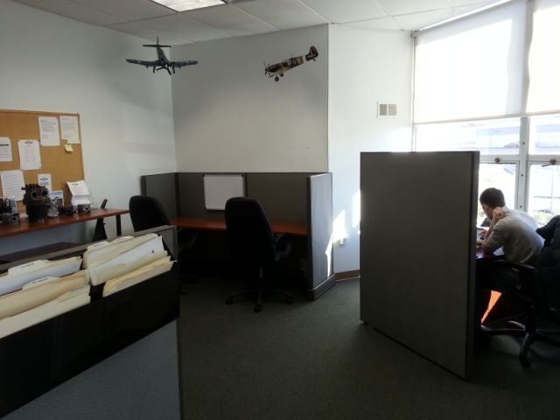

A view of the classroom:

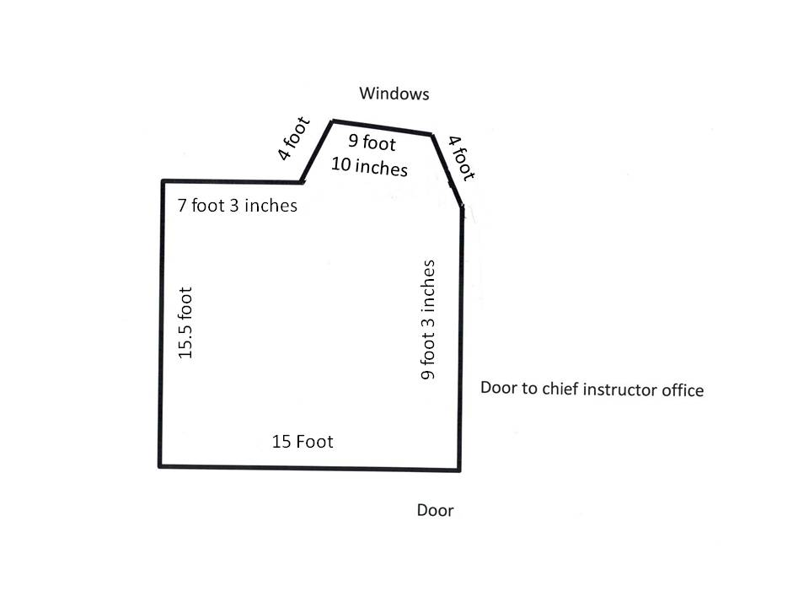

The classroom has accommodations for group training. The classroom can hold a maximum of 12 people. The following diagram depicts the facility to be used. The diagram above shows the classroom size.

WIFA Instrument TCO Rev 7
Revised Jan 3 2016
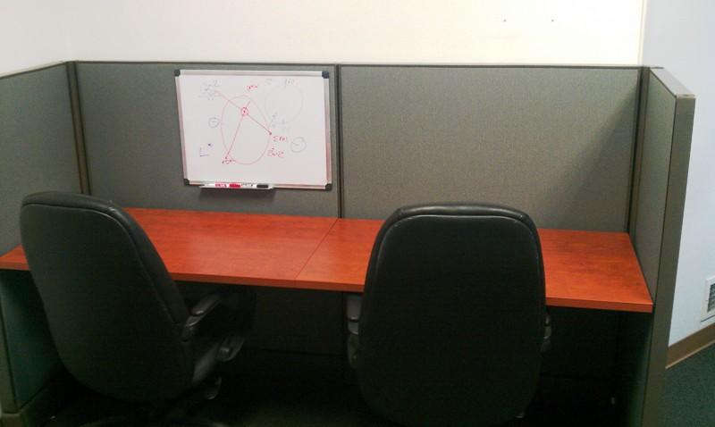
A view of one of the cubicles in the classroom. Each cubicle has a whiteboard with nearby access to internet flight planning and weather briefings.
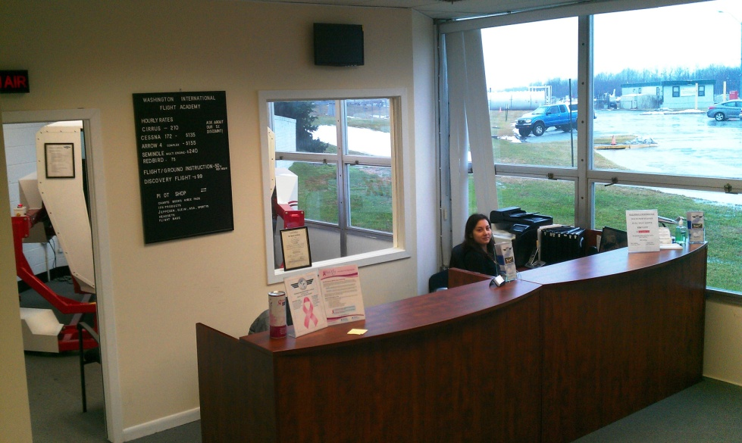
Reception Area

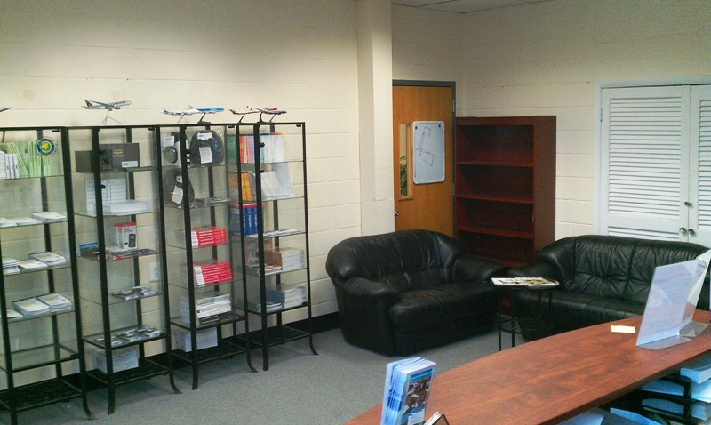
Another view of the reception area
WIFA Instrument TCO Rev 7
Revised Jan 3 2016

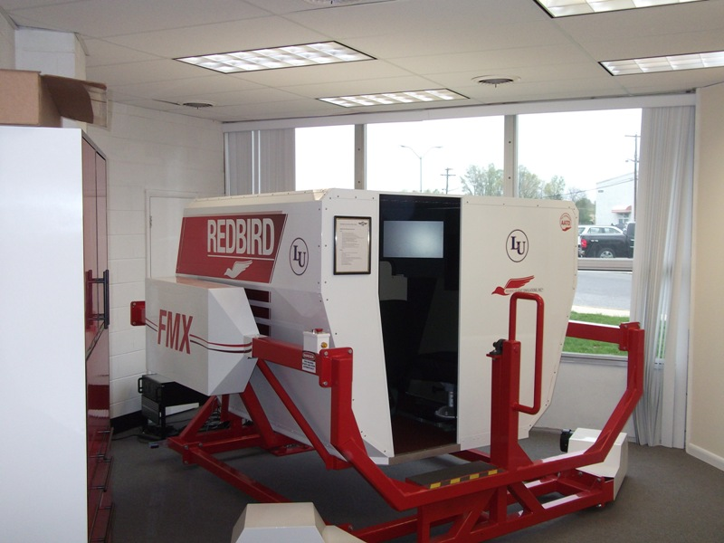
A view of the room dedicated to the Redbird FMX AATD. The room is Air Conditioned with a private entrance and is solely dedicated to the use of the AATD.

AIRPORT
Montgomery County Airpark (GAI) Airport is the main operations base for training in this course. It has a hard-surfaced runway which meets the requirements of FAR § 141.38 for day and night flight operations. Maintenance services available 24 hours. Fuel service is available 24 hours via self-serve.

AIRPORT FACILITIES
Washington International Flight Academy facility includes a pilot briefing area; the briefing area is equipped with Internet service, computer, a printer and a standard line telephone for obtaining weather briefings from the Flight Service Station (FSS). The facility is used exclusively by students.

WIFA Instrument TCO Rev 7
Revised Jan 3 2016

AIRCRAFT
The aircraft listed below will be used for all flight training in this course. These aircraft meet the requirements of FAR § 141.39. Radio equipment will consist of at least one 360 channel transceiver and a 4096 code transponder with Mode C capability. The aircraft is/are equipped for day/night VFR and for IFR as specified in FAR 91.205.

Listing of Aircraft used by the Washington International Flight Academy for Instrument Training:

Type of Aircraft | Year of Manufacture | N-Number
Piper PA28-201-RT | 1982 | N528FT
Cessna 172 S | 2005 | N2464H
Cessna 172 P | 1984 | N34HD
Cessna 172 N | 1980 | N5157K
Cessna 172 P | 1986 | N9400L
Cessna 172 R  Cessna 172 S  Cessna R172 K  Piper PA28161  Piper PA28161  Cessna 172M  Cessna 172 N  Cessna 172 Q  Piper PA28201RT | 1998  2005  1978  1978  1981  1976  1978  1983  1982 | N2621Z  N2277T  N758ES  N2172D  N8445S  N1377U  N5215E  N911AT  N528FT

ADVANCED AVIATION TRAINING DEVICE (AATD)
This Redbird FMX AATD meets the requirements of FAR § 141.41 (b) Appendix B, Appendix C and Appendix D. The AATD listed above will be used for the ground training listed in the Syllabus and for up to 40% of the hours of flight training in accordance with Part 141.4 (b) Appendix C.

Chief Instructor:
Ziv Levy

Assistant Chief Instructor:
Harry Kraemer

Flight and Ground Instructor Requirements:

Medical Requirement: 3rd Class Medical
Minimum Certifications: Commercial Pilot Certificate, Flight Instructor Certificate that matches the appropriate Category and Class of aircraft
Minimum Flight Experience: 300 Hours of total flight time in the appropriate Category

Assistant Chief Instructor Requirements:

Must match the Medical and Certification requirements of Flight and Ground Instructor
Minimum Flight Experience: 250 hours of Instruction Given and 500 hours of PIC time logged and must have held a Flight Instructor Certificate for a minimum of 12 months.

Chief Instructor Requirements:

Must match the Medical and Certification requirements of Flight and Ground Instructor
Minimum Flight Experience: 500 hours of Instruction Given and 1000 hours of PIC time logged and must have held a Flight Instructor Certificate for a minimum of 24 months.
WIFA PPL TCO Rev 7
Revised Jan 11 2016

Sample Certificates:
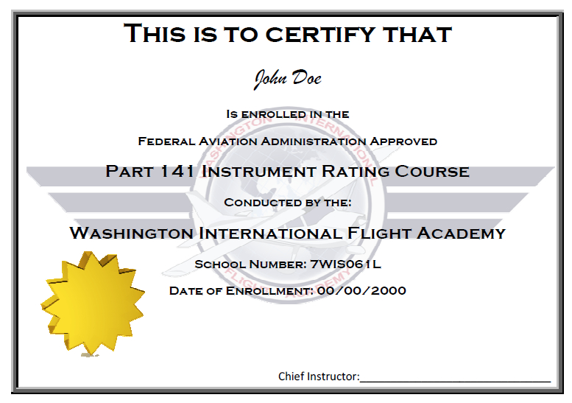
WIFA Instrument TCO Rev 7
Revised Jan 3 2016
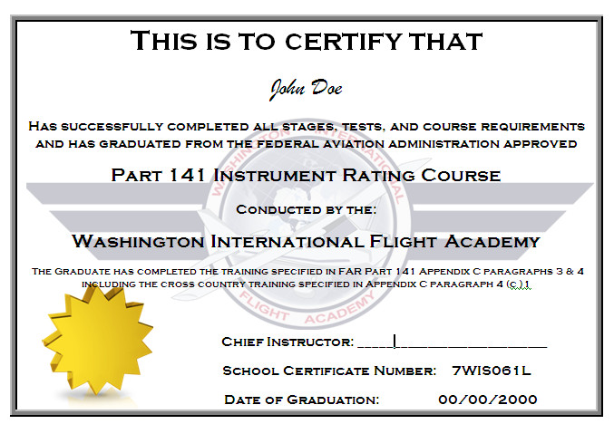

WIFA Instrument TCO Rev 7
Revised Jan 3 2016

