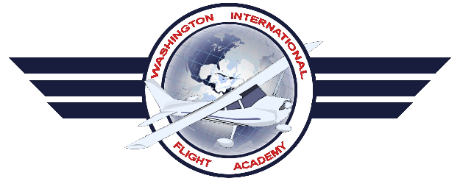
Washington International Flight Academy

141 Training Course Outline

Private Pilot
Airplane Single Engine Land

List of Effective Pages
Topic |  |  |  | Revised By | Date |  | Rev # | Page:
List of Effective Pages |  |  |  | Harry Kraemer | 01/11/2016 |  | 7 | 1
Record of Revisions |  |  |  | Harry Kraemer | 01/11/2016 |  | 7 | 2
Facilities Overview |  |  |  | Harry Kraemer | 01/11/2016 |  | 7 | 3
Ground Instructional Facilities |  |  |  | Harry Kraemer | 01/11/2016 |  | 7 | 3
Overall Main Classroom Layout |  |  |  | Harry Kraemer | 01/11/2016 |  | 7 | 4
Airport |  |  |  | Harry Kraemer | 01/11/2016 |  | 7 | 6
Airport Facilities |  |  |  | Harry Kraemer | 01/11/2016 |  | 7 | 6
Aircraft |  |  |  | Harry Kraemer | 01/11/2016 |  | 7 | 7
Chief Instructor |  |  |  | Harry Kraemer | 01/11/2016 |  | 7 | 7
Assistant Chief Instructor |  |  |  | Harry Kraemer | 01/11/2016 |  | 7 | 7
Sample Enrollment Certificate |  |  |  | Harry Kraemer | 01/11/2016 |  | 7 | 8
Sample Graduation Certificate |  |  |  | Harry Kraemer | 01/11/2016 |  | 7 | 8
Student Training Records |  |  |  | Harry Kraemer | 01/11/2016 |  | 7 | 9
Flight Instructor Proficiency records |  |  |  | Harry Kraemer | 01/11/2016 |  | 7 | 10
Student And Instructor Requirements |  |  |  | Harry Kraemer | 01/11/2016 |  | 7 | 11
Course Introduction |  |  |  | Harry Kraemer | 01/11/2016 |  | 7 | 12
Syllabus Outline |  |  |  | Harry Kraemer | 01/11/2016 |  | 7 | 16
Training Course Description |  |  |  | Harry Kraemer | 01/11/2016 |  | 7 | 18
Appendix I: Private pilot Airplane Single Engine Land Training Syllabus and lesson plans. |  |  |  | Harry Kraemer | 01/11/2016 |  | 7
Appendix II: Written Stage Exams and Answer Sheets |  |  |  | Harry Kraemer | 01/11/2016 |  | 7
Appendix III: Student Training Record Folder |  |  |  | Harry Kraemer | 01/11/2016 |  | 7
WIFA PPL TCO Rev 7
Revised Jan 11 2016
Record of Revisions
Revision Number | Revision Date | Insertion Date | By |  |  | Comments
~Original~ | 01/20/2013 | 01/20/2013 | Benzion Zwebner |  |  | Original Submission
Rev 7 | 01/11/2016 |  | Harry Kraemer |  |  | Added two aircraft, Modified Graduation Certificate, added Appendix I and II
Rev 7 | 01/11/2016 |  | Harry Kraemer |  |  | Added flight instructor proficiency records sheet and changed Assistant Chief Instructor
Rev 7 | 01/11/2016 |  | Harry Kraemer |  |  | Added new Ground school record sheet to appendix III  Added N2277T to fleet of aircraft
Rev 7 | 01/11/2016 |  | Harry Kraemer |  |  | Amended Chief Instructor and Assistant Chief Instructor
Rev 7 | 01/11/2016 |  | Harry Kraemer |  |  | Added Aircraft to Fleet
Rev 7 | 01/11/2016 |  | Harry Kraemer |  |  | Amended Chief Instructor and Assistant Chief Instructors

WIFA PPL TCO Rev 7
Revised Jan 11 2016

Washington International Flight Academy Facilities Overview

Washington International Flight Academy is located at the Montgomery County Airpark (GAI) Airport, Gaithersburg, MD and is operated as:
Washington International Flight Academy
Montgomery County Airpark (GAI) Airport.
7940 Airpark Rd., Gaithersburg, MD 20879

GROUND INSTRUCTIONAL FACILITIES.
Ground instructional facilities are located in Washington International Flight Academy facility, located at Montgomery County Airpark (GAI) Airport, Gaithersburg, MD. Training space consists of 1 training room with 3 separate cubicles, a classroom capably of group study sessions and a room dedicated for a Redbird FMX AATD. Each training space has a table and chairs for student and instructor. The classroom has accommodations for group training (up to 12 students). The following diagram depicts the main reception facility to be used.
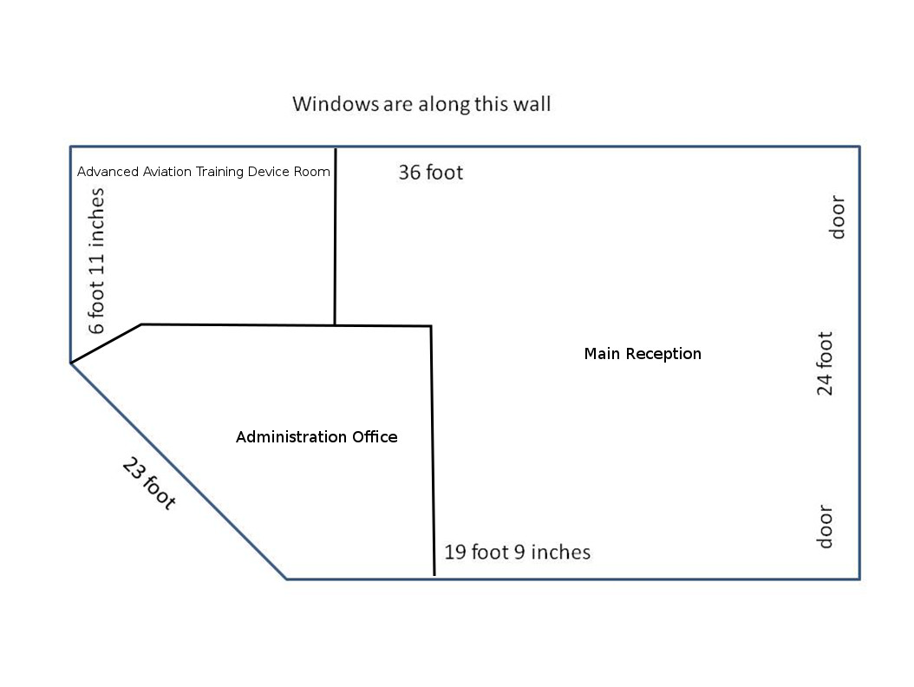

WIFA PPL TCO Rev 7
Revised Jan 11 2016

Washington International Flight Academy Main Classroom Layout
All office/classroom/briefing areas are located together in the same building. Aircraft are in tie downs within 50 feet and in a hangar nearby. A restroom is located within the facility. Air conditioning is provided and available for use as needed in addition to heating. Ground instructional facilities are located in Washington International Flight Academy facility, located at Montgomery County Airpark (GAI) Airport, Gaithersburg, MD. Training space consists of 1 training room with 3 separate cubicles. Each training space has a table and chairs for student and instructor. The classroom has accommodations for group training. The classroom can hold a maximum of 12 people. The following diagram depicts the facility to be used.

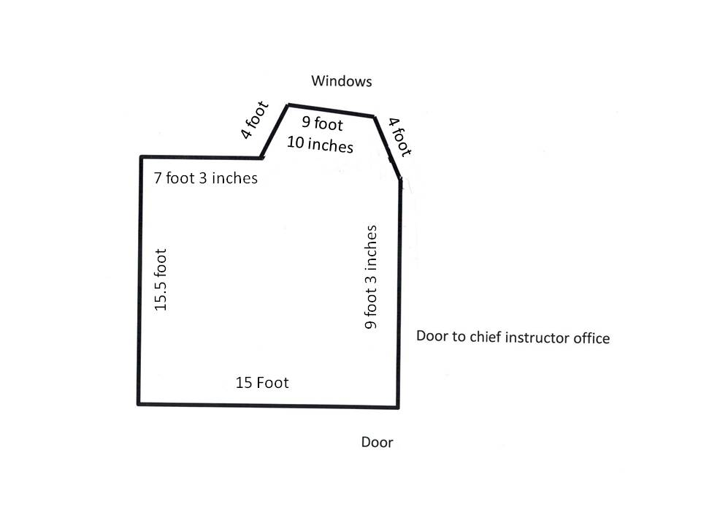

:
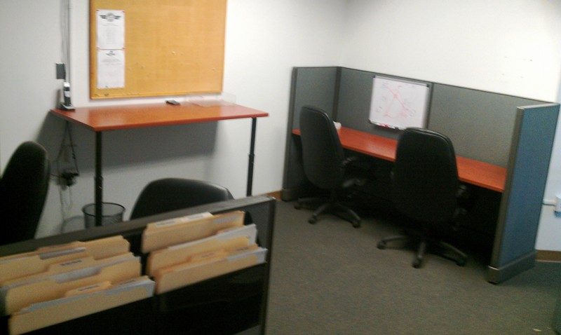
WIFA PPL TCO Rev 7
Revised Jan 11 2016
A view of the private cubicle room

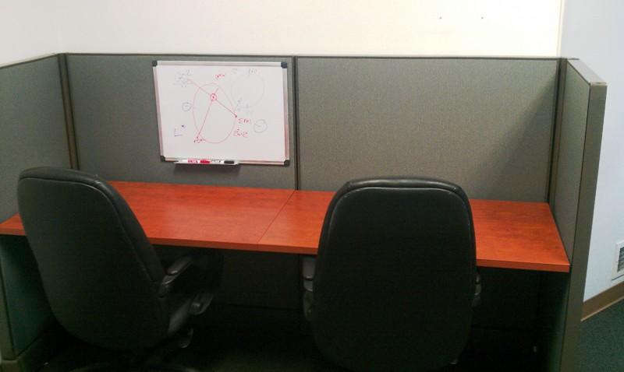
A view of one of the cubicles in the classroom. Each Cubicle has a whiteboard with nearby access to internet flight planning and weather briefings.
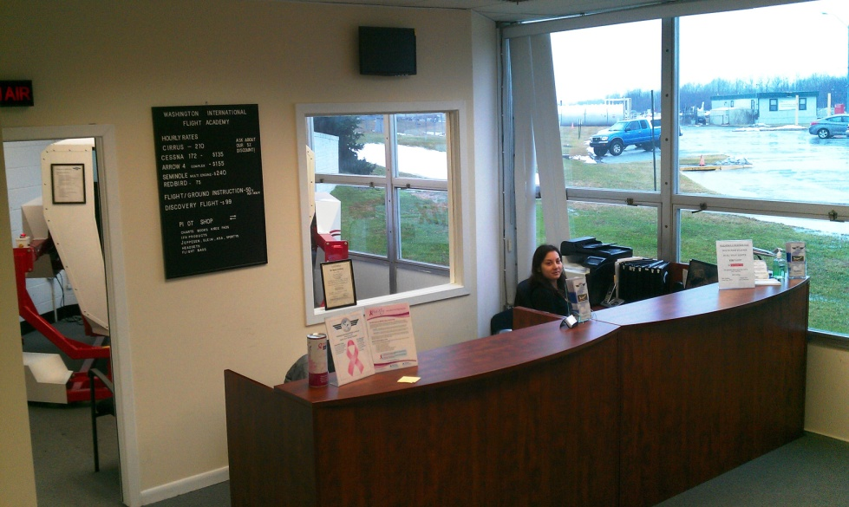
Reception Area

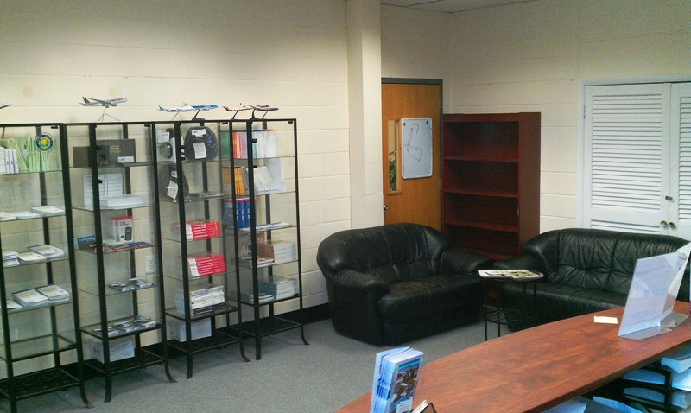
WIFA PPL TCO Rev 7
Revised Jan 11 2016
Another view of the reception area

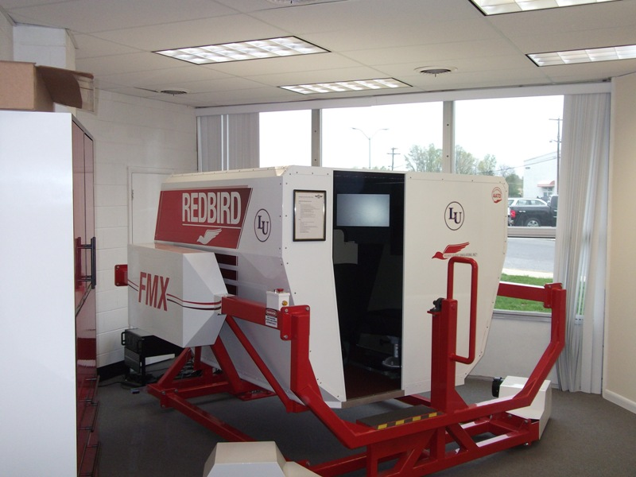
A view of the room dedicated to the Redbird FMX AATD. The room is Air Conditioned with a private entrance and is solely dedicated to the use of the AATD.

AIRPORT.
Montgomery County Airpark (GAI) Airport is the main operations base for training in this course. It has a hard-surfaced runway which meets the requirements of FAR § 141.38 for day and night flight operations. Maintenance services available 24 hours. Fuel service is available 24/7 via Self Serve Pump.

AIRPORT FACILITIES.
Washington International Flight Academy facility includes a pilot briefing area; the briefing area is equipped with Internet service, computer, a printer and a standard line telephone for obtaining weather briefings from the Flight Service Station (FSS). The facility is used exclusively by students.

WIFA PPL TCO Rev 7
Revised Jan 11 2016

AIRCRAFT
The aircraft listed below will be used for all flight training in this course. These aircraft meet the requirements of FAR § 141.39. Radio equipment will consist of at least one 360 channel transceiver and a 4096 code transponder with Mode C capability. The aircraft is/are equipped for day/night VFR and for IFR as specified in FAR 91.205.

Listing of Aircraft used by the Washington International Flight Academy for Instrument Training:

Type of Aircraft | Year of Manufacture | N-Number
Cessna 172-S | 2005 | N2464H
Cessna 172-Q | 1983 | N911AT
Cessna 172-N | 1980 | N5157K
Cessna 172-N | 1978 | N5215E
Cessna 172-M | 1976 | N1377U
Cessna 172-P | 1986 | N9400L
Piper PA-28-161 | 1981 | N8445S
Cessna 172 SP  Piper PA-28-161  Piper PA28201RT  Cessna 172-P  Cessna 172-R  Cessna R172 K | 2005  1978  1982  1984  1998  1978 | N2277T  N2172D  N528FT  N34HD  N2621Z  N758ES

Chief Instructor and Assistant Chief Instructor:

Chief Instructor:
Ziv Levy

Assistant Chief Instructor:
Harry Kraemer

WIFA PPL TCO Rev 7
Revised Jan 11 2016

Sample Certificates:
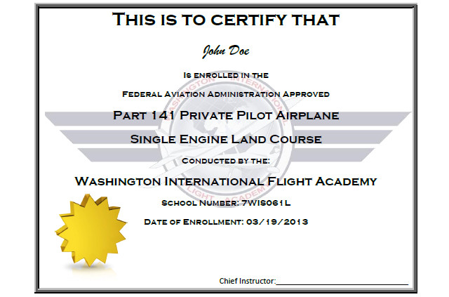

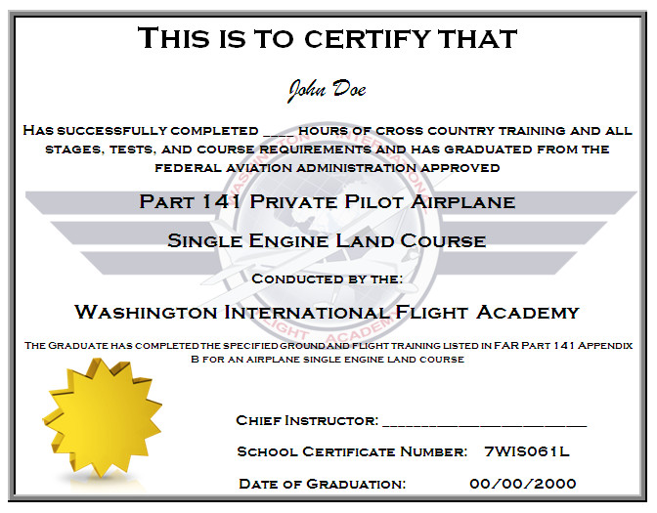
WIFA PPL TCO Rev 7
Revised Jan 11 2016

Student Training Records

The Washington International Flight Academy will utilize “Private Pilot Student Record” folders (attached as appendix III) to maintain sufficient recordkeeping for students enrolled in the Private Pilot Airplane Single Engine Land Course.

The Folder provides for recordkeeping pertaining to Enrollment Date, Flight Check Records, Stage Exam Results, 90-Day Endorsements, Ground Lessons, Individual Flight Grading, Knowledge Test Results and Personal Information. Copies of the written stage exam results and the pre-solo written exam will be kept in the Students Training Folder.

WIFA PPL TCO Rev 7
Revised Jan 11 2016

Flight Instructor Proficiency Records:

CFI Name: |  |  |  | Date of Hire:
Qualifications: CFI CFII MEI |  |  |  | Date of Termination:
Aircraft | Date | N-Number | Flight Time | Item | Due for  Renewal 1 | Due for  Renewal 2 | Due for  Renewal 3
C172 |  |  |  | Sec. Aware
C172 G1000 |  |  |  | Medical
PA-28 |  |  |  | BFR
PA-28 201RT |  |  |  | CFI
PA44-180 |  |  |  | Winter
SR20

141 CFI Proficiency Records
Private Pilot | Date | Aircraft | N-number | Time Flown | Check Instructor | Signature
Initial
Instrument | Date | Aircraft | N-number | Time Flown | Check Instructor | Signature
Initial
Commercial | Date | Aircraft | N-number | Time Flown | Check Instructor | Signature
Initial
WIFA PPL TCO Rev 7
Revised Jan 11 2016
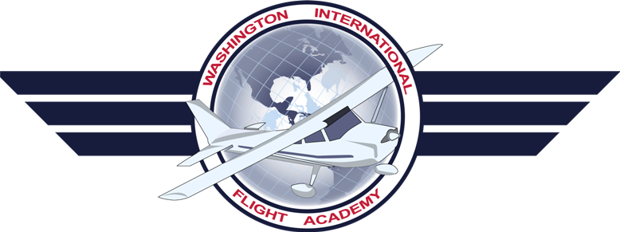

Private Pilot Airplane
Single Engine Land Course

Student and Instructor Requirements

Student Enrollment:

Minimum Age: 16 Years Old
Medical Requirement: 3rd Class Medical
Pilot Certificate: Student Pilot Certificate, Recreational Pilot Certificate

Flight and Ground Instructor Requirements:

Medical Requirement: 3rd Class Medical
Minimum Certifications: Commercial Pilot Certificate, Flight Instructor Certificate that matches the appropriate Category and Class of aircraft
Minimum Flight Experience: 300 Hours of total flight time in the appropriate Category

Assistant Chief Instructor Requirements:

Must match the Medical and Certification requirements of Flight and Ground Instructor
Minimum Flight Experience: 250 hours of Instruction Given and 500 hours of PIC time logged and must have held a Flight Instructor Certificate for a minimum of 12 months.

Chief Instructor Requirements:

Must match the Medical and Certification requirements of Flight and Ground Instructor
Minimum Flight Experience: 500 hours of Instruction Given and 1000 hours of PIC time logged and must have held a Flight Instructor Certificate for a minimum of 24 months.
WIFA PPL TCO Rev 7
Revised Jan 11 2016
Introduction

The Private Pilot Course is designed to coordinate the academic study assignments and flight training required by pilots operating in an increasingly complex aviation environment. New subject matter is introduced during the ground lessons, which include eight items:

1) In-Depth textbook assignments | 5) Stage Exams for evaluation and reinforcement
2) Selected Video Presentations | 6) AIM
3) Thorough instructor/student discussions | 7) Advisory Circulars
4) Comprehensive exercise book questions | 8) Airport Facility Directory

After completing the ground lesson, the student will apply these new principles in the Airplane during the flight lesson. It is required that each student purchase/provide their own copy of the Jeppesen Private Pilot Manual as a study textbook and a copy of the Jeppesen Private Pilot Airman Knowledge Test Guide.

Optimum effectiveness is realized when ground lessons are completed just prior to the respective flight lessons, as outlined in the syllabus. However, it is also acceptable to present lessons in a formal ground school before the student is introduced to the Airplane. If a considerable length of time has elapsed between the ground lesson and the associated flight, the instructor may wish to conduct a short review of essential material. One rule dictated by sound educational philosophy is that the flight lesson not be conducted until the related ground lesson has been completed.

In the flight syllabus, the content portion contains areas of operation which are italicized. Listed under the areas of operation are the tasks which should be emphasized for that flight. When no tasks are listed, the instructor should assign the tasks, as appropriate, for that area of operation.

COURSE OBJECTIVE
The student will obtain the knowledge, skill, and aeronautical experience necessary to meet the requirements for a private pilot certificate with an airplane category rating.

COURSE COMPLETION STANDARD
The student must demonstrate through knowledge tests, flight tests, and show through appropriate records that (s)he meets the knowledge, skill, and experience requirements necessary to obtain a private pilot certificate with an airplane category rating.

REQUIREMENTS FOR SOLO FLIGHT
Before you can fly solo, you must hold a student pilot certificate and at least a current third- class medical certificate. You also must be at least 16 years of age in order to obtain a student pilot certificate and be able to read, speak, write, and understand the English language. Remember that solo flight operations require specific training, successful completion of a pre-solo written exam, and endorsements from your flight instructor.

REQUIREMENTS FOR GRADUATION
You must be at least 17 years of age to graduate, be able to read, speak, write, and understand the English language, meet the same requirements listed in the time table for dual and solo flight, and satisfactorily complete the training outlined in this syllabus. When you meet the minimum requirements of FAR Part 141, Appendix B, you may be considered eligible for graduation.
WIFA PPL TCO Rev 7
Revised Jan 11 2016

LESSON DESCRIPTION AND STAGES OF TRAINING
Each lesson is fully described within the syllabus, including the objectives, standards, and measurable units of accomplishment and learning. The stage objectives and standards are described at the beginning of each stage within the syllabus.

TESTS AND CHECKS
The syllabus incorporates stage checks and end-of-course tests in accordance with FAR 141, Appendix B. The chief instructor is responsible for ensuring that each student accomplishes the required stage checks and end-of-course tests in accordance with the schools approved training course. However, the chief instructor may delegate authority for stage checks and end-of-course tests to the assistant chief or check instructor. You also must complete stage exams, pilot briefings, and final examinations that are described within the syllabus.
WIFA PPL TCO Rev 7
Revised Jan 11 2016
THE PRIVATE PILOT COURSE DESCRIPTION

GROUND TRAINING
In accordance with 14 CFR PART 141, ground school training is an integral part of pilot certification courses. The ground training syllabus has been designed to meet this requirement and may be conducted concurrently with flight training. This is the most effective method for course utilization, because the academic knowledge is obtained immediately prior to its application during flight training. When the course is presented as a formal classroom program, lessons should be followed in numerical order as listed in the ground training segment of the syllabus. However, to provide a degree of flexibility for adapting to individual student needs and the training environment, the syllabus lessons may be altered with approval of the chief flight instructor. Any deviation should not disturb the course continuity or objective. Lessons may be completed out of order within the same stage but not between stages. Each lesson may be presented in one classroom session, or it may be divided into two sessions, as necessary.

USING THE GROUND LESSON
The ground lessons generally are divided into two sections: Lesson Introduction and Class Discussion. Some of the ground lessons also incorporate a video presentation which aids in the introduction of the material. During the introduction, the instructor should outline the subject material to be covered during the training session, the objective for learning that information, and the performance standards necessary for successful lesson completion. Each ground lesson also includes a Study Assignment for the next lesson.

TEXTBOOK
Prior to each ground lesson, the student should read and study the assigned textbook chapter. The Private Pilot Manual is comprehensive and well illustrated for easier study and understanding. It, along with other publications indicated by the Chief flight instructor, contains the information necessary to complete the academic stages of the Private Pilot Syllabus.

EXERCISE BOOK AND STAGE EXAMS
The final step of each lesson is for the students to complete the appropriate questions in the exercise book and discuss any incorrect responses with the instructor. This ensures student understanding of the subject material prior to beginning the next ground lesson. When the lesson is complete, the instructor assigns the next chapter for out-of-class reading. At the end of each ground training stage, the students are required to complete the stage exam successfully before entering the next stage.

END-OF-COURSE EXAMS
When all of the appropriate ground lesson assignments are complete, the student will take the end-of-course exam. After a thorough review of the end-of-course exam material, the actual FAA Airplane Private Pilot Airmen Knowledge Test should be completed without delay.

COURSE IMPLEMENTATION
WIFA PPL TCO Rev 7
Revised Jan 11 2016
The Private Airplane Syllabus are designed to fulfill the requirements of a Private Pilot Certification Course in accordance with 14 CFR PART 141, Appendix B.

PRIVATE PILOT CERTIFICATION COURSE

The Private Pilot Airplane Syllabus is presented first in both an overview and a lesson by- lesson format. The combined flight and ground training includes the entire outline from Stage I through the completion of Stage III. The lesson sequence and content have been designed to provide the student with maximum academic and flight training prior to the introduction of new maneuvers or procedures. Therefore, the sequence shown in the syllabus outline should not be altered when the coordinated program is utilized. If absolutely necessary, the placement of ground lesson assignments in the coordinated program may be changed to allow the student to progress more rapidly in his academic study than is outlined in the course. If this method is used, the student should not be allowed to progress into the ground lesson assignments of the next stage until he has completed the flights in the current stage of training. This is important, because the student's recall of academic knowledge decreases with an increase in time between subject introduction during ground training and its application in flight training. The private course consists of 35 hours of ground training and 37.7 hours of flight training.

WIFA PPL TCO Rev 7
Revised Jan 11 2016

PRIVATE PILOT SINGLE ENGINE LAND FLIGHT AND GROUND COURSE SYLLABUS OUTLINE
Lesson Time Allocation
Class Discussion | Stage Exam |  | Dual Local | Cross County | Night | Solo | Instrument Time | Total Flight Time
 |  | FL1 - Discovery Flight | 0.5 |  |  |  |  | 0.5
2.0 |  | GL1 – Aerodynamic Principals
 |  | FL2 – Basic Maneuvers | 1.0 |  |  |  |  | 1.0
1.0 |  | GL2 – SFRA Procedures
 |  | FL3 – Basic Maneuvers | 1.5 |  |  |  |  | 1.5
 |  | FL4 – Slow Flight & Steep Turns | 1.5 |  |  |  |  | 1.5
2.5 |  | GL3 – Airplane Systems
 |  | FL5 - Stalls | 1.5 |  |  |  |  | 1.5
2.5 |  | GL4 – The Flight Environment
 |  | FL6 – Ground Reference Maneuvers and Engine Out to a Field | 1.5 |  |  |  |  | 1.5
2.0 |  | GL5 – Communication and Flight Information
 |  | FL7 –Local Traffic Patterns | 1.0 |  |  |  |  | 1.0
 |  | FL8 – Local Traffic Patterns | 1.0 |  |  |  |  | 1.0
1.5 |  | GL6 – Federal Aviation Regulations
 |  | FL9 – Rejected Landings and Engine Out Landings | 1.0 |  |  |  |  | 1.0
 |  | FL10 – Local Traffic Patterns | 1.0 |  |  |  |  | 1.0
 |  | FL11 – Local Traffic Patterns DMW | 1.5 |  |  |  |  | 1.5
 | 1.0 | STAGE EXAM I & Review
1.0 |  | GL6 – Pre-Solo Written Exam Review
 |  | FL12- STAGE CHECK I – Pre-Solo | 1.0 |  |  |  |  | 1.0
 |  | FL13 – Initial Solo | 0.5 |  |  | 0.5 |  | 1.0
2.5 |  | GL7 – Meteorology for pilots
 |  | FL14 – Solo Traffic Patterns Local | 0.2 |  |  | 1.0 |  | 1.2
2.0 |  | GL8 – Interpreting Weather Data
 |  | FL15 – Solo Traffic Patterns Local |  |  |  | 1.0 |  | 1.0
 |  | FL16 – Performance Take Offs and Landings | 1.0 |  |  |  |  | 1.0
2.0 |  | GL9 – Human Factors in aviation
 |  | FL17 – Attitude Instrument Flying | 1.5 |  |  |  | 1.3 | 1.5
 | 1.0 | STAGE EXAM II & Review
 |  | FL18 – Attitude Instrument Flying | 1.5 |  |  |  | 1.3 | 1.5
2.5 |  | GL10 – Computing Performance & Weight and Balance
 |  | FL19 – Night Traffic Patterns | 1.0 |  | 1.0 |  |  | 1.0
2.5 |  | GL11 – Navigation
2.0 |  | GL12 – Planning a Cross Country Flight
 |  | FL20 – Cross Country | 2.5 | 2.5 |  |  |  | 2.5
 |  | FL21 – Cross Country | 2.5 | 2.5 |  |  |  | 2.5
 | 1.0 | STAGE EXAM III & Review
 |  | FL22 – Night Cross Country | 2.5 | 2.5 | 2.0 |  |  | 2.5
3.0 |  | GL13 – Review
 |  | FL23 – STAGE CHECK II - Cross Country | 2.5 | 2.5 |  |  |  | 2.5
 |  | FL24 – Solo Cross Country |  | 2.5 |  | 2.5 |  | 2.5
 | 1.5 | END-OF-COURSE EXAM A & Review
 |  | FL25 – PPL Check-ride Prep | 1.5 |  |  |  | 0.2 | 1.5
 | 1.5 | END-OF-COURSE EXAM B & Review
 |  | FL26 – PPL Check-ride Prep | 1.5 |  |  |  | 0.2 | 1.5
 |  | FL27 - End of Course Check flight | 1.5 |  |  |  | 0.2 | 1.5
29 | 6 | -Totals - | 34.2 | 12.0 | 3.0 | 5.0 | 3.2 | 39.2
 |  | Total Flight time: 39.2
Total Ground Time: 35.0
WIFA PPL TCO Rev 7
Revised Jan 11 2016

Page intentionally left Blank
WIFA PPL TCO Rev 7
Revised Jan 11 2016
Training Course Description

Private Pilot Certification Course Airplane Single-Engine Land – Ground Training

Ground Training Portion: 35 Hours

GROUND TRAINING OBJECTIVES.
The student will obtain the knowledge, skill, and aeronautical knowledge necessary to meet the requirements for a private pilot certificate with an airplane category rating and a single-engine land class rating.

GROUND TRAINING COMPLETION STANDARDS.
The student must compete the 35 hours of ground training and demonstrate through knowledge tests and show through appropriate records that he / she has the necessary knowledge to pass the FAA Private Pilot Knowledge Test.

STAGE I

STAGE OBJECTIVES
During this stage, the student will be introduced to pilot training, aviation opportunities, human factors in aviation, and become familiar with airplane systems and aerodynamic principles, as well as the flight environment. The student also will obtain a basic knowledge of safety of flight, airports, aeronautical charts, airspace, radio communications, and air traffic control services, including the use of radar. In addition, the student will learn radio procedures and the common sources of flight information.

STAGE COMPLETION STANDARDS
This stage is complete when the student has completed the Stage I written exam with a minimum passing score of 80%, and the instructor has reviewed each incorrect response to ensure complete understanding before the student progresses to Stage II.

STAGE II

STAGE OBJECTIVES
During this stage, the student will become familiar with weather theory, typical weather patterns, and aviation weather hazards. In addition to meteorological theory, the student will learn how to obtain and interpret various weather reports, forecasts, and graphic charts. Finally, the student will become familiar with FARs as they apply to private pilot operations.

STAGE COMPLETION STANDARDS
This stage is complete when the student has completed the Stage II written exam with a minimum passing score of 80%, and the instructor has reviewed each incorrect response to ensure complete understanding before the student progresses to Stage III.

STAGE III
WIFA PPL TCO Rev 7
Revised Jan 11 2016

STAGE III OBJECTIVES
During this stage, the student will learn how to predict performance and control the weight and balance condition of the airplane. In addition, the student will be introduced to pilotage, dead reckoning, and navigation equipment. This includes understanding the basic concepts of how to use aeronautical charts, plotters, flight computers, and flight publications to plan cross-country flight. The student also will learn how to use VOR, ADF, and advanced navigation systems. In addition, the student will obtain an understanding of the physiological factors which can affect both pilot and passengers during flight. Finally, the student will learn how to conduct comprehensive preflight planning for cross-country flights and gain insight into factors affecting aeronautical decision making.

STAGE COMPLETION STANDARDS
This stage is complete when the student has completed the Stage III written exam with a minimum passing score of 80%, and the instructor has reviewed each incorrect response to ensure complete understanding.

Private Pilot Certification Course Airplane Single-Engine Land
WIFA PPL TCO Rev 7
Revised Jan 11 2016

Flight Training Portion: 37.7 Hours

FLIGHT TRAINING OBJECTIVES.
The student will obtain the necessary aeronautical skill and experience necessary to meet the requirements for a private pilot certificate with an airplane category rating and a single-engine land class rating.

FLIGHT TRAINING COMPLETION REQUIREMENTS.
The student must demonstrate through flight tests and school records that the necessary aeronautical skill and experience requirements to obtain a private pilot certificate with an airplane category rating and single-engine land class rating have been met.

STAGE I

STAGE OBJECTIVES
During this stage, the student obtains the foundation for all future aviation training. The student becomes familiar with the training airplane and learns how the airplane controls are used to establish and maintain specific flight attitudes and ground tracks. The student will also gain the proficiency to solo the training airplane in the traffic pattern.

STAGE COMPLETION STANDARDS
At the completion of this stage, the student will demonstrate proficiency in basic flight maneuvers, and will successfully soloed in the traffic pattern. In addition, the student will have the proficiency required for introduction of maximum performance takeoff and landing procedures in Stage II.

STAGE II

STAGE OBJECTIVES
This stage allows the student to expand the skills learned in the previous stage. The student is introduced to short-field and soft-field takeoff and landing procedures, as well as night flying, which are important steps in preparation for cross-country training. Additionally, greater emphasis is placed on attitude control by instrument reference to increase the student's overall competence. In the cross-country phase, the student will learn to plan and conduct cross-country flights using pilotage, dead reckoning, and radio navigation systems, and how to safely conduct flights in the National Airspace System.

STAGE COMPLETION STANDARDS
This stage is complete when the student can accurately plan and conduct cross-country flights. In addition, the student will have the proficiency to safely demonstrate consistent results in performing short-field and soft-field takeoffs and landings and night operations. The proficiency level must be such that the successful and safe outcome of each task is never seriously in doubt.

STAGE III
WIFA PPL TCO Rev 7
Revised Jan 11 2016

STAGE OBJECTIVES
During this stage, the student will gain additional proficiency in solo cross-country operations and will receive instruction in preparation for the End-of-Course Flight Check.

STAGE COMPLETION STANDARDS
This stage is complete when the student demonstrates performance of private pilot operations at a standard that meets or exceeds the minimum performance criteria established in the practical test standards for a private pilot certificate.

WIFA PPL TCO Rev 7
Revised Jan 11 2016

