This is to certify that
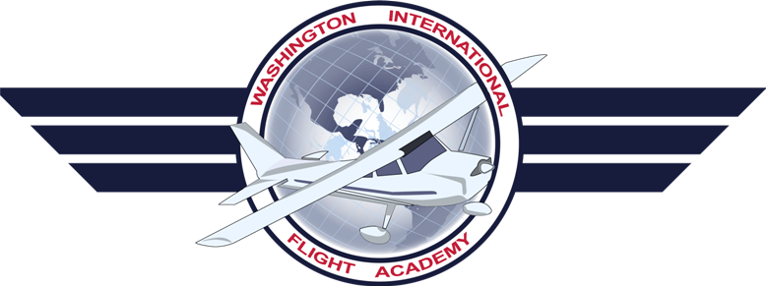
XXX XXX
Has successfully all stages, tests, and course requirements and has graduated from the federal aviation administration approved
XXX
Ground School Course
Conducted by the:
Washington International Flight Academy
The Graduate has completed the specified ground and flight training listed in FAR Part 141 Appendix B for an airplane single engine land course

Chief Instructor: Ziv Levy
School Certificate Number: 7WIS061L
Date of Graduation: XX/XX/XXXX

